RECOLOR: A MOBILE VISION ASSISTIVE TOOL FOR COLOR VISION DEFICIENCY USING ADAPTIVE DALTONIZATION
AND IMAGE PROCESSING ALGORITHMS

An Undergraduate Thesis
Submitted to the Faculty of the
College of Information Technology and Computer Science
Lyceum of the Philippines University-Cavite

In Partial Fulfillment
of the Requirements for the Degree of
Bachelor of Science in Computer Science

MARK RISEN B. CAPARAS
CHARLES JUSTINE B. RULL
JOHANN NIKKOLAI L. CEPEDA
STEPHEN L. LACSA

August 2026

ACCESS LEAF

Bachelor of Science in Computer Science

MARK RISEN B. CAPARAS
CHARLES JUSTINE B. RULL
JOHANN NIKKOLAI L. CEPEDA
STEPHEN L. LACSA

RECOLOR: A MOBILE VISION ASSISTIVE TOOL FOR COLOR VISION DEFICIENCY USING ADAPTIVE DALTONIZATION
AND IMAGE PROCESSING ALGORITHMS

ARCELL R. HADLOCON, LPT MIT
Research Adviser

Date: ______________

This thesis can be made available to the general public | YES or NO
This thesis can be accessed only after consultation with the author/s and thesis adviser | YES or NO
This thesis can be accessed only by those bound by confidentiality agreement | YES or NO

_______________________ _______________________
MARK RISEN B. CAPARAS CHARLES JUSTINE B. RULL

_______________________ _______________________
JOHANN NIKKOLAI L. CEPEDA STEPHEN L. LACSA

_______________________

ARCELL R. HADLOCON, LPT MIT

ACCEPTANCE SHEET

This thesis entitled RECOLOR: A MOBILE VISION ASSISTIVE TOOL FOR COLOR VISION DEFICIENCY USING ADAPTIVE DALTONIZATION
AND IMAGE PROCESSING ALGORITHMS prepared and submitted by MARK RISEN B. CAPARAS, CHARLES JUSTINE B. RULL, JOHANN NIKKOLAI L. CEPEDA, and STEPHEN L. LACSA, in partial fulfillment of the requirements for the degree of BACHELOR OF SCIENCE IN COMPUTER SCIENCE is hereby accepted.

ARCELL R. HADLOCON, LPT, MIT
Research Adviser

_______________________
Date Signed

Accepted in partial fulfillment of the requirements for the degree of BACHELOR OF SCIENCE IN COMPUTER SCIENCE

JOVEN B. CAJIGAS, LPT, MIT
OIC Dean, College of Information Technology and Computer Science

_______________________
Date Signed

MARK IRVIN C. CELIS, DBA
Vice President for Academic Affairs

_______________________
Date Signed

AUTHOR PERMISSION STATEMENT

Title of work: ReColor A Mobile Vision Assistive Tool For Color Vision Deficiency Using Adaptive Daltonization and Image Processing Algorithms

We hereby grant the LPU-Cavite Academic Resource Center a non-exclusive, worldwide, royalty free license to reproduce, upload, and disseminate this work in whatever form subject to the provisions of applicable laws, the provision of the LPU IPR policy and in any contractual obligations.

Furthermore, I also would like to grant the following rights to LPU-Cavite Academic Resource Center:

- To allow the LPU-Cavite Academic Resource Center to share/provide the work to the requesting party for the purpose of teaching, research and/or personal study either in print or electronic/digital format.
- To give open access to the above-mentioned work, thus allowing “fair-use” of the work in accordance with the provisions of the IPC of the Philippines (Republic Act No. 8293), especially for teaching, scholarly and research purposes.
- To allow LPU Constituents only to have access to the above-mentioned work.

MARK RISEN B. CAPARAS
CHARLES JUSTINE B. RULL
JOHANN NIKKOLAI L. CEPEDA
STEPHEN L. LACSA

AUGUST 2026

CERTIFICATE OF ORIGINALITY

Title of work: ReColor A Mobile Vision Assistive Tool For Color Vision Deficiency Using Adaptive Daltonization and Image Processing Algorithms

We hereby declare that this thesis is our own work and that, to the best of our knowledge and belief, contains no material previously published or written by another person nor material to which to a substantial extent has been accepted for award of any other degree or diploma of a university or other institute of higher learning, except where due acknowledgment is made in the text.

We also declare that the intellectual content of this thesis is the product of our work, even though we may have received assistance from others on style, presentation, and language expression.
sign
sign
___________________ _______________________
MARK RISEN B. CAPARAS CHARLES JUSTINE B. RULL
sign
sign
_______________________ _______________________
JOHANN NIKKOLAI L. CEPEDA STEPHEN L. LACSA

Attested by:
sign
_______________________
ARCELL R. HADLOCON, LPT, MIT
Research Adviser

Noted by:

JOVEN B. CAJIGAS, LPT, MIT
OIC Dean, College of Information Technology and Computer Science
_______________________
Date Signed

ACKNOWLEDGMENT

Above all, we offer our highest praise and deepest gratitude to Almighty God. For the unwavering strength, wisdom, and resilience granted to us throughout this endeavor, we are truly thankful. His endless grace and guidance have been our absolute foundation through every challenge and triumph of this academic journey.

The realization of this study, ReColor, would not have been possible without the guidance, support, and encouragement of numerous individuals who stood by us.

We extend our sincere gratitude to our thesis professor, Ms. Alyssa Paola Pocaan. Your rigorous academic standards and continuous guidance provided the necessary framework to structure our research and bring this study to life.

We are profoundly grateful to our thesis adviser, Mr. Arcell Hadlocon, alongside our esteemed panelists at the Lyceum of the Philippines University - Cavite: Dr. Jerian Peren, who also graciously serves as our Computer Science Program Chair, Sir Sean Gono, and Mr. Roger Wyne. Your collective technical expertise and constructive feedback were instrumental in refining our approach to the discrete assessment of CVD. Thank you for consistently challenging us to elevate the quality and precision of this application.

We are deeply indebted to the professionals at the Philippine Eye Research Institute (PERI) for their invaluable clinical guidance. A special measure of thanks goes to our Clinical Advisor, Ms. "Em-Em" Lamento - Villegas, for tirelessly accommodating our group and sharing her vital expertise. We also extend our sincere appreciation to the former Director of PERI, Dr. Arni Sicam, and the current Director, Dr. Harvey S. Uy, MD, for wholeheartedly supporting this endeavor and championing our research.

We also wish to express our heartfelt appreciation to Justine Deluana, a Junior Computer Science student whom we proudly consider an honorary member of our group. Your generous assistance, dedication, and willingness to lend a helping hand behind the scenes throughout this project have been truly invaluable to us.

To our peers in the College of Information Technology and Computer Science, and our colleagues across various student organizations including LYCESGO and SATA: thank you for the shared late nights, the collaborative spirit, and the unwavering camaraderie. Balancing our academic, leadership, and personal responsibilities with the demands of a complex computer vision project was a formidable challenge, but your shared support made the burden lighter and the successes more meaningful. To our fellow and future Computer Science students who will soon undertake their own research: let this study be a reminder to not merely play it safe. We challenge you to push beyond your comfort zones, disrupt the status quo, and pursue innovative solutions that create genuine impact.

To our families, partners, and loved ones, our deepest and most profound thanks belong to you. Your endless patience, sacrifices, and unwavering love have paved the way for our education and our futures. Whether you have been our core support system at home alongside our siblings, encouraging us across long distances, or watching over us from above as cherished parents whose memories and instilled values of hard work continue to guide us, this milestone is as much yours as it is ours.
MARK RISEN B. CAPARAS
CHARLES JUSTINE B. RULL
JOHANN NIKKOLAI L. CEPEDA
STEPHEN L. LACSA

TABLE OF CONTENTS

 | PAGE
Title Page | i
Access Leaf | ii
Acceptance Sheet | iii
Author Permission Statement | iv
Certificate of Originality | v
Acknowledgment | vi
Table of Contents | vii
List of Tables | viii
List of Figures | ix
List of Appendices | x
Abstract | xi
CHAPTER I: INTRODUCTION
Background and Rationale of the Study | 1
Objectives of the Study | 2
Significance of the Study | 4
Scope and Limitation | 5
CHAPTER II: REVIEW OF RELATED LITERATURE
Literature Review | 6
Conceptual Framework | 15
Definition of Terms | 20
CHAPTER III: METHODOLOGY
Research Design | 23
Sampling Technique | 24
Participants of the Study | 25
Research Locale | 25
Research Instrument | 26
Data Gathering Procedure  System Development Process  System Architecture | 26  27  27
Data Analysis | 28
Ethical Considerations | 28
CHAPTER IV: RESULTS AND DISCUSSION
Results and Presentation of Data  ** Presentation of Project Design, Result of Testing, Evaluation and Validation | 29
Discussion  ** Analysis and Interpretation of Data | 35
CHAPTER V: SUMMARY, CONCLUSION AND RECOMMENDATIONS
Summary and Conclusion | 45
Recommendations | 48
LITERATURE CITED | 51
APPENDICES | 72

LIST OF TABLES

TABLE |  | PAGE
1 | Non quis animi et saepe sunt et veritatis officia qui illo commodi at ducimus dolores. Ab libero eaque qui distinctio facilis aut autem enim et | 22
2 | Est iure excepturi et recusandae voluptatem est quia quidem est perferendis dolores ut porro voluptates sed be | 28
3 | Non quis animi et saepe sunt et veritatis officia qui illo commodi at ducimus dolores. Ab libero eaque qui distinctio facilis aut autem enim et | 41

LIST OF FIGURES

TABLE |  | PAGE
1 | Ab libero eaque qui distinctio facilis aut autem enim et | 22
2 | Est iure excepturi et recusandae voluptatem est quia quidem est perferendis dolores ut porro voluptates sed be | 28
3 | Ab libero eaque qui distinctio facilis aut autem enim et | 41

LIST OF APPENDICES

TABLE |  | PAGE
A | Letter of Request | 81
B | Survey Questionnaire | 82
C | Informed Consent Form | 83

LIST OF ABBREVIATIONS

α | Cronbach's Alpha
ANR | Application Not Responding
APK | Android Package Kit
AAB | Android App Bundle
API | Application Programming Interface
AMOLED | Active Matrix Organic Light-Emitting Diode
ARM | Advanced RISC Machine
AsyncStorage | Asynchronous Storage (React Native local persistence)
BaaS | Backend as a Service
CIELAB (L*a*b*) | Commission Internationale de l'Éclairage Lab Color Space
CIEDE2000 | Color Difference Formula (CIE, Year 2000)
CNN | Convolutional Neural Network
CPU | Central Processing Unit
CVD | Color Vision Deficiency
C* | Chroma (perceptual color saturation in CIELAB)
DAL | Daltonization (algorithm toggle label)
ΔE | Delta-E (Color Difference Metric)
DepEd | Department of Education
DOH | Department of Health
DFD | Data Flow Diagram
EAS | Expo Application Services
ERD | Entity Relationship Diagram
FPS | Frames Per Second
GPU | Graphics Processing Unit
HSV | Hue, Saturation, Value (color model)
HUE | Hue Rotation (algorithm toggle label)
IAM | Identity and Access Management
IEC | International Electrotechnical Commission
IoU | Intersection over Union
IPO | Input-Process-Output
IPS LCD | In-Plane Switching Liquid Crystal Display
IT | Information Technology
JND | Just Noticeable Difference
JSON | JavaScript Object Notation
κ | Cohen's Kappa
L* | Lightness (CIELAB coordinate)
LMS | Long, Medium, Short (cone photoreceptor response model)
MARS | Mobile Application Rating Scale
ML | Machine Learning
NDA | Non-Disclosure Agreement
NVSP | National Vision Screening Program
PERI | Philippine Eye Research Institute
PII | Personally Identifiable Information
PNG | Portable Network Graphics
RA | Republic Act
RA 4593 | Republic Act 4593 (PERI Charter)
RA 7277 | Republic Act 7277 (Magna Carta for Disabled Persons)
RA 10173 | Republic Act 10173 (Data Privacy Act of 2012)
RA 11358 | Republic Act 11358 (National Vision Screening Act)
RBAC | Role-Based Access Control
RGB | Red, Green, Blue (color model)
SDK | Software Development Kit
SkSL | Skia Shading Language
SKIA | Google's 2D Graphics Engine (used in @shopify/react-native-skia)
SSL | Secure Sockets Layer
SSIM | Structural Similarity Index
sRGB | Standard Red, Green, Blue (IEC 61966-2-1 color space)
TFLite | TensorFlow Lite
UI | User Interface
UX | User Experience
U-Net | Encoder-Decoder Convolutional Neural Network Architecture
UAT | User Acceptance Testing
WCAG | Web Content Accessibility Guidelines
XYZ | CIE 1931 Tristimulus Color Space

ABSTRACT

Lorem ipsum dolor sit amet. Ut quia aliquid sit commodi aliquam aut nesciunt repellendus et distinctio deleniti. Cum amet quisquam sit pariatur provident qui voluptate voluptatem vel quia veritatis ad officiis porro. Nam totam aliquam ab cumque facere non impedit totam aut illum dolorum. Eum repudiandae natus aut adipisci itaque qui doloremque necessitatibus eum architecto molestiae aut nihil asperiores ea soluta omnis vel incidunt natus. Quo ipsa reprehenderit non repellendus velit vel suscipit aliquam sit voluptatum repellendus! Eum quis recusandae et aliquid enim et eveniet maiores ut labore officia sit autem voluptate. Ea omnis accusantium id laborum tenetur id aliquid dolorum ut impedit ratione et vitae dolore a eaque quia. Ut deserunt fuga et nesciunt rerum et officia beatae sit omnis galisum. Et repellat nihil cum rerum labore vel rerum explicabo non pariatur ratione non aliquam magnam quo voluptates cupiditate ea consequatur eius! In molestias veniam et fugiat quas aut praesentium necessitatibus sed internos rerum. Eum Quis quibusdam hic adipisci galisum sit molestiae error id nihil quia et error deleniti. Qui sunt asperiores sit dolor saepe sed tenetur sapiente ut sequi rerum.

Keywords: blast resistance, gene, disease resistance, hybrid rice

CHAPTER I

INTRODUCTION

Background and Rationale of the Study
Color vision deficiency (CVD), affecting approximately 350 million individuals worldwide (1 in 12 males and 1 in 200 females; Asare et al., 2024), represents a pervasive yet under-addressed challenge in human-computer interaction and daily living. Global epidemiological data indicate that red–green CVD affects up to 8% of males and 0.5% of females, with prevalence varying across populations and ethnic groups (Birch, 2012; Chan et al., 2025). Recent meta-analyses further estimate a pooled global prevalence of 2.59% among children and adolescents, with males at 4.38% and the deutan type being the most common subtype across all regions (Jeong, Kim, & Park, 2025). In the Philippines, studies show that approximately 5.17% of male high school students, particularly in Metro Manila, are affected, predominantly by the deutan type, which impairs green color perception (Cruz et al., 2010). Individuals with CVD face practical difficulties in tasks such as interpreting color-coded information, distinguishing traffic signals, and selecting appropriate clothing, often affecting confidence, independence, and access to opportunities.
In response to these challenges, technological solutions have emerged to complement traditional diagnostic tools such as the Ishihara Test and Farnsworth D-15. Software-based interventions and mobile applications, in particular, have shown potential to enhance accessibility by applying adaptive filters and image processing techniques. However, most available tools remain limited to static images, lack context-aware adaptability, and fail to provide sustained functional assistance in dynamic, everyday environments. These limitations emphasize the need for innovative solutions that combine diagnostic and corrective functionalities within an accessible mobile platform tailored to diverse user needs.
The Philippine Eye Research Institute (PERI), established under Republic Act 4593, serves as the country's leading institution for blindness prevention and eye research. In line with Republic Act 11358, or the National Vision Screening Act, PERI collaborates with the Department of Health (DOH) and the Department of Education (DepEd) to implement vision screening programs for Filipino children. While these initiatives ensure early detection of visual impairments, they currently emphasize refractive errors and amblyopia and lack dedicated screening or functional support for CVD. This reveals a critical research and implementation gap in addressing color vision deficiencies within the Philippine context, particularly in ensuring both detection and practical assistance for affected individuals.
The proposed system, ReColor, seeks to address this gap by developing an Android-based mobile vision assistive tool that integrates adaptive image processing algorithms for color correction, identification, and simulation. Unlike conventional screening tools, ReColor not only embeds the Ishihara Test for preliminary detection but also provides adaptive color correction tailored to anomalous trichromacy, specifically protanomaly and deuteranomaly, which are the most prevalent CVD types among Filipinos. The daltonization algorithm performs physiologically grounded color remapping in the LMS color space using Viénot-Brettel-Mollon (1999) simulation matrices and Fidaner error-redistribution, applying uniform correction with self-gating via the error term to enhance perceptual discriminability. An alternative HSV-based hue rotation algorithm provides a comparative baseline for evaluating correction effectiveness across CVD types. The system further incorporates CIELAB ΔE perceptual distance matching against an 80+ shade reference database for tap-to-identify color naming, and SKIA GPU-accelerated shader rendering for on-demand CVD simulation on captured images.
Additionally, a U-Net convolutional neural network with a three-level encoder-decoder architecture was trained and evaluated as a research contribution, achieving 95.8% pixel accuracy and 81.1% Mean IoU on 10-class semantic color segmentation. This model demonstrates the feasibility of learned approaches for future region-specific adaptive correction. However, after evaluating the trade-offs between algorithmic and machine learning approaches, the deployed system adopts self-gating daltonization, which achieved a 7× speedup (2.8s to 0.4s per image) while eliminating the dependency on an 8MB model file and the risk of classifier misclassification errors. The trained CNN is retained as bundled TFLite assets for future integration. By combining diagnostic screening, functional enhancement, and data collection into a single mobile framework, ReColor aligns with the objectives of the National Vision Screening Act while extending its impact to daily living. This integration positions the system as a culturally responsive, accessible, and scalable solution for improving quality of life and advancing inclusive design in the Philippines.

Objectives of the Study
This study seeks to design, develop, and evaluate ReColor, an Android-based mobile vision assistive tool for individuals with color vision deficiency. The application integrates image processing algorithms for real-time color correction, identification, and simulation, while also embedding Ishihara-based screening for early detection and awareness. It aims to serve as an affordable, scalable, and context-appropriate solution that supports both functional assistance and informed career guidance for affected individuals in the Philippines:
- To design and implement an adaptive color correction and identification pipeline using image processing algorithms, that integrates:
  - LMS color space daltonization algorithms for uniform remapping of colors along confusion lines to improve perceptual discriminability for individuals with protanomaly and deuteranomaly.
  - CIELAB ΔE perceptual distance matching against an 83-shade reference database (IDENTIFIER_DB) for tap-to-identify color naming.
  - SKIA GPU-accelerated color matrix filtering for on-demand CVD simulation on captured images.
- To incorporate multimodal assistive features (haptic and auditory feedback) that enhance user accessibility and provide non-visual support for color distinctions.
- To integrate a career-awareness component that informs individuals with CVD about professions requiring normal color perception to support informed career choices.
- To evaluate the technical performance of the system using:
  - Color Difference (ΔE, CIEDE2000) to measure perceptual accuracy of corrected images.
  - Structural Similarity Index (SSIM) to ensure naturalness and structural integrity of enhanced images.
  - Processing Latency (ms per frame) to assess real-time performance and responsiveness on mobile devices.
  - Cross-device benchmarking across representative Android devices to assess device compatibility.
- To assess the acceptance, accessibility, and software quality of ReColor among color vision–deficient users and expert evaluators such as eye doctors and software specialists, based on Android app core standards, WCAG 2.2 accessibility guidelines, and validated statistical methods such as paired t-test and Cronbach's Alpha.

Significance of the Study
This study holds significant value for multiple stakeholders, with the Philippine Eye Research Institute (PERI) as its foremost beneficiary. As the national center for ophthalmic research and a long-standing advocate of blindness prevention in the Philippines, PERI can utilize ReColor as both a reference tool and a potential digital platform for CVD screening and management. The application's adaptive framework—employing LMS color space transformations, CIELAB ΔE distance matching against an 83-shade reference database, and GPU-accelerated freeze-frame CVD simulation—provides new avenues for public health interventions, education campaigns, and cross-agency collaborations aimed at improving visual accessibility for Filipinos.
Individuals with Color Vision Deficiency benefit directly from ReColor's multimodal assistive features. The daltonization module enhances color discriminability in real-world scenarios such as reading color-coded maps, selecting clothing, and interpreting traffic signals. The tap-to-identify color naming feature provides instant verbal and haptic feedback when encountering ambiguous colors, reducing reliance on external assistance. The integrated Ishihara screening allows individuals to gain awareness of their condition without clinical visits, empowering them to make informed career choices through the embedded career-awareness module.
Educators and Career Counselors gain an evidence-based tool for identifying students with CVD early in their academic trajectory. Since certain career paths—such as aviation, electrical engineering, graphic design, and military service—require normal color vision, early detection allows counselors to provide alternative career recommendations tailored to each student's abilities and interests. This supports more inclusive guidance that acknowledges rather than stigmatizes the condition.
The Academic and Research Community benefits from ReColor's evaluation of image processing algorithms for mobile-based color vision enhancement. A U-Net convolutional neural network was trained and validated as a research contribution, achieving 95.8% pixel accuracy in semantic color segmentation and demonstrating the potential for future adaptive systems. The application's open evaluation framework, which includes technical benchmarking (ΔE, SSIM, processing latency), expert validation, and user acceptance testing, establishes reproducible methodologies for assessing CVD assistive technologies.
Government Agencies and Health Policymakers aligned with Republic Act 11589 (National Vision Screening Act of 2021) gain a scalable digital tool that supports population-level CVD screening. ReColor's Firebase integration allows anonymized data aggregation, enabling researchers and policymakers to analyze CVD prevalence, severity distributions, and demographic patterns across different regions of the Philippines.
Technology Developers and App Designers working on accessibility solutions can draw insights from ReColor's implementation of image processing pipelines, GPU-based rendering, and Firebase-backed data management. The study documents performance benchmarks across various Android devices, providing practical guidance on optimizing mobile assistive technologies for resource-constrained environments. The evaluation of both algorithmic approaches (deployed) and machine learning models (research) offers a comparative framework for future developers to balance computational efficiency, perceptual accuracy, and user experience in assistive technology design.

Scope and Limitation
Color Vision Deficiency (CVD) encompasses several distinct types based on the affected cone photoreceptors: monochromacy (complete absence of functional cones or only one cone type functional, resulting in total color blindness), dichromacy (absence of one cone type, comprising protanopia, deuteranopia, and tritanopia), and anomalous trichromacy (all three cone types present but one with altered spectral sensitivity, comprising protanomaly, deuteranomaly, and tritanomaly). Among these, this research specifically targets the two subtypes of anomalous trichromacy most prevalent in the Filipino population: Protanomaly (reduced sensitivity to red light) and Deuteranomaly (reduced sensitivity to green light). Together, these red–green color vision deficiencies affect approximately 6% to 8% of males globally (Birch, 2012; Chan et al., 2025), consistent with local findings among Filipino males (Cruz et al., 2010; Pilestone, n.d.; Apollo Hospitals, 2025). The study excludes Tritanomaly (blue-light sensitivity deficiency) due to its rarity both globally and locally, as well as monochromacy and dichromacy, which represent more severe conditions requiring distinct intervention approaches. By focusing on Protanomaly and Deuteranomaly, the project maximizes relevance and user impact given the high prevalence of these CVD types in the Philippines.
The project scope targets midrange to upper-midrange Android smartphones as the primary deployment platform, reflecting the commonly available hardware among Filipino users. The recommended target device specifications include an ARM-based system-on-chip equivalent to or exceeding the Qualcomm Snapdragon 700 series, a minimum of 6 GB RAM to support concurrent camera frame buffering, GPU shader rendering, and UI operations, and a display capable of at least 1080p resolution. AMOLED displays are recommended for their superior color accuracy and wider gamut, which are important for faithful color-corrected output; however, the system is also compatible with IPS LCD panels, which remain more common in budget devices. These specifications ensure sufficient performance capabilities to support the image processing pipelines required by the application, including LMS-based daltonization, CIELAB ΔE color identification, and SKIA GPU-accelerated CVD simulation.
User scope will be limited to individuals of legal age, with testing conducted in both indoor and outdoor environments to account for varied lighting conditions that affect color correction performance. The system is optimized for standard indoor to daylight illumination levels of approximately 300 to 500 lux; accuracy of color correction and color identification may degrade in low-light environments below 50 lux due to reduced camera sensor performance and diminished color signal quality. The timeframe for development, testing, and evaluation is set between August 2025 and May 2026. Key technologies used include React Native with react-native-vision-camera for camera access, @shopify/react-native-skia for GPU-accelerated shader rendering, and Firebase for authentication, real-time data synchronization, and anonymized research data aggregation. The daltonization module applies uniform LMS-based color correction to all pixels using self-gating via the error term, alongside HSV-based hue rotation as a comparative baseline algorithm. A U-Net convolutional neural network was trained and evaluated for 10-class semantic color segmentation as a research contribution (achieving 95.8% pixel accuracy and 81.1% Mean IoU), but region-specific adaptive correction based on segmentation output is not implemented in the current runtime pipeline; the deployed system prioritizes algorithmic reliability and computational efficiency. All three camera-based features—color enhancement, color identification, and CVD simulation—operate on captured still images (freeze-frame or tap-to-identify pattern) rather than live video-rate processing.
In direct support of Republic Act No. 11358, or the National Vision Screening Act, the system also incorporates an awareness and early detection component through embedded Ishihara testing and career-awareness prompts. This feature aids in potentially identifying CVD cases and supports the Act's objectives of early vision screening, research, and public health awareness. By providing guidance on careers that may be affected by CVD, ReColor extends the scope of national screening efforts toward long-term inclusivity, informed decision-making, and equitable participation in education and employment. Limitations include device display variability affecting color reproduction fidelity across different panel technologies and manufacturers, degraded color correction and identification accuracy under low-light conditions below 50 lux, absence of live video-rate processing for enhancement and simulation modes, and the Ishihara screening module providing preliminary detection only without substituting for clinical diagnosis via anomaloscopy.

CHAPTER II

REVIEW OF RELATED LITERATURE

Color Vision Deficiency Overview
Color vision deficiency (CVD) is a common visual impairment characterized by the reduced ability or inability to distinguish certain colors, primarily caused by anomalies or absence of cone photoreceptors in the retina responsible for color perception (National Eye Institute, 2025; American Optometric Association, 2021). The most prevalent form is congenital red-green color blindness, inherited in an X-linked pattern and affecting predominantly males (EnChroma, 2022). Other types include blue-yellow deficiencies and complete color blindness, though these are rarer. Additionally, acquired CVD can result from eye diseases, neurological disorders, or exposure to toxins (American Optometric Association, 2021). Globally, an estimated 8% of males and 0.5% of females experience CVD, which significantly impacts daily activities and occupational tasks reliant on accurate color discrimination (National Eye Institute, 2025; Colormax, 2021).
The functional limitations of CVD pose substantial challenges in education, healthcare, transportation, and employment, necessitating effective adaptive technologies (EnChroma, 2021). Current solutions, such as static optical filters and software with limited real-time adaptation, often fail to accommodate changing lighting conditions or individual severity of deficiency (Almutairi & Alharbi, 2022; Machado et al., 2023). These shortcomings underscore the critical need for dynamic, accessible, and affordable interventions to enhance color accessibility and improve quality of life for individuals with CVD worldwide (Shinohara & Wobbrock, 2023; World Health Organization, 2020).

CVD Prominence in the Philippines
In the Philippines, studies on the prevalence of Color Vision Deficiency (CVD) remain limited in scale. Regional evidence suggests rates comparable to international figures, with recent meta-analyses reporting prevalence among males ranging from 5% to 8%, with the deutan type being the most common (Almustanyir, 2025; Jeong, Kim, & Park, 2025). This aligns with broader global estimates but underscores the lack of nationwide, gender-inclusive prevalence data in the Philippine context. Globally, approximately 2.8% of the population—or over three million Filipinos—are affected, emphasizing the importance of early detection and heightened awareness (World Health Organization, 2020). Traditional diagnostic tools such as the Ishihara plates and Farnsworth D-15 remain widely used, while the anomaloscope, considered the gold standard, sees limited use locally due to high costs and technical requirements (Garcia, Martinez, & Fernandez, 2022; Kumar, Patel, & Singh, 2023).
Despite these figures, CVD continues to be underrecognized in the Philippines, with awareness often occurring only when students face challenges in academic tasks that rely on color-coding, such as maps, charts, and laboratory work (Chen, Wu, & Zhao, 2023). The absence of systematic screening not only impacts educational performance but also constrains career opportunities, as individuals with CVD may face exclusion from fields requiring precise color discrimination such as engineering, aviation, and healthcare (Shinohara & Wobbrock, 2023). While Republic Act 7277, or the Magna Carta for Disabled Persons, provides broad protections for individuals with disabilities, CVD is not consistently acknowledged under this law, resulting in minimal policy-level accommodations (Department of Social Welfare and Development [DSWD], 2019). These limitations in research, policy, and inclusivity highlight the urgent need for accessible, technology-driven interventions tailored to Filipino users with CVD.
Despite these figures, CVD continues to be underrecognized in the Philippines, with awareness often occurring only when students face challenges in academic tasks that rely on color-coding, such as maps, charts, and laboratory work (Chen, Wu, & Zhao, 2023). The absence of systematic screening not only impacts educational performance but also constrains career opportunities, as individuals with CVD may face exclusion from fields requiring precise color discrimination such as engineering, aviation, and healthcare (Shinohara & Wobbrock, 2023). While Republic Act 7277, or the Magna Carta for Disabled Persons, provides broad protections for individuals with disabilities, CVD is not consistently acknowledged under this law, resulting in minimal policy-level accommodations (Department of Social Welfare and Development [DSWD], 2019). These limitations in research, policy, and inclusivity highlight the urgent need for accessible, technology-driven interventions tailored to Filipino users with CVD.

ReColor as Contributory to the National Vision Screening Program (RA 11358)
Republic Act No. 11358, or the National Vision Screening Act, calls for the development of a National Vision Screening Program (NVSP) for kindergarten students. The NVSP is developing early screening, referral, and research with a view to reducing visual impairment affecting learning and development and is currently being initiated by the Department of Education (DepEd) and the Department of Health (DOH) in collaboration with the Philippine Eye Research Institute (PERI). Trained teachers are assessing kindergarten students using standardized screening kits for conditions such as refractive error and amblyopia (PERI, 2019). Early screening helps reduce the burden of visual disability to benefit children in the long-term. Early screening supports the constitutional provision to promote health, along with inclusive education found in DepEd policies.
ReColor contributes to the objectives of RA 11358 by embedding Ishihara-based screening for Color Vision Deficiency (CVD) and extending beyond detection through real-time adaptive correction using daltonization and CNN-based color segmentation. This mobile, accessible platform supplements the NVSP by addressing visual challenges not fully covered with traditional kits, particularly those involving red–green deficiencies, while ensuring scalability in resource-constrained settings (Khan, Li, & Chen, 2022). Furthermore, ReColor’s capacity to generate prevalence and usage data aligns with the law’s intent for continuing research and evidenced-based policymaking, allowing PERI and allied agencies to expand vision health strategies to historically underserved populations. Through a combination of screening, functional assistance, and research, ReColor serves as a technology-driven complement to the NVSP in support of the law’s more extensive agenda of improving health for all Filipinos at minimum-effects levels.

Different Types of Color Vision Deficiency
Table 1

Different Types of Color Vision Deficiency (CVD)
CVD Type | Description | Subtypes | Prevalence | Implications
Monochromacy | Complete absence of functional cone cells, or only one cone type functional, causing total color blindness (Cole, 2016; Dans et al., 2017). | Monochromacy (achromatopsia); Cone monochromacy. | Very rare: 0.00003%–0.003% globally; ~0.02% of Filipino children (Almutleb & Doshi, 2020). |  | Severe light sensitivity; limited acuity; no effective corrective aids available.
Dichromacy | Absence of one cone type, leading to two-dimensional color perception (Cruz et al., 2010; Wikipedia, n.d.). | Protanopia (no red cones);  Deuteranopia (no green cones);  Tritanopia (no blue cones). | ~5.17% among Filipino males (mainly deuteranopia); tritanopia <0.01% and not sex-linked (Cruz et al., 2010). |  | Strong confusion between reds/greens or blues/yellows; high impact on academic/professional tasks.
Anomalous Trichromacy | All three cone types are present but one has altered spectral sensitivity, usually red-green (Neitz & Neitz, 2017). | Protanomaly (altered red sensitivity);  Deuteranomaly (altered green sensitivity);  Tritanomaly (rare, blue-yellow). | Most common: affects ~5% of males, especially deuteranomaly (Pattie et al., 2022). |  | Colors appear washed out; may partially benefit from optical aids, but costly and limited (Almutairi & Alharbi, 2022).

Color Vision Deficiency (CVD) remains a persistent challenge, with existing interventions offering varying degrees of effectiveness. Optical aids such as EnChroma and VINO glasses filter overlapping wavelengths to enhance color contrast, showing some benefit for individuals with mild to moderate red-green deficiencies. However, their high cost, dependence on lighting conditions, and limited effectiveness for severe cases constrain their accessibility, particularly in low-resource contexts (Almutairi & Alharbi, 2022; Pattie et al., 2022). Software-based solutions, including digital filters and mobile applications, provide more affordable and widely accessible alternatives by modifying color outputs on electronic displays. Despite these advantages, many remain confined to static images, exhibit slow or non-real-time performance on mobile devices, and lack integration into dynamic daily tasks (Machado et al., 2023; Shinohara & Wobbrock, 2023).
Among commercially available mobile applications, Color Blind Pal provides a camera-based color inspector and hue-shift filter, allowing users to identify and distinguish colors in real time using descriptive color names. However, it lacks adaptive daltonization or integrated diagnostic capabilities. Daltonize Me Camera offers GPU-accelerated real-time daltonization through OpenGL, supporting all three CVD types, but does not incorporate user profiling, per-pixel CNN-based adaptation, or screening functionality. The Chromatic Vision Simulator, developed by Asada (2012) from a color science research background, provides accurate real-time CVD simulation for protan, deutan, and tritan types but is designed for awareness and design validation rather than assistive correction. None of these existing applications integrate screening, adaptive per-pixel correction, and awareness features within a unified platform gap that ReColor is specifically designed to address.
Emerging approaches in real-time digital processing aim to overcome these limitations through adaptive algorithms, though performance variability across devices continues to pose challenges. Meanwhile, gene therapy research has demonstrated groundbreaking results in animal models by introducing functional opsin genes to restore red-green perception, but its clinical application in humans remains experimental and fraught with ethical and safety concerns (Mancuso et al., 2009). These limitations highlight the urgent need for innovative, accessible, and real-time mobile solutions that address both functional assistance and contextual adaptability for individuals living with CVD.

Comparative Analysis of Existing tools and methods for Color Enhancement
Table 2

Comparative Analysis of Methods Addressing Color Vision Deficiency
Method / Application | Mechanism | Advantages | Limitations | Status
Optical Aids (Glasses / Contacts) | Filters overlapping wavelengths to enhance contrast (e.g., EnChroma, tinted lenses) (Almutairi & Alharbi, 2022) | Commercially available; immediate use; enhances subjective discrimination (Machado et al., 2023) | Lighting-dependent; high cost; does not restore normal vision (Almutairi & Alharbi, 2022) | Widely available but limited effectiveness
Software / Digital Aids | Digital filters applied to images or video to separate confusing colors (Shinohara & Wobbrock, 2023) | Affordable; accessible; adaptable to devices (Shinohara & Wobbrock, 2023) | Often non-real-time; limited beyond static images; slower on mobile devices (Machado et al., 2023) | Available as mobile/desktop apps
Gene Therapy | Introduces functional opsin genes into cones to restore photopigments (Mancuso et al., 2009) | Targets root cause; potential to restore red-green perception (Mancuso et al., 2009) | Experimental only; ethical/safety concerns; not used clinically | Tested in animal models only
Color Blind Pal (Fiorentini, 2015) | Camera-based color inspector and filter; identifies color names (common, scientific, colloquial); hue-shift mode for CVD types | Real-time camera; free; cross-platform (iOS/Android); stripe overlay preserves original colors | No adaptive daltonization; no integrated screening or diagnostic; no per-pixel correction | Publicly available on App Store and Google Play
Daltonize Me Camera (Lima, 2014) | Real-time daltonization via OpenGL hardware acceleration; supports protan, deutan, and tritan simulation and correction | GPU-accelerated; real-time camera daltonization; supports all three CVD types | No CNN-based adaptation; no user profiling; no integrated screening or awareness features | Available on iOS App Store
Chromatic Vision Simulator (Asada, 2012) | Research-based CVD simulation for protan, deutan, and tritan types using scientific color models (Asada, 2012) | Developed by a color science researcher; cross-platform (iOS/Android); real-time camera simulation | Simulation only (no correction or daltonization); intended for designers and educators, not CVD users | Available on App Store and Google Play

The Ishihara Test: Strengths, Limitations, and Implications for CVD Interventions
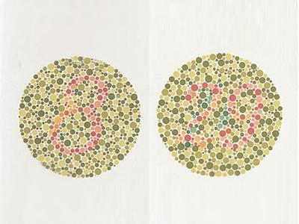
Figure 1
Ishihara Color Test

Note: Adapted from OCULUS Ishihara Tests from OCULUS, Inc. by OpthalmologyWeb n.d
The Ishihara Color Test is among the most important and reliable clinical tools for detecting red-green color vision deficiencies (Via, protanopia, red blindness, Deuteranopia, green blindness), due to its simplicity, non-invasiveness, and great sensitivity, it has become widely used in clinical and community-based screenings (Hussain et al., 2021; Kumar et al., 2023). The standard 38 pseudoisochromatic plate test method allows for expedient test administration that is tailored to different severity levels, with the initial control plates evaluating baseline vision and subsequent plates progressively challenging in order to identify mild anomalous trichromacy versus total dichromacy (Cole, 2016). Recent studies affirm its diagnostic reliability against more complex methods, and clearly, the advent of digital adaptations provides a useful method of testing utilizing smartphones (Singh & Sharma, 2020).
While the Ishihara test is quite reliable, it is also limited. It lacks sensitivity to blue-yellow deficiencies, such as tritanopia, and cannot provide a degree of color vision deficiency, which necessitates further testing (Wang et al., 2021). Nevertheless, some of its limitations are also benefits in terms of its universal applicability and cost-effectiveness, even in a low-resource context, such as the Philippines. These limitations serve as further rationale for the use of a technology-based solutions that can contribute not only to color vision differentiation, but to a more tailored, personalized, real-time, use of the testing frameworks.
The Ishihara test is published in multiple editions for different screening contexts. The full 38-plate edition evaluates Plates 1–21 using a two-stage system: 17 or more correct responses indicate normal vision, 13 or fewer indicate red-green deficiency, and 14–16 are indeterminate (Cole, 2016). Plates 22–25 classify the deficiency type as protan or deutan through dual-embedded numerals along different confusion lines (Ishihara, 1917; Birch, 1997). The concise 14-plate edition evaluates Plates 2–11 with a stricter threshold: 10 or more correct indicate normal vision, 7 or fewer indicate deficiency, and 8–9 require confirmatory testing (Ishihara, 1960). Classification Plates 12–14 differentiate protan from deutan through transformation plates and tracing tasks. The 14-plate edition achieves 97% sensitivity and 100% specificity in occupational screening protocols (Birch, 1997; Rodriguez-Carmona et al., 2012). ReColor implements both modes: a Quick Mode (14 plates) for rapid detection and a Comprehensive Mode (38 plates) for detailed classification.
New mobile apps, such as ReColor, are available to augment the strengths of the Ishihara test; these apps provide adaptive remapping of color vision from respondents with an anomalous trichromacy to improve their access and living with a color vision deficiency.

Farnsworth D-15 Test in CVD Screening
Figure 2
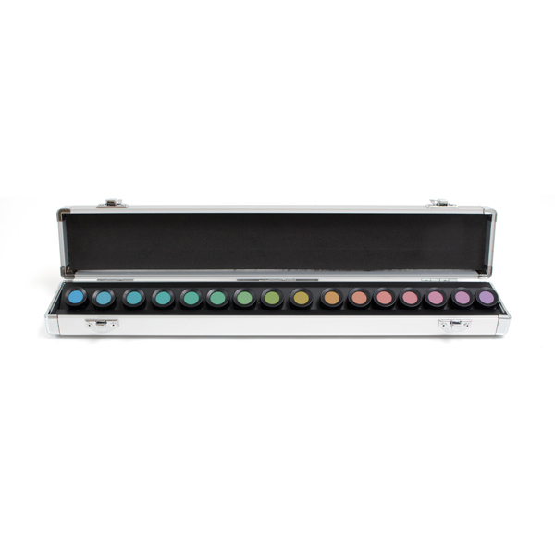
Farnsworth D-15 Color Test Kit

Note: Adapted from Farnsworth D-15 Color Test by Ophthalmic Instruments n,d

The Farnsworth D-15 test is a widely recognized tool for diagnosing and classifying color vision deficiencies (CVD), particularly in clinical and occupational contexts. It requires individuals to arrange colored discs in perceptual sequence, effectively identifying deviations along the protan, deutan, and tritan axes (Colorlite, 2025). Its strength lies in its efficiency and high specificity, averaging around 97%, which makes it reliable for confirming moderate to severe cases of CVD (Colorlite, 2025).
Despite these advantages, the test demonstrates limited sensitivity, with detection rates ranging between 53.5% and 79.3%. This limitation reduces its effectiveness in identifying mild CVD, underscoring the need for supplementary testing when clinical precision is required (Colorlite, 2025). Nevertheless, studies such as Alotaibi et al. (2021), which applied the D-15 in screening medical students after Ishihara testing, confirm its role in efficiently detecting moderate deficiencies and informing career-related guidance.
Recent developments also highlight efforts to enhance the test’s accessibility and accuracy. Digital and technology-assisted adaptations, including electronic formats and filtered testing, are being explored to improve usability and diagnostic reach in diverse settings (Zhou et al., 2024). These innovations reinforce the continued relevance of the D-15 test while emphasizing the need for complementary solutions that address its sensitivity gaps, particularly for early detection and everyday applications.

Practical Applications of Machine Learning in CVD Standpoint
Machine learning (ML) has emerged as a powerful approach in addressing color vision deficiency (CVD) by enabling adaptive and personalized corrections beyond the static capabilities of optical filters. Recent studies demonstrate the use of predictive models to map perceptual shifts in anomalous trichromacy and dichromacy, allowing for more precise and individualized color transformations based on device cameras and user feedback (Liu et al., 2023). Deep learning methods, in particular, have shown promise in enhancing color contrast under variable lighting conditions, thereby improving usability in everyday environments compared to pre-set overlays (Chen et al., 2024). ML-powered augmented reality and mobile applications can generate personalized correction maps that evolve through continuous interaction with users, resulting in higher acceptance and contextual accuracy (Khan et al., 2022).
Despite these advancements, challenges such as high computational demands, reliance on large training datasets, device-specific performance constraints, and the added complexity of on-device inference remain significant barriers to deployment on resource-constrained mobile platforms. For the ReColor system, these trade-offs were carefully evaluated during development: a U-Net convolutional neural network was trained and validated for semantic color segmentation as a research contribution, while the deployed runtime pipeline relies on deterministic image processing algorithms — specifically LMS color space daltonization, CIELAB perceptual distance matching, and GPU-accelerated shader rendering — that prioritize computational efficiency, algorithmic reliability, and deterministic behavior without requiring on-device ML inference. This design decision reflects a broader trend in assistive technology development, where proven algorithmic methods are deployed for immediate accessibility while ML-based approaches are validated as foundations for future adaptive systems (Shinohara & Wobbrock, 2023).

Convolutional Neural Networks for Color Vision Deficiency Enhancement
Convolutional Neural Networks (CNNs) have fundamentally transformed image processing by enabling automatic and adaptive feature extraction directly from raw data. Their architecture of convolution, pooling, and fully connected layers supports hierarchical learning of spatial features such as edges, textures, and patterns without manual intervention (Alzubaidi et al., 2021; Li et al., 2022). This same architecture has placed CNNs at the forefront of object detection, segmentation, and image enhancement, with considerable robustness to variations in dimensions, motion, and distortions that make them suitable for real-life scenarios where lighting and background conditions vary (Bhatt et al., 2021; Rangel et al., 2024). Additionally, their integration into end-to-end frameworks supports adaptation on mobile platforms that require fast, on-device computation.
In the context of color vision deficiency (CVD), CNNs offer the possibility of personalizing image correction through camera input analysis, segmentation of perceptually uncertain regions, and prediction of optimal color transformations tailored to individual needs (Khan et al., 2022). By contrast to static filters and manual correction algorithms, CNNs can adapt to changing environments, providing more precise and context-sensitive color remapping (Machado et al., 2023). Nevertheless, significant hurdles remain, including computational power requirements for training, possible inference delays on low-resource devices, and the need for large labeled datasets for effective learning. These challenges are particularly acute for mobile assistive applications where battery life, processing latency, and model size directly affect user experience.
Within the ReColor project, a U-Net encoder-decoder CNN was trained and evaluated for 10-class per-pixel semantic color segmentation, achieving 95.8% pixel accuracy and 81.1% Mean IoU on the validation set. This model demonstrates the feasibility of learned approaches for dense color classification in CVD assistive contexts. However, after evaluating the trade-offs between ML-based and algorithmic approaches, the deployed system adopted self-gating daltonization via LMS error-redistribution, which achieved a 7× speedup (2.8s → 0.4s per image) while eliminating the dependency on an 8MB model file and the risk of classifier misclassification errors. The trained CNN is retained as a validated research contribution and a foundation for future region-specific adaptive correction systems, while the current deployment prioritizes algorithmic determinism, computational efficiency, and clinical reliability — attributes essential for an assistive tool intended for daily use by individuals with CVD.

Daltonization Algorithms for Adaptive Color Remapping
Daltonization is a computational technique used to simulate and correct color vision deficiencies by shifting colors along confusion lines into more distinguishable hues, thereby enhancing perceptual differences for individuals with CVD while maintaining image naturalness (Viénot et al., 1999; Shen et al., 2021; Keresteš et al., 2023). The foundational Viénot-Brettel-Mollon (1999) model derives 3×3 color transformation matrices from the physiological response curves of the human L, M, and S cones, projecting pixel values in linearized sRGB space onto dichromatic confusion planes to simulate how individuals with protanopia, deuteranopia, or tritanopia perceive color. Fidaner (2005) extended this simulation into a correction framework by computing the per-pixel error vector — the difference between the original pixel and its simulated CVD perception — and redistributing this lost information into channels the user can still perceive through empirically calibrated error-shift matrices. The redistribution weights (typically 0.6–0.7) represent an empirical balance between visible correction and preserved naturalism: values exceeding 1.0 produce oversaturated artifacts, while values below 0.5 yield insufficient correction (Fidaner et al., 2005).
A critical property of this error-redistribution approach is self-gating: for pixels the CVD user already perceives correctly, the simulation output closely approximates the original, producing a near-zero error vector, and the pixel passes through the pipeline essentially unchanged. For pixels within the user's confusion zone, the error is large and the redistribution shifts those colors into distinguishable alternatives. This mathematical self-gating eliminates the need for an external pixel classifier or segmentation model to determine which pixels require correction — the error magnitude itself acts as an implicit gate (Viénot et al., 1999; Fidaner et al., 2005). ReColor exploits this property by applying daltonization uniformly to all pixels without a CNN mask, achieving deterministic correction with sub-500ms processing latency on mid-range Android devices. As a comparative baseline, ReColor also implements HSV-based hue rotation, a rule-based approach that rotates hue values within a configurable angular band around each CVD type's primary confusion axis, providing a representative of heuristic methods against which the physically motivated daltonization can be evaluated for perceptual effectiveness and image naturalness.

From Traditional Clustering to Image Processing Algorithms
Image segmentation and color classification techniques exist on a methodological continuum from unsupervised clustering to deep learning-based dense classification, with both paradigms sharing the fundamental objective of assigning every pixel to a discrete categorical group based on feature similarity. Traditional methods such as K-Means (MacQueen, 1967) partition pixels using handcrafted distance metrics in low-dimensional color spaces, but are limited by their reliance on Euclidean distance in RGB space, which fails to capture higher-order perceptual relationships (Zaitoun & Aqel, 2015). Encoder-decoder architectures such as U-Net (Ronneberger et al., 2015) represent the learned extension of this principle, where the encoder maps pixels into hierarchical feature representations through successive convolutional and pooling layers, while the decoder reconstructs pixel-level class assignments via upsampling and skip connections. Meanwhile, perceptual color spaces such as CIELAB offer a middle ground: they enable accurate color classification through distance-based matching without requiring model training, leveraging the perceptual uniformity of the Lab* coordinate system to produce color difference measurements (ΔE) that correlate with human visual perception (CIE, 2004; Sharma et al., 2005).
Within the ReColor framework, this continuum informed the selection of algorithms for different system components. K-Means clustering was evaluated during early development but abandoned due to its sensitivity to initialization, susceptibility to local optima, and inability to distinguish spectrally similar colors under varying illumination (Badrinarayanan et al., 2017). A U-Net CNN was subsequently trained and achieved 95.8% pixel accuracy, demonstrating the feasibility of learned segmentation for future adaptive correction. However, for the deployed color identification feature, CIELAB ΔE perceptual distance matching against a curated 77-shade reference database was selected as the production algorithm, providing deterministic, inspectable classification without the computational overhead of on-device ML inference. For color correction, self-gating daltonization via LMS error-redistribution was adopted, eliminating the need for any segmentation model in the correction pipeline. This progression from clustering through deep learning to perceptual distance matching and physically-motivated correction reflects a principled engineering trade-off: each technique was evaluated on its merits, and the deployed system prioritizes algorithmic reliability, transparency, and computational efficiency while retaining the trained CNN as a validated research contribution for future integration (Minaee et al., 2022).

CIELAB Color Space and ΔE Perceptual Distance for Color Identification
Figure
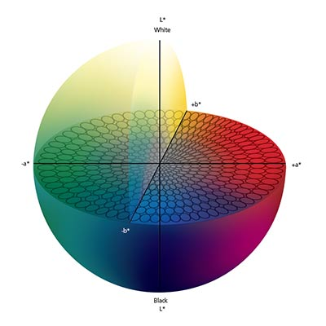
CIELAB Color Space

Note: Adapted from Tolerancing Part 3: Color Space vs. Color Tolerance by xrite,org

The CIELAB color space, defined by the Commission Internationale de l'Éclairage (CIE, 1976), is a three-dimensional color model designed to approximate human visual perception. Its three coordinates — L* (lightness, 0–100), a* (green-red axis, approximately −128 to +128), and b* (blue-yellow axis, approximately −128 to +128) — are derived from the CIE XYZ tristimulus values through a nonlinear transformation referenced to a standard illuminant, typically D65 (6504K daylight). The defining property of CIELAB is perceptual uniformity: equal Euclidean distances in Lab* space correspond approximately to equal perceived color differences, a property that RGB and HSV color spaces fundamentally lack (Fairchild, 2013; Sharma et al., 2005). This uniformity makes CIELAB the foundation for industrial color difference measurement across print, paint, textile, and display calibration industries, standardized as the ΔE metric under ISO 12647 and CIEDE2000 (CIE, 2004). The ΔE scale provides an interpretable perceptual ruler: values below 1.0 are imperceptible to the human eye, values between 2 and 10 are noticeable at a glance, and values above 10 represent clearly different colors (Mokrzycki & Tatol, 2011).
For the ReColor Color Identifier module, CIELAB ΔE serves as the core classification algorithm. Each captured pixel's RGB values are converted to linear light via sRGB gamma decoding (IEC 61966-2-1), transformed to CIE XYZ using the standard D65 observer matrix, and then mapped to Lab* coordinates. The resulting Lab* triplet is compared against a curated reference database of 77 entries spanning 10 perceptual color classes (Neutral, Red, Orange, Yellow, Green, Cyan, Blue, Violet, Pink, Brown), and the nearest reference entry by weighted ΔE distance is returned as the classification result. Lightness (L*) is down-weighted by a factor of 0.5 in the distance calculation to ensure that dark and bright variants of the same hue (e.g., dark red and bright red) classify to the same color name, since color identity depends primarily on chromaticity (a* and b*) rather than luminance. A chroma gate (C* = √(a² + b²) ≥ 12) prevents near-gray pixels — which have unreliable hue due to sensor noise — from being misclassified as chromatic colors. This approach offers three advantages over ML-based classification for the color naming task: determinism (the reference database is inspectable and reproducible), zero training data requirement (the 10 classes are defined from color-vision literature), and industry-standard perceptual accuracy (ΔE is the international standard for color-difference measurement). Competing applications such as Color Blind Pal use HSL-based lookup tables and OmniTrics uses RGB Euclidean distance, both of which lack the perceptual uniformity that CIELAB provides (Fairchild, 2013).

HSV Color Model and Hue Rotation for Color Enhancement
Figure
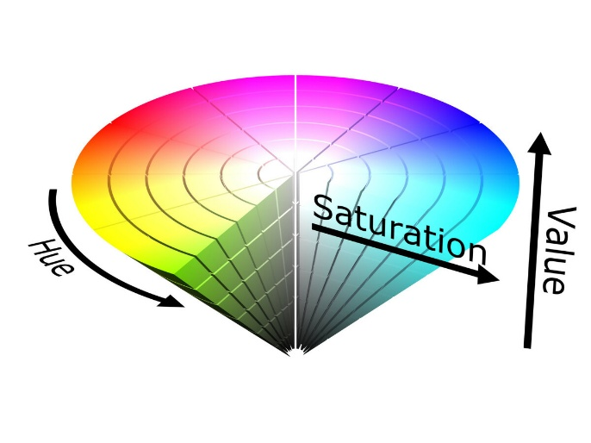
HSV Color Model

Note: Adapted from HSV by Ophthalmic hyperskill.org

The HSV (Hue, Saturation, Value) color model represents color as three intuitively meaningful components: hue (the color angle on a 0°–360° wheel, where 0° = red, 120° = green, 240° = blue), saturation (the purity of the color, from 0 = gray to 1 = fully saturated), and value (the brightness, from 0 = black to 1 = maximum intensity). Unlike RGB, where modifying a single color attribute requires simultaneous changes across all three channels, HSV isolates chromatic identity (hue) from achromatic properties (saturation and value), enabling targeted manipulation of color appearance without affecting brightness or contrast (Gonzalez & Woods, 2018). This separation makes HSV particularly suitable for hue-based correction strategies in which the goal is to rotate confused colors into distinguishable alternatives while preserving the image's luminance structure. The RGB-to-HSV conversion is computationally lightweight, requiring only comparison and division operations without the matrix multiplications or nonlinear transformations demanded by CIELAB or LMS color spaces, making it practical for per-pixel processing on mobile devices.
Hue rotation as a CVD correction strategy operates by identifying the angular region on the HSV color wheel where confusion is strongest for a given deficiency type (e.g., 0° ± 60° for protan and deutan red-green confusion, 240° ± 60° for tritan blue-yellow confusion) and applying a configurable angular shift to pixels within that band. A linear taper function ensures that pixels at the center of the confusion band receive the full rotation (e.g., +40° for protan), while pixels at the band edges receive progressively less rotation, reaching zero at the boundary. This prevents visible discontinuities (banding artifacts) in color gradients that would otherwise occur with a hard cutoff. A saturation gate (S < 0.15) prevents near-gray pixels — whose hue values are unreliable due to minimal chroma — from being incorrectly rotated, which would introduce colored noise into neutral regions. Within the ReColor system, hue rotation serves as a comparative baseline algorithm against which the physically-motivated Viénot-Fidaner daltonization is evaluated. While daltonization derives its correction from the physiological cone response model and achieves self-gating through the error term, hue rotation represents a rule-based heuristic approach that requires manual definition of confusion bands and rotation angles. This dual-algorithm architecture enables the thesis to comparatively evaluate correction effectiveness, image naturalness, and user preference across two fundamentally different algorithm families.

A Hybrid Computational Framework for CVD Enhancement
The development of effective CVD assistive tools requires the integration of multiple computational techniques, each addressing a distinct aspect of the color correction and identification pipeline. Prior work has demonstrated that no single algorithm adequately addresses all facets of CVD assistance: simulation requires physiologically grounded cone-response models, correction demands perceptual error redistribution, and color identification benefits from perceptually uniform distance metrics (Viénot et al., 1999; Shen et al., 2021; Fairchild, 2013). CNNs are powerful for dense pixel classification but introduce computational overhead, model size constraints, and non-deterministic behavior that may be undesirable in assistive contexts where reliability is paramount (Li et al., 2021; Khan et al., 2022). This recognition has driven recent frameworks toward hybrid architectures that combine algorithmically distinct modules, each selected for its suitability to a specific task within the pipeline.
ReColor implements such a multi-algorithm framework comprising three deployed image processing pipelines and one research-validated model. LMS color space daltonization with Viénot-Brettel-Mollon (1999) simulation matrices and Fidaner error-redistribution matrices provides self-gating color correction that adapts per-pixel based on error magnitude. CIELAB ΔE perceptual distance matching against a 77-shade reference database delivers deterministic, inspectable color identification without requiring model training. SKIA GPU-accelerated shader rendering via SkSL RuntimeShader provides on-demand CVD simulation with sub-16ms rendering latency. HSV-based hue rotation serves as a comparative baseline for evaluating correction effectiveness against the physically-motivated daltonization. Each algorithm was selected based on its fitness for the specific task: physically-motivated models for correction and simulation, perceptually uniform metrics for identification, and rule-based heuristics for comparative analysis.
Together, these algorithms constitute a scalable framework for mobile assistive deployment that balances computational efficiency, perceptual accuracy, and deterministic behavior. The U-Net CNN, trained to 95.8% pixel accuracy for 10-class semantic segmentation, was evaluated as a research contribution demonstrating the feasibility of learned approaches for future region-specific adaptive correction, but was deliberately excluded from the deployed pipeline after empirical comparison showed that self-gating daltonization achieved comparable perceptual outcomes with 7× lower latency and without the added complexity of on-device ML inference. This design reflects a principled engineering trade-off: proven algorithmic methods are deployed for immediate clinical and daily-use reliability, while the validated CNN provides a foundation for future adaptive systems that could integrate learned segmentation for context-aware correction.

TensorFlow Lite and Python for Model Training and Evaluation
Python plays a central role in artificial intelligence (AI) development due to its simplicity, readability, and extensive ecosystem of libraries that accelerate machine learning workflows (Raschka & Mirjalili, 2022). Widely adopted frameworks such as TensorFlow, PyTorch, and scikit-learn are Python-based, making it the preferred language for research, prototyping, and deployment of AI models (Abadi et al., 2016; Goyal et al., 2021). Its versatility extends from data preprocessing to deep learning model deployment, enabling rapid innovation in AI-powered solutions across diverse domains, including healthcare, vision enhancement, and accessibility technologies. For the ReColor project, Python served as the primary environment for training the U-Net segmentation model and the EfficientNetB0-based color identifier model, with TensorFlow and Keras providing the training framework and evaluation pipeline.
Within this ecosystem, TensorFlow Lite serves as a lightweight extension optimized for mobile and embedded platforms, supporting inference with low latency and efficient resource usage (TensorFlow, 2024). For ReColor, TFLite was used to convert trained Keras models into optimized mobile-compatible formats (color_model.tflite at 512KB and color_identifier.tflite at 323KB), which were bundled as application assets for potential future integration. While the current deployed pipeline relies on algorithmic approaches — LMS daltonization, CIELAB ΔE matching, and SKIA GPU rendering — rather than runtime ML inference, the TFLite conversion and bundling demonstrates the technical feasibility of on-device CNN deployment for future adaptive correction systems. The react-native-fast-tflite library provides the JavaScript bridge for invoking TFLite models from React Native, and the supporting tensor utilities (prepareInputTensor, getClassMask, upscaleMaskNearest) in tensorHelper.js implement the full inference pipeline, validating that the integration pathway exists for future development iterations that may incorporate learned segmentation into the live correction flow.

React Native and SKIA for Mobile GPU-Accelerated Image Processing
React Native is a widely adopted framework for cross-platform mobile development, allowing developers to build native-like applications using JavaScript and React (Moshkovich et al., 2021). Its cross-platform architecture makes it suitable for computation-heavy tasks such as adaptive color vision enhancement, where native module bridging provides access to platform-specific hardware capabilities. Key extensions strengthen its capabilities for assistive vision applications: react-native-vision-camera (v4.7.3) provides high-performance access to native camera APIs for low-latency photo capture with configurable quality prioritization (Hahn et al., 2022); react-native-fast-tflite (v1.5.1) enables JavaScript-based invocation of TensorFlow Lite models for potential on-device ML inference; and Firebase SDK (v12.6) supports secure authentication, real-time Firestore synchronization, and offline-first data persistence for user profiles and test results.
The application is built using Expo's managed workflow (~v54) with EAS Build for cloud-based Android compilation, which simplifies native module integration and deployment while supporting custom native dependencies such as react-native-vision-camera, react-native-skia, and react-native-fast-tflite through development builds rather than the standard Expo Go client (Expo, 2024). Expo's image-manipulator module provides the image resizing pipeline that normalizes captured photos to processing-appropriate dimensions (1040px for enhancement and simulation, 640px for color identification) before algorithmic processing.
The @shopify/react-native-skia library (v2.2.12) provides the GPU rendering layer critical to ReColor's CVD simulation pipeline. Skia is Google's open-source 2D graphics engine underlying Chrome, Android, and Flutter, and react-native-skia exposes its full capability to React Native applications, including hardware-accelerated Canvas rendering and custom shader programs written in SkSL (Skia Shading Language). ReColor's CVD simulation employs a RuntimeShader that executes a per-pixel color transformation on the GPU: the shader decodes sRGB gamma, applies the Viénot 3×3 simulation matrix via dot products, clamps out-of-gamut values, and re-encodes to sRGB — all in half-precision (16-bit float) arithmetic that mobile GPUs execute approximately 2× faster than single-precision operations with no visible quality loss. This GPU pipeline processes a 1040×780 image in approximately 4ms compared to approximately 400ms for the equivalent JavaScript pixel loop, enabling instant CVD type switching on a frozen frame without re-capture or re-decode. The makeImageSnapshot() API allows the post-shader GPU canvas to be captured as a lossless PNG for saving, ensuring the user receives the simulated output rather than the original capture. This architecture replaces the OpenCV-based processing pipeline originally planned during the design phase, offering equivalent or superior performance for the specific color transformation operations required by the ReColor system while maintaining a pure JavaScript/native bridge architecture without additional C++ dependencies.

Android Core App Quality Standards as a Benchmark for Evaluating ReColor
The Android Core App Quality Guidelines, established by Google, serve as a fundamental benchmark for ensuring usability, reliability, and performance in mobile applications. These guidelines emphasize consistent UI/UX patterns, adherence to Material Design principles, and seamless navigation to provide a predictable and user-friendly experience (Android Developers, 2023). Empirical studies demonstrate that compliance with platform-specific standards improves app learnability and user satisfaction by leveraging familiar interaction patterns (Moshkovich et al., 2021). For assistive tools such as ReColor, strict adherence to these principles is essential to guarantee accessibility for individuals with Color Vision Deficiency (CVD), particularly in resource-constrained contexts like the Philippines where Android dominates the mobile market with over 90% share (Statcounter, 2024).
Beyond usability, Android’s evaluation framework highlights key technical dimensions such as performance, stability, and security. Google’s Android Vitals program encourages developers to monitor metrics including crash rates, application not responding (ANR) errors, and battery usage, which directly impact user retention and satisfaction (Burke et al., 2022). The guidelines also mandate minimal permission requests and robust privacy practices to maintain user trust and comply with security standards (Luo et al., 2019). Complementary to these platform-specific measures, accessibility principles outlined in WCAG 2.2 reinforce inclusive practices such as sufficient contrast ratios, descriptive labels, and non-color cues for equitable use (W3C, 2023). Collectively, these standards create a holistic framework that parallels international models like ISO/IEC 25010 while tailoring them to Android’s ecosystem. Applied to ReColor, Android Core evaluation ensures the app not only functions effectively but also meets expectations for responsiveness, inclusivity, and trustworthiness, thus supporting its role as a scalable vision-assistive tool.

Accessibility Standards in Software Development: WCAG 2.2
Best practices for developing colorblind-friendly palettes emphasize pre-planning color schemes, avoiding problematic color pairs (e.g., red/green, green/brown, blue/gray), and maintaining accessible contrast ratios as defined by the Web Content Accessibility Guidelines (WCAG) 2.2, which recommend a minimum contrast ratio of 4.5:1 for text and critical visuals (Smith et al., 2022; W3C, 2023). Integrating non-color cues such as textures, patterns, or symbols further enhances clarity for individuals with severe deficiencies by reducing reliance on color alone (Chen & Zhao, 2023). Tools such as Coblis simulators and palette generators enable designers to validate accessible color schemes efficiently, ensuring usability across digital platforms (Patel et al., 2020; Venngage, n.d.). In the context of ReColor, these practices provide design guidelines that directly inform how adaptive daltonization and CNN-based color segmentation remap colors into more distinguishable palettes without compromising usability.
Empirical studies confirm that implementing colorblind-friendly palettes improves comprehension and reduces misinterpretation in data visualization and user interfaces, directly enhancing user engagement and decision-making (Murray et al., 2021). Their adoption is particularly critical in domains such as healthcare, education, and public communication, where accurate interpretation of visual data is essential. For ReColor, embedding these accessibility practices strengthens the app’s capability to generate color-corrected visuals that are both perceptually distinct and compliant with global accessibility standards. This alignment ensures the system not only enhances real-time vision for anomalous trichromats but also upholds principles of inclusivity and equity in mobile assistive technology design (Johnson & Roberts, 2020; Garcia & Lee,2023).

Best Practices in Colorblind-Friendly Palette Design and Their Application in ReColor.
Best practices for developing colorblind-friendly palettes emphasize pre-planning color schemes, avoiding problematic color pairs (e.g., red/green, green/brown, blue/gray), and maintaining accessible contrast ratios as defined by the Web Content Accessibility Guidelines (WCAG) 2.2, which recommend a minimum contrast ratio of 4.5:1 for text and critical visuals (Smith et al., 2022; W3C, 2023). Integrating non-color cues such as textures, patterns, or symbols further enhances clarity for individuals with severe deficiencies by reducing reliance on color alone (Chen & Zhao, 2023). Tools such as Coblis simulators and palette generators enable designers to validate accessible color schemes efficiently, ensuring usability across digital platforms (Patel et al., 2020; Venngage, n.d.). In the context of ReColor, these practices provide design guidelines that directly inform how adaptive daltonization and CNN-based color segmentation remap colors into more distinguishable palettes without compromising usability.
Empirical studies confirm that implementing colorblind-friendly palettes improves comprehension and reduces misinterpretation in data visualization and user interfaces, directly enhancing user engagement and decision-making (Murray et al., 2021). Their adoption is particularly critical in domains such as healthcare, education, and public communication, where accurate interpretation of visual data is essential. For ReColor, embedding these accessibility practices strengthens the app’s capability to generate color-corrected visuals that are both perceptually distinct and compliant with global accessibility standards. This alignment ensures the system not only enhances real-time vision for anomalous trichromats but also upholds principles of inclusivity and equity in mobile assistive technology design (Johnson & Roberts, 2020; Garcia & Lee, 2023).

Conceptual Framework
Figure 1
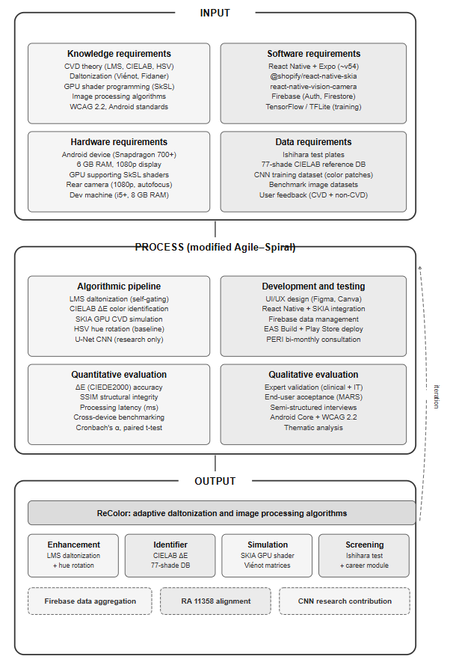
Conceptual Framework of ReColor

The figure above shows the conceptual framework of the study which explains how sint quas vel natus dignissimos eos aspernatur esse ad omnis repudiandae quo commodi ipsam a temporibus maiores aut saepe galisum. Hic quos

galisum vel veniam aperiam eum tempore excepturi ea sunt consectetur. Et reprehenderit sint id totam sunt hic libero sequi sed nemo repellat non commodi accusamus non adipisci galisum non quisquam repellendus. Qui nesciunt quia ad cumque quia et excepturi soluta aut veniam deleniti vel pariatur necessitatibus. Et totam omnis non harum harum et animi natus sed itaque eligendi qui dolor repellat et quia illo. Et facilis dicta aut omnis internos et quis molestiae ea omnis alias qui nulla dolor et ullam animi. Non nihil pariatur qui ipsum labore ut dicta facere aut sequi maiores eum ullam suscipit sit impedit temporibus.
Non distinctio laudantium ut ratione iste et asperiores deleniti qui sequi officiis in quidem dolore. Qui aspernatur quia et quis fugit qui doloribus repellendus eum consequatur voluptatibus a exercitationem dignissimos.

Definition of Terms
Adaptive Color Remapping. A process of adjusting and transforming colors in images so that they become more distinguishable for people with color vision deficiencies.
Adaptive Daltonization. A color correction technique that simulates CVD perception using Viénot-Brettel-Mollon (1999) matrices, computes the per-pixel error between the original and simulated image, and redistributes the lost color information into surviving channels using Fidaner error-shift matrices. The algorithm is self-gating: pixels the user can already perceive produce near-zero error and remain unchanged, while confused colors are corrected without requiring an external classifier.
Chroma Gate. A threshold-based filter that separates chromatic (colored) pixels from achromatic (gray) pixels based on their distance from the neutral axis in CIELAB space (C* = √(a² + b²)). In ReColor, pixels with chroma below 12 are classified as neutral to prevent sensor noise from producing false color assignments.
CIELAB (L*a*b*). A three-dimensional color space defined by the Commission Internationale de l'Éclairage (CIE, 1976) designed to approximate human visual perception. Its three coordinates — L* (lightness), a* (green-red axis), and b* (blue-yellow axis) — are derived from CIE XYZ tristimulus values. CIELAB is perceptually uniform: equal Euclidean distances correspond approximately to equal perceived color differences.
CNN (Convolutional Neural Network). A deep learning architecture that uses convolutional, pooling, and fully connected layers to automatically extract hierarchical spatial features from raw data for tasks such as image classification and segmentation.
Color Vision Deficiency (CVD). A visual impairment characterized by the reduced ability or inability to distinguish certain colors, primarily caused by anomalies or absence of cone photoreceptors in the retina.
Cronbach's Alpha. A measure of internal consistency that evaluates how closely related a set of items are as a group, commonly used to assess the reliability of survey instruments.
Delta-E (ΔE). A metric quantifying the perceptual distance between two colors in CIELAB space. Values below 1.0 are imperceptible to the human eye, values between 2 and 10 are noticeable at a glance, and values above 10 represent clearly different colors. ΔE is the international standard for color-difference measurement under ISO 12647.
Deuteranomaly. A type of anomalous trichromacy where sensitivity to green light is reduced, causing difficulty distinguishing green-related shades. (no change)
EAS Build (Expo Application Services). A cloud-based build service provided by Expo that compiles React Native applications into native Android and iOS binaries without requiring a local development environment for each platform.
Expo. A managed workflow platform for React Native that simplifies native module integration, build configuration, and deployment. ReColor uses Expo ~v54 with development builds (not Expo Go) to support custom native dependencies such as react-native-vision-camera and react-native-skia.
Firebase. A Backend-as-a-Service (BaaS) platform by Google that provides authentication, real-time databases (Firestore), cloud storage, and cloud messaging for mobile and web applications.
Freeze-Frame Pattern. A processing architecture in which the camera captures a still image that is then processed algorithmically, rather than applying transformations to a live video feed. ReColor uses this pattern for color enhancement and CVD simulation to avoid HAL race conditions and ensure processing reliability on Android devices.
HAL Race Guard. A two-part mechanism (delayed camera activation + beforeRemove listener) that prevents native camera hardware conflicts when transitioning between camera screens on Android. The Hardware Abstraction Layer (HAL) requires time to release the camera device handle before another screen can acquire it.
HSV (Hue, Saturation, Value). A color model that represents color as three intuitively meaningful components: hue (0°–360° color angle), saturation (0–1 color purity), and value (0–1 brightness). HSV isolates chromatic identity from achromatic properties, enabling targeted hue manipulation without affecting brightness or contrast.
Hue Rotation. A rule-based color correction technique that rotates hue values within a configurable angular band on the HSV color wheel to improve color discriminability for CVD users. In ReColor, hue rotation serves as a comparative baseline algorithm against which daltonization is evaluated.
LMS Color Space. A color space based on the response curves of the three types of human cone photoreceptors: Long (red-sensitive), Medium (green-sensitive), and Short (blue-sensitive). (no change)
MARS (Mobile Application Rating Scale). A validated tool for assessing the quality of mobile health applications across dimensions of engagement, functionality, aesthetics, and information quality. (no change)
On-Device Inference. Running artificial intelligence models directly on a smartphone or device without relying on cloud servers, ensuring privacy and responsiveness. In ReColor, TFLite models were trained and converted for potential on-device deployment but are not invoked in the current runtime pipeline; the deployed system uses algorithmic image processing methods instead.
Paired T-Test. A statistical test used when comparing scores measured or gathered from the same group, used in ReColor to compare pre- and post-correction Ishihara screening results.
Processing Latency (ms/frame). The amount of time required for a system to process a single image frame, measured in milliseconds.
Protanomaly. A type of anomalous trichromacy where sensitivity to red light is reduced, causing difficulty distinguishing red-related shades.
Pseudoisochromatic Plates. A series of plates used to assess color vision, featuring dotted numbers of one color against a contrasting background.
Quantization. A technique in deep learning that reduces model size and speeds up inference by representing numbers with fewer bits, sometimes at the cost of accuracy.
RA 11358. National Vision Screening Act that mandates the establishment of the National Vision Screening Program (NVSP) for kindergarten pupils. (no change)
React Native. A cross-platform framework that enables mobile app development for both iOS and Android using JavaScript and React. (no change)
Real-Time Processing. The capability of a system to analyze and respond to input data with minimal delay. In the ReColor context, the Color Identifier operates on a tap-to-identify basis (one-shot per tap), while enhancement and simulation modes operate on captured still images via the freeze-frame pattern rather than continuous video frames.
RuntimeShader. A react-native-skia API that applies a custom SkSL shader program to an image or canvas element at render time on the GPU. ReColor uses a RuntimeShader to execute the Viénot CVD simulation matrix as a per-pixel color transformation with sub-16ms rendering latency.
Self-Gating. A property of error-redistribution daltonization where the per-pixel error magnitude itself determines which pixels require correction. Pixels the CVD user can already perceive correctly produce near-zero error and pass through unchanged, while confused pixels undergo significant color shifts — eliminating the need for an external classifier or segmentation model.
Semantic Segmentation. A computer vision method that assigns a class label to each pixel in an image, helping identify objects and regions of interest. (no change)
🔵 SKIA. Google's open-source 2D graphics engine underlying Chrome, Android, and Flutter. In ReColor, SKIA is accessed via @shopify/react-native-skia to provide GPU-accelerated Canvas rendering and custom shader execution for CVD simulation.
🔵 SkSL (Skia Shading Language). A shader programming language used to write per-pixel GPU programs executed by the SKIA rendering engine. ReColor's CVD simulation shader performs gamma-correct sRGB decode, 3×3 matrix multiplication, clamping, and sRGB re-encode in half-precision arithmetic.
🔵 sRGB Gamma Correction. The nonlinear encoding applied to digital images to optimize for human perceptual uniformity. Algorithms that model physical light (Viénot cone response, CIELAB conversion, daltonization error math) must decode sRGB to linear space before processing and re-encode afterward. ReColor uses the pow(2.2) approximation for simulation and enhancement, and the exact IEC 61966-2-1 piecewise curve for color identification.
SSIM (Structural Similarity Index). An image quality metric that measures the similarity between two images based on structural information, luminance, and contrast.
TensorFlow Lite (TFLite). A lightweight version of TensorFlow designed to run machine learning models efficiently on mobile and embedded devices.
User Interface (UI). The visual and interactive elements of an application through which users engage with the system.
🔵 Viénot-Brettel-Mollon (1999) Matrices. A set of 3×3 color transformation matrices derived from physiological cone response curves that project pixel values in linearized sRGB space onto dichromatic confusion planes. Each matrix simulates how an individual with a specific CVD type (protanopia, deuteranopia, or tritanopia) perceives color. A key property is that row sums approximate 1.0, preserving achromatic (gray) values.
Vision Enhancement. The process of using technology to improve how people see, particularly for those with visual impairments or color vision deficiencies.
WCAG 2.2 (Web Content Accessibility Guidelines). An international standard ensuring digital content is accessible to people with disabilities, focusing on perceivable, operable, understandable, and robust design principles.

CHAPTER III

METHODOLOGY

Research Design
The study implemented a mixed-methods design to evaluate ReColor, a mobile vision assistive tool for individuals with Color Vision Deficiency (CVD). The design combined qualitative inquiry and quantitative evaluation to examine the system’s image processing pipeline, usability, accessibility, and impact on awareness, daily functioning, and career guidance. The Philippine Eye Research Institute (PERI) served as the primary clinical partner for expert validation and pilot recruitment.
For the qualitative component, data were collected through semi-structured interviews, focus group discussions, and open-ended survey items with purposively sampled end users (clinically diagnosed or self-reported protanomaly and deuteranomaly) and non-CVD participants. In addition, expert evaluators including ophthalmologists, optometrists, and software specialists provided professional feedback through structured interviews and validation checklists. Qualitative data were transcribed, coded, and analyzed using thematic analysis (Braun & Clarke, 2006). Trustworthiness was enhanced through investigator triangulation, member checking, and an audit trail.
Investigator triangulation was achieved by cross-validating findings across three independent data streams: (1) clinical validation data from ophthalmologists and optometrists assessing diagnostic accuracy and perceptual fidelity; (2) technical validation data from IT experts evaluating algorithmic performance, system stability, and compliance with Android Core App Quality standards; and (3) user experience data from end users (both CVD and non-CVD) reporting on usability, accessibility, and perceived improvement. By comparing and corroborating themes across these three stakeholder perspectives, the study ensured that conclusions were not dependent on a single data source or evaluator group.
For the quantitative component, the study measured diagnostic validity, algorithmic performance, usability, and system responsiveness across the system’s deployed processing pipelines. The Daltonization and Hue Rotation algorithms were evaluated using CIEDE2000 ΔE for color accuracy, SSIM for structural preservation, and processing latency for responsiveness. The CIELAB ΔE Color Identifier was evaluated through classification accuracy against ground-truth color labels. The Ishihara Screening Module was assessed using accuracy, sensitivity, specificity, and Cohen’s Kappa against PERI-confirmed diagnoses. Usability and accessibility were assessed with the Mobile Application Rating Scale (MARS), Android Core App Quality benchmarks, and standardized questionnaires. Statistical analysis included descriptive statistics, reliability testing (Cronbach’s Alpha), and inferential tests such as paired t-tests or Wilcoxon signed-rank tests for pre–post comparisons, with effect sizes and 95% confidence intervals reported.
A prospective pilot cohort provided within-subject, repeated-measures data on feasibility and preliminary efficacy. PERI advised a minimum clinical cohort of five CVD participants for pilot testing; the cohort was supplemented by additional non-CVD users and technical evaluators for broader usability assessment.

Algorithms and Model Training
Tricolor’s algorithmic foundation is organised across four distinct deployed pipelines, each serving a different facet of colour vision deficiency (CVD) assistance: simulation of how CVD users perceive colour, enhancement of real-world imagery to restore lost colour contrasts, identification of individual colours by name, and screening for CVD type and severity via the Ishihara test. Together, these pipelines span the full user journey — from initial diagnosis through to daily assistive use. Additionally, a U-Net convolutional neural network was trained and evaluated as a research contribution but is not invoked in the deployed runtime pipeline.

A) CVD Simulation via Viénot Combined Matrices (Viénot, Brettel, & Mollon, 1999)
The simulation pipeline forms the empathy layer of the application: it allows normally-sighted users (clinicians, educators, family members) to see the world as a CVD user experiences it. This is also the foundation upon which the enhancement algorithms are built, since daltonization requires an accurate simulation as its first computational step.
The algorithm applies a pre-computed 3×3 matrix transform to each pixel in linearised RGB space. For a given CVD type t ∈ {Protan, Deutan, Tritan}, every pixel undergoes:

RGB_linear = γ⁻¹(RGB_sRGB) // sRGB → linear (gamma decode)
RGB_sim = M_t × RGB_linear // CVD simulation
RGB_output = γ(RGB_sim) // linear → sRGB (gamma encode)

where M_t is the Viénot combined matrix for the target CVD type and γ denotes the sRGB transfer function. ReColor implements this simulation on two backends to balance fidelity and compatibility. On the camera screen (CVDSimulationScreen), a Skia RuntimeShader written in SkSL executes the matrix multiplication on the GPU in half-precision floating point, yielding near-instantaneous rendering (~4ms) after frame capture. For gallery images (CVDGalleryScreen), the same matrix is applied via a CPU-side JavaScript pixel loop in double precision. Both paths operate on the same CVD_COMBINED matrices defined in tensorHelper.js, ensuring mathematical consistency across the application.

B) Daltonization via Error Redistribution
Where the simulation pipeline shows what is lost, the daltonization pipeline attempts to restore it. This is the primary enhancement algorithm and the one most directly impactful for CVD users in daily life. It operates on the principle that the perceptual error between the original image and the simulated image represents information the user cannot access, and that this error can be redistributed into the color channels the user can still perceive.
The algorithm proceeds in three stages per pixel, all in linearized sRGB space:
Simulate: Apply the Viénot matrix M_t to obtain the simulated pixel: RGB_sim = M_t × RGB_linear
Compute error: Calculate the perceptual deficit: E = RGB_linear − RGB_sim, representing the colour information invisible to the user.
Redistribute: Shift the error into surviving cone channels via an error-shift matrix: RGB_out = RGB_linear + S_t × E
The error-shift matrices S_t are designed so that missing-cone information is redirected to the two intact cone types. For example, in protanopia (missing L-cones), the red-channel error is pushed into both the green and blue channels with a weight of 0.7, producing perceptible luminance and hue shifts that encode the previously invisible red–green distinction.
The implementation architecture supports an optional segmentation mask parameter: when a mask is provided, only pixels belonging to CVD-confusable color classes (e.g., Red, Orange, Brown for Protan) would be daltonized, leaving already-distinguishable regions untouched. In the deployed system, the mask parameter is set to null, and daltonization is applied uniformly to all pixels. This design decision was made after evaluating a U-Net CNN segmentation model (95.8% pixel accuracy, 81.1% Mean IoU) that demonstrated the feasibility of mask-gated correction but introduced a 7× latency increase (2.8s → 0.4s per image) and an 8MB model dependency. Without the mask, the error term naturally self-gates: non-confusable colors produce near-zero simulation error and pass through the pipeline essentially unchanged, while colors within the user’s confusion zone undergo significant correction. The trained CNN model is retained as bundled TFLite assets for future integration.

C) Adaptive Hue Rotation (Recoloring Enhancement)
ReColor provides a second enhancement algorithm as a comparative alternative to daltonization. While daltonization is an error-redistribution method (adding compensatory information), hue rotation is a recolouring method (shifting existing colours away from the confusion axis). This dual-algorithm design enables comparative studies on user preference and task performance.
The algorithm operates in HSV colour space. For each pixel, it determines whether the pixel’s hue falls within a CVD-specific confusion band (defined by a centre angle, range, and maximum shift). Pixels within the band receive a hue rotation that is strongest at the band centre where confusion is most severe and tapers linearly to zero at the band edges.

Table
Hue Rotation Parameters for CVD-Specific Confusion Bands
CVD Type | Confusion Centre | Band Width | Max Shift
Protan | 0° (red) | ±60° | +40°
Deutan | 0° (red) | ±60° | +40°
Tritan | 240° (blue) | ±60° | −30°

Near-achromatic pixels (saturation < 0.15) are skipped entirely, since hue rotation on desaturated colors introduces perceptible color casts without meaningful benefit.

D) Color Identification using CIELAB Delta-E
The color identifier addresses a complementary need: rather than transforming an entire image, it tells the user the name of a specific color they are looking at. This is particularly valuable for tasks where color identity matters: choosing clothing, reading color-coded information, or identifying indicator lights.
The algorithm converts the sampled pixel from sRGB through the CIE XYZ color space (using the D65 standard illuminant) into CIELAB, a perceptually uniform color space where Euclidean distance approximates perceived color difference. It then searches an 80+ entry reference database spanning 10 color families (Red, Orange, Yellow, Green, Cyan, Blue, Violet, Pink, Brown, Neutral) for the nearest match using a weighted variant of CIE76 ΔE:
ΔE = √(0.5 · ΔL*² + Δa*² + Δb*²)
The lightness component (L*) is down-weighted by a factor of 0.5 to ensure that dark and bright variants of the same hue (e.g., dark red and bright red) classify to the same color name, since color identity depends primarily on chromaticity (a* and b*) rather than luminance. A chroma gate (C* = √(a*² + b*²) ≥ 12) prevents near-gray pixels from being misclassified as chromatic colors due to sensor noise. The interaction pattern is tap-to-identify: users tap the screen to capture a snapshot, the dominant color at the tap point is extracted from a 10×10 pixel neighbourhood average, and the classification result is displayed with the color name, hex value, and confidence percentage.

E) Ishihara Weighted Scoring with Diagnostic Classification
The Ishihara test pipeline digitizes the standard 38-plate clinical protocol and extends it with a weighted scoring system that gives additional influence on the diagnostic plates (Plates 22–25) used for Protan/Deutan differentiation. The system offers two modes: Quick Mode (14 plates) and Comprehensive Mode (25 plates), validated by the Philippine Eye Research Institute (Lamento-Villegas, 2026).

Table –
Ishihara Plate Categories and Weighted Scoring Configuration
Category | Plates | Weight | Purpose
Demo | 1 | 0 | Verification; excluded from scoring
Screening | 2–9, 26–38 | 1 | Detects presence of red–green CVD
Vanishing | 10–17 | 1 | Visible only to normal vision; inability to read confirms CVD
Hidden | 18–21 | 1 | Visible only to CVD users; normal vision sees nothing
Diagnostic | 22–25 | 2 | Protan vs. Deutan differentiation (2× weight)
Plates are presented in Fisher-Yates shuffled order (Plate 1 always first) with a 3-second timer per plate, as recommended by PERI to prevent analytical puzzle-solving behaviour. The shuffled plate order is saved as an audit trail in Firestore. Severity is determined by weighted percentage: ≥80% Normal, 65–79% Indeterminate, 45–64% Mild, 25–44% Moderate, <25% Severe. Protan/Deutan differentiation uses the diagnostic plates (22–25) via the detectProtanDeutan() function.

Figure
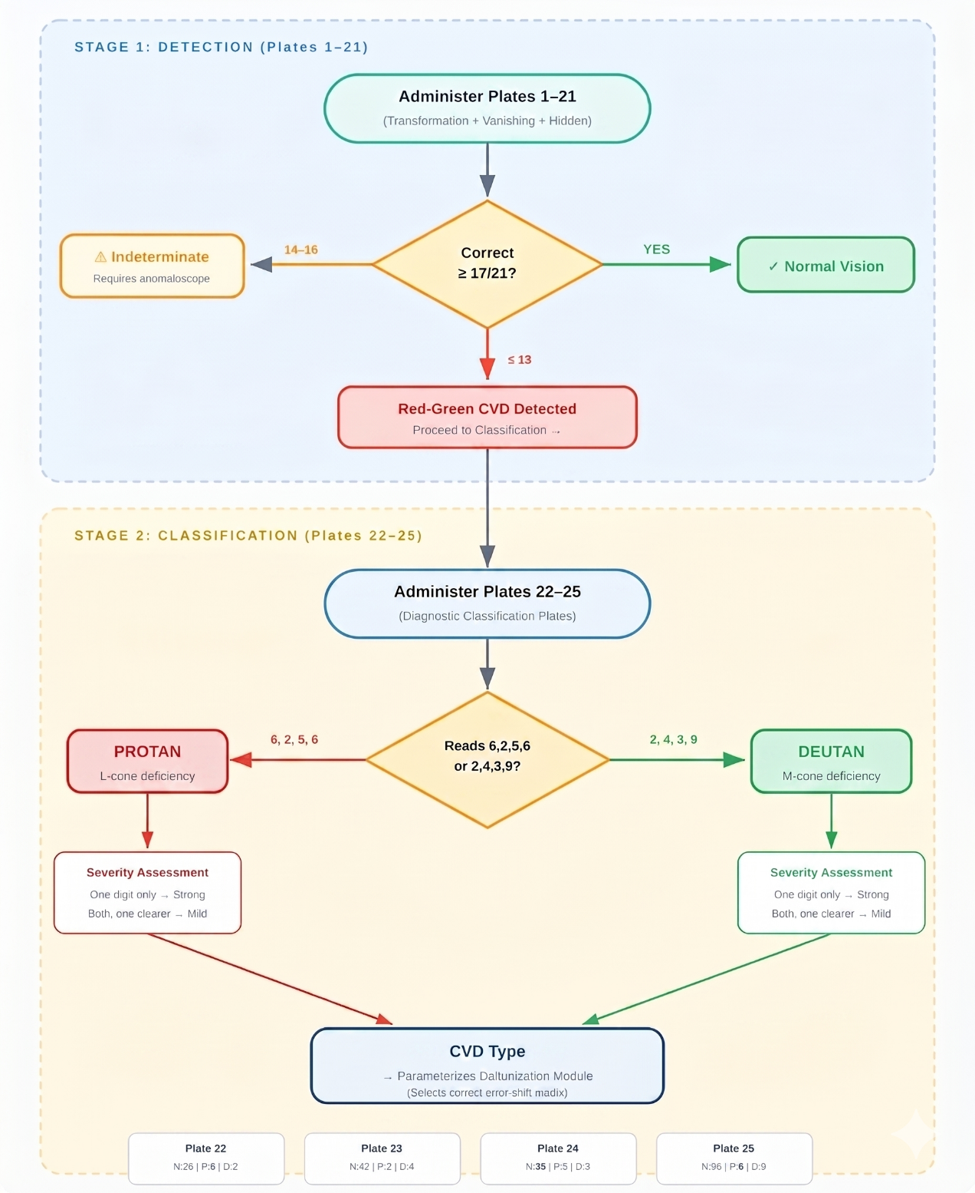
Ishihara Plate Administration Guide

Camera Pipeline Mathematical Simulation
This section presents the mathematical foundations and implementation architecture of the three camera-based processing modes in the ReColor application: the Color Identifier, the CVD Simulation, and the Camera Enhancement. All three modes share a common capture infrastructure, sRGB gamma-correction pipeline, and a 10-class color taxonomy, which are described first as shared infrastructure before each mode-specific pipeline is detailed.

Shared Infrastructure

VisionCamera Capture Pipeline
All three camera screens use the React Native VisionCamera library with an identical lifecycle: (1) useCameraPermission() requests the CAMERA permission from the host OS; (2) useCameraDevice(position) selects the back or front sensor; (3) useIsFocused() detects whether the screen is currently visible and deactivates the camera on navigation away; and (4) cameraRef.current.takePhoto() captures a high-resolution still frame returned as a file path. The captured photo is always processed off-preview and no live pixel manipulation occurs in JavaScript.

HAL Race Guard
On Android, the Hardware Abstraction Layer (HAL) requires time to release a camera device when the previous screen unmounts. If the next camera screen activates before the HAL completes teardown, a native-side camera-open conflict crashes the application. Two guards address this: (1) a delayed activation timer (700–900 ms) that defers setCameraReady(true) until the HAL has released the previous device handle, and (2) a beforeRemove navigation listener that calls setCameraReady(false) before React removes the screen from the tree, giving the camera a clean teardown window.

sRGB Gamma Correction
A JPEG pixel value of 128 does not represent half the physical luminance of 255. sRGB is a non-linear encoding optimized for perceptual uniformity (IEC 61966-2-1). Any algorithm that models physical light — Vienot cone response, CIELAB XYZ conversion, or daltonization error mathematics — must operate in linear space. Two gamma models are used:
Exact piecewise (used in the Color Identifier for CIELAB conversion):
linear = c / 12.92 if c ≤ 0.04045
linear = ((c + 0.055) / 1.055) ^ 2.4 otherwise

Power-law approximation (used in the Simulation shader and Daltonization loop):
linear = c ^ 2.2 (sRGB → linear decode)
sRGB = linear ^ 0.4545 (linear → sRGB encode; 0.4545 = 1/2.2)

The approximation introduces less than 1% error relative to the exact piecewise curve but provides approximately 3× throughput on per-pixel loops processing hundreds of thousands of pixels. The Color Identifier uses the exact curve because CIELAB class assignment is sensitive to systematic bias; the Simulation and Enhancement pipelines use the approximation because output values are re-encoded to sRGB, absorbing residual error.

10-Class Color Taxonomy
The application uses a fixed taxonomy of 10 perceptual color classes, defined in tensorHelper.js. All algorithms — color naming, CVD confusion sets, and daltonization gating agree on these 10 names:
Table
10 Color-Class taxonomy
Class Index | Class Name
0 | Neutral
1 | Red
2 | Orange
3 | Yellow
4 | Green
5 | Cyan
6 | Blue
7 | Violet
8 | Pink
9 | Brown

Table
CVD Confusion Class Sets
CVD Type | Confused Classes | Physiological Basis
Protan | Red, Orange, Violet, Brown | Missing L-cone; reds collapse to dark
Deutan | Red, Orange, Green, Brown | Missing M-cone; classic red-green axis
Tritan | Yellow, Cyan, Blue, Pink | Missing S-cone; blue component lost

Color Identifier Pipeline

Data Flow
The Color Identifier is the only mode that does not use the freeze pattern. Each user tap produces a fresh one-shot identification: (1) the user taps the live camera preview; (2) a crosshair appears at the tap point; (3) the app captures a photo via takePhoto with qualityPrioritization: "speed"; (4) the image is resized to 640 px wide via ImageManipulator; (5) a cover-mode coordinate mapping converts screen-space tap coordinates to the correct image pixel, accounting for aspect-ratio cropping; (6) a 10×10 pixel neighborhood is averaged to reduce sensor noise by a factor of √100 = 10×; and (7) identifyColor(avgR, avgG, avgB) runs the CIELAB Delta-E nearest-neighbor classifier against 77 reference entries.

sRGB to CIELAB Conversion
The conversion proceeds in three stages. First, sRGB gamma decoding converts pixel values to linear RGB using the exact IEC 61966-2-1 piecewise function. Second, linear RGB is transformed to CIE XYZ using the D65-referenced sRGB primary matrix:
X = (0.4124564·R + 0.3575761·G + 0.1804375·B) / 0.95047
Y = (0.2126729·R + 0.7151522·G + 0.0721750·B) / 1.00000
Z = (0.0193339·R + 0.0961964·G + 0.9503041·B) / 1.08883

The division normalizes to the D65 illuminant (6504 K standard daylight) so that pure white (1,1,1) maps to XYZ = (1,1,1). Third, XYZ is converted to CIELAB using the nonlinear f-function:

f(t) = t^(1/3) if t > 0.008856
f(t) = 7.787·t + 16/116 otherwise
L* = 116·f(Y) − 16 a* = 500·(f(X) − f(Y)) b* = 200·(f(Y) − f(Z))

CIELAB is a perceptually uniform color space: equal Euclidean distances correspond to approximately equal perceived color differences. This property is essential for nearest-neighbor color classification — RGB Euclidean distance does not match human perception.

Weighted Delta-E Distance
ΔE = √( 0.5·(L1−L2)² + (a1−a2)² + (b1−b2)² )
Lightness (L*) is down-weighted by a factor of 0.5 because the color class name does not depend on brightness “dark red" and "bright red" are both "Red." Without down-weighting, "dark red" would be classified closer to "dark green" than to "bright red," breaking the naming semantics. Hue and chroma axes (a*, b*) retain full weight as they determine color identity.

Chroma Gate
C* = √(a*² + b*²)
If C* < 10 (the neutral chroma threshold), the pixel is classified as truly achromatic and only neutral reference entries (black, gray, white) are considered. If C* ≥ 10, neutral entries are excluded and only chromatic classes compete. Without this gate, sensor noise in near-gray pixels (small random a*/b* values) would produce spurious chromatic classifications.

CVD Simulation Pipeline

Overview
The CVD Simulation mode shows a normal-vision user what a person with color vision deficiency perceives. It is an educational tool, not an assistive one. The user freezes a photo via the snowflake button, then selects Protan, Deutan, or Tritan to apply the simulation. Switching between CVD types is instantaneous because it changes only GPU shader uniforms on the cached texture — no re-capture or re-decode occurs.

Vienot-Brettel-Mollon 1999 Simulation Matrices
The simulation is performed by a 3×3 matrix multiplication that projects the trichromatic RGB signal onto the dichromatic confusion plane corresponding to the missing cone type. These matrices operate in linear RGB space and were derived by Vienot, Brettel, and Mollon (1999) from physiological LMS cone fundamentals.

Table —
Vienot 1999 Combined CVD Simulation Matrices (sRGB domain)
CVD Type | Row | R Coefficient | G Coefficient | B Coefficient
Protan | R_out | 0.152286 | 1.052583 | −0.204868
Protan | G_out | 0.114503 | 0.786281 | 0.099216
Protan | B_out | −0.003882 | −0.048116 | 1.051998
Deutan | R_out | 0.367322 | 0.860646 | −0.227968
Deutan | G_out | 0.280085 | 0.672501 | 0.047413
Deutan | B_out | −0.011820 | 0.042940 | 0.968881
Tritan | R_out | 1.255528 | −0.076749 | −0.178779
Tritan | G_out | −0.078411 | 0.930809 | 0.147602
Tritan | B_out | 0.004733 | 0.691367 | 0.303900

Key matrix properties: (1) Each row sums to approximately 1.0, which preserves achromatic colors — an input of (v, v, v) produces an output of (v, v, v), confirming that grays remain unchanged under simulation. (2) Negative coefficients are mathematically valid projection terms but can produce out-of-gamut intermediate values, requiring a clamp operation. (3) The Tritan matrix contains a coefficient exceeding 1.0 (1.255 on R), reflecting the compensatory gain of the remaining L and M cones when the S-cone is absent.

SkSL GPU Shader Implementation
The simulation matrix is applied on the GPU using a Skia Shading Language (SkSL) runtime shader integrated via react-native-skia. The shader receives the CVD matrix as three float3 uniform vectors (row0, row1, row2) and executes the following per-pixel computation:
lin = pow(pixel.rgb, 2.2) // sRGB → linear
sim = [dot(row0, lin), dot(row1, lin), dot(row2, lin)]
sim = clamp(sim, 0.0, 1.0) // gamut clip
out = pow(sim, 0.4545) // linear → sRGB

The shader uses half (float16) precision, which runs approximately 2× faster than single-precision on mobile GPUs with no visible quality loss for 8-bit display output. A 1040×780 image (811,200 pixels) is processed in approximately 4 ms on the GPU, compared to approximately 400 ms for an equivalent JavaScript pixel loop. Switching CVD types updates only the uniform vectors — React re-renders the shader on the same cached texture within a single 16 ms frame at 60 Hz.

Camera Enhancement Pipeline

Overview
The Camera Enhancement is the only truly assistive mode. It captures a photo, then processes the pixels so that a CVD user can distinguish colors they normally confuse. Two algorithms are selectable: Daltonization (the default, physically motivated) and Hue Rotation (a comparative baseline from a different algorithm family). Users can toggle between them on the same captured image to compare correction effects.

Algorithm A: Daltonization (Brettel-Fidaner)
Daltonization proceeds in three mathematical steps per pixel:
Step 1 — Simulate: sim = SIM · original
Step 2 — Error: err = original − sim
Step 3 — Redistribute: out = original + E · err
Where SIM is the Vienot simulation matrix and E is the Fidaner error-redistribution matrix. For pixels the CVD user already perceives correctly, sim ≈ original, so err ≈ 0, and out ≈ original — the pixel is unchanged. For confused pixels, err is large, and the error is shifted into channels the user can perceive. This self-gating property means the error magnitude acts as its own classifier, eliminating the need for a CNN or pixel classification .
Table
Fidaner Error-Redistribution Matrices
CVD Type | Row | R_err | G_err | B_err
Protan | R_out | 0.0 | 0.0 | 0.0
Protan | G_out | 0.7 | 1.0 | 0.0
Protan | B_out | 0.7 | 0.0 | 1.0
Deutan | R_out | 1.0 | 0.6 | 0.0
Deutan | G_out | 0.0 | 0.0 | 0.0
Deutan | B_out | 0.0 | 0.6 | 1.0
Tritan | R_out | 1.0 | 0.0 | 0.7
Tritan | G_out | 0.0 | 1.0 | 0.7
Tritan | B_out | 0.0 | 0.0 | 0.0

Design principle: the row corresponding to the missing cone's channel is zeroed (no value in redistributing error to a channel the user cannot perceive). The 0.7 and 0.6 weights are Fidaner's empirical optimum values above 1.0 produce oversaturation, while values below 0.5 produce under-correction.

Algorithm B: Hue Rotation
Hue Rotation operates in HSV color space, rotating the hue angle of pixels within a CVD-specific confusion band away from the confusion axis. The rotation is configured by three parameters per CVD type:
Table
Hue Rotation Configuration
CVD Type | Center (°) | Range (°) | Shift (°)
Protan | 0 (red) | 60 | +40
Deutan | 0 (red) | 60 | +40
Tritan | 240 (blue) | 60 | −30

The rotation uses a linear taper: full shift at the band center, tapering linearly to zero at the band edges (weight = 1 − dist/range). This prevents visible banding artifacts at the rotation boundary. A saturation gate (S < 0.15) skips near-gray pixels whose hue is unreliable due to sensor noise. Circular hue distance handles the 360° wraparound correctly.

Comparative Analysis: Daltonization vs. Hue Rotation
Table
Algorithm Comparison
Property | Daltonization | Hue Rotation
Theoretical basis | Physical cone-response model (Vienot 1999) | Heuristic rule-based
Self-gating | Yes (error ≈ 0 for perceivable pixels) | No (manual band definition)
Identity preservation | High — only shifts what is lost | Low — shifts entire band
Coverage | All tones | Band-limited (range = 60°)
Parameter count | 9 (SIM) + 9 (ERR) per CVD | 3 (center, range, shift) per CVD
Achromatic preservation | By matrix design (rows sum to 1) | By saturation gate

GPU Simulation Fidelity Validation
To validate that the GPU shader's float16 precision does not introduce perceptible differences, a fidelity comparison was conducted between the SkSL shader output (half precision) and a float64 CPU reference implementation using identical matrices. Six synthetic test images (720×480) were processed across all three CVD types (18 conditions), with per-pixel CIEDE2000 ΔE measuring the perceptual difference.

Table
GPU vs CPU Simulation Fidelity Summary
Metric | Value | Status
Overall mean ΔE | 0.027 | PASS
Overall max ΔE | 1.199 | —
Conditions passing | 18/18 | PASS

The overall mean ΔE of 0.027 is well below the perceptual threshold of 1.0, confirming that the GPU shader faithfully reproduces the CPU reference simulation. Saturated primaries and neutral grays produced ΔE = 0.000 (bit-exact). The single highest per-pixel deviation (ΔE = 1.199) occurred in a noisy region of the natural scene image under Protan simulation a statistically insignificant outlier that is imperceptible in practice.

Evaluation Metrics
Algorithmic Performance Metrics. The daltonization and hue rotation algorithms are evaluated using CIEDE2000 ΔE to measure perceptual accuracy of corrected images against normal-vision references (target: ΔE < 2.0 for perceptual indistinguishability), and SSIM to verify structural preservation without visual artifacts (target: SSIM > 0.90). A comparative analysis between the two algorithms is conducted across matched test images per CVD type. The CIELAB ΔE color identifier is assessed through classification accuracy and per-class precision against ground-truth color labels spanning all 10 color families. CVD simulation fidelity is verified by computing per-pixel CIEDE2000 ΔE between the GPU (half-precision) and CPU (double-precision) backends to quantify any precision loss (target: mean ΔE < 1.0). Processing latency is measured in milliseconds across capture, processing, and encoding stages, with cross-device benchmarking on budget, mid-range, and flagship Android devices.
Diagnostic Validity Metrics. Ishihara screening accuracy is evaluated using sensitivity, specificity, and Cohen's Kappa (κ) against PERI-confirmed clinical diagnoses, interpreted via the Landis and Koch (1977) scale (κ > 0.80 = almost perfect agreement). Pre- and post-correction Ishihara scores are compared using paired t-tests or Wilcoxon signed-rank tests (depending on normality via Shapiro-Wilk at α = 0.05), with effect sizes (Cohen's d or r = Z/√N) and 95% confidence intervals reported.
User Acceptance and Expert Validation Metrics. The End User Survey (32 items), IT Expert Checklist (57 items), and Clinical Expert Validation (28 items) use a 4-point Likert scale (4 = Highly Acceptable to 1 = Unacceptable). Internal consistency is verified using Cronbach's Alpha (α ≥ 0.70). Descriptive statistics (mean, SD, frequency) are computed per item and dimension, with overall weighted mean determining acceptability: 3.50–4.00 Highly Acceptable, 2.50–3.49 Acceptable, 1.50–2.49 Fairly Acceptable, 1.00–1.49 Unacceptable.
Qualitative Metrics. Open-ended responses from semi-structured interviews, clinical expert questions, and end-user free-response items are analyzed using Braun and Clarke's (2006) six-phase thematic analysis. Trustworthiness is established through investigator triangulation across clinical, technical, and user experience data streams, member checking, and audit trail documentation.

Table
Evaluation Metrics Framework or ReColor
Category | Module / Feature | Metric | Tool / Method | What It Measures | Target / Threshold
Algorithmic Performance | Daltonization vs. Hue Rotation | CIEDE2000 ΔE | ISO 12647 color difference formula | Perceptual accuracy of corrected image vs. normal-vision reference | ΔE < 2.0 (imperceptible)
 | Daltonization vs. Hue Rotation | SSIM | Structural Similarity Index | Structural preservation; absence of visual artifacts | SSIM > 0.90
 | Daltonization vs. Hue Rotation | Comparative ΔE & SSIM | Per CVD type (Protan / Deutan / Tritan) | Algorithm comparison across matched test images | Daltonization ≥ Hue Rotation per type
 | Color Identifier (CIELAB ΔE) | Classification Accuracy & Precision | Ground-truth swatch comparison (10 families) | Correct color class and per-class precision | ≥ 85% overall accuracy
 | CVD Simulation (GPU vs. CPU) | Per-pixel CIEDE2000 ΔE | GPU half-precision vs. CPU double-precision | Precision loss from SkSL half-float arithmetic | Mean ΔE < 1.0
 | All camera pipelines | Processing Latency (ms) | Cross-device benchmarking (budget / mid / flagship) | End-to-end: capture + processing + encode | < 3,000ms on mid-range device
Diagnostic Validity | Ishihara Screening | Sensitivity & Specificity | PERI clinical diagnosis as reference standard | CVD detection rate (sensitivity); normal vision non-detection rate (specificity) | Sensitivity ≥ 0.80; Specificity ≥ 0.80
 | Ishihara Screening | Cohen’s Kappa (κ) | Landis & Koch (1977) scale | Agreement between app diagnosis and PERI-confirmed diagnosis | κ ≥ 0.61 (substantial agreement)
 | Pre vs. Post Correction | Paired t-test / Wilcoxon | Shapiro-Wilk normality at α = 0.05 | Ishihara score improvement after daltonization; effect size (Cohen’s d or r = Z/√N) | p < 0.05; 95% CI reported
User & Expert Validation | End User Survey (32 items) | Weighted Mean (4-pt Likert) | Descriptive statistics (mean, SD, frequency) | Usability, accessibility, and feature acceptance across five core modules | ≥ 3.50 = Highly Acceptable
 | IT Expert Checklist (57 items) | Weighted Mean (4-pt Likert) | Android Core + WCAG 2.2 benchmarks | Technical quality, accessibility compliance, and system stability | ≥ 3.50 = Highly Acceptable
 | All survey instruments | Cronbach’s Alpha (α) | Internal consistency test | Reliability of each instrument’s item set | α ≥ 0.70
Qualitative | Semi-structured interviews (19 questions) | Thematic Analysis | Braun & Clarke (2006) 6-phase framework | User perceptions, barriers, daily impact, and improvement suggestions | Theme saturation across participant responses
 | Clinical & User open-ended items | Investigator Triangulation | Cross-stream comparison (clinical / technical / user) | Corroboration of quantitative findings across independent data sources | Consistent themes across ≥ 2 streams

Sampling Technique
This study utilized purposive sampling, a non-probability sampling technique, to deliberately select participants who could provide the most relevant and meaningful insights into the development and evaluation of ReColor. Purposive sampling was chosen because the study specifically required individuals with Color Vision Deficiency (CVD), a relatively rare condition, as well as experts with specialized knowledge in ophthalmology, optometry, and information technology. Random sampling was not feasible due to the low prevalence of CVD in the general population and the need for expert evaluators with domain-specific expertise.
Through purposive selection, the study ensured that participants represented the primary stakeholders of the system: end-users with CVD, non-CVD individuals for comparative awareness testing, and clinical and technical experts for validation. This method allowed the researchers to gather context-specific data that directly aligned with the study objectives, ensuring that ReColor was both user-centered and technically validated.

Participants of the Study
The study included forty-eight (48) participants, who were intentionally chosen in a way that would give a deep understanding of the clinical, technical, and user-centered points of view regarding the ReColor mobile app. The selection of these participants made it possible for the different points of view to be heard regarding both clinical validation and usability testing, such as from people with Color Vision Deficiency (CVD), regular end-users, vision health practitioners, and information technology (IT) specialists. This purposive blending of participants was in line with the mixed-methods and prospective pilot cohort design of the study, giving equal weight to both qualitative and quantitative validation.

Table 13
Summary of Study Participants of ReColor
Participant Group | No. of Participants | Role in the Study | Primary Purpose | Evaluation Focus
Clinical Participants (CVD) | 5 | Individuals diagnosed with Color Vision Deficiency (CVD), referred by the Philippine Eye Research Institute | Validate the Ishihara screening and adaptive correction module | Diagnostic accuracy, sensitivity, specificity, Cohen’s Kappa
End Users | 30 | General users (CVD and non-CVD) testing the mobile app | Assess usability, accessibility, and awareness features | Usability scores, accessibility metrics, user satisfaction
Ophthalmologists / Optometrists | 3 | Licensed eye care professionals providing expert validation | Evaluate clinical soundness and ethical compliance | Expert validation, clinical accuracy, qualitative feedback
IT Experts | 10 | Software and mobile app professionals | Evaluate system performance and technical compliance | Android Core App standards, security, functionality, and compatibility

Clinical Participants (n = 5)
Five participants diagnosed with Color Vision Deficiency were recruited through the Philippine Eye Research Institute (PERI). Their participation was essential for validating the ReColor system’s screening accuracy and adaptive color correction functionality under authentic visual conditions. This group tested the Ishihara module and color remapping algorithms to determine the perceptual improvement achieved through the app. The number of CVD participants was determined based on PERI’s 2025 recommendation, which advised that five participants are sufficient for pilot-level clinical validation, ensuring ethical manageability, individualized testing, and representative feedback within the scope of a controlled study.

General End-Users (n = 30)
Thirty (30) non-CVD participants were included to evaluate the overall usability, accessibility, and performance of the ReColor mobile application. These participants represented typical users such as students, professionals, and individuals from the general population who may utilize the app for awareness, educational, and assistive purposes. Their feedback was instrumental in measuring user experience factors such as interface intuitiveness, color differentiation clarity, and satisfaction levels. The inclusion of this group ensured that ReColor adheres to user-centered design principles and complies with the Android Core App Quality Guidelines (Google, 2025). The sample size was selected to provide sufficient diversity and reliability for usability testing and statistical analysis.

Ophthalmology Professionals (n = 3)
Three (3) ophthalmology professionals, consisting of ophthalmologists and optometrists affiliated with the Philippine Eye Research Institute and collaborating institutions, were consulted to review the diagnostic accuracy of the ReColor screening module. Their expert evaluation provided medical validation of the Ishihara test adaptation and ensured alignment with established color vision screening standards. The inclusion of this group supported the study’s goal of bridging clinical standards with digital accessibility, ensuring that the system functions as both a reliable screening aid and an educational tool.

Information Technology Experts (n = 10)
Ten (10) IT professionals with expertise in software engineering, artificial intelligence, and human-computer interaction were involved to assess the technical soundness of ReColor. Their evaluation focused on the application’s algorithmic accuracy, system reliability, and adherence to the ISO/IEC 25010 Software Quality Model in terms of functionality, usability, and performance efficiency. Their inclusion provided essential feedback on code quality, data handling, and user interface responsiveness, contributing to the optimization of ReColor’s hybrid pipeline integrating K-Means clustering, Daltonization, and Convolutional Neural Networks (CNNs).

Research Locale
The study was conducted through a distributed research locale design to accommodate the mobile nature of the ReColor system. Since the application operates on Android devices, data collection and usability testing were carried out across multiple locations based on the convenience of the participants. The primary institutional beneficiary and reference point for this study is the Philippine Eye Research Institute (PERI), located in Quezon City, Metro Manila, which serves as the national center for ophthalmic research and vision screening initiatives.
Testing and evaluation were conducted both online and in person, allowing flexibility in participation and ensuring inclusivity regardless of participants’ geographic or logistical constraints. Recruitment of participants was primarily achieved through peer referrals and community recommendations to reach individuals with varying degrees of color vision deficiency.
This distributed setup enhanced the ecological validity of the study by capturing real-world variations in lighting, device performance, and environmental conditions that directly influence visual perception and usability outcomes. Figure 8 presents a map showing the geographical relation of the various participant testing sites to the Philippine Eye Research Institute, highlighting its role as the central institutional point of reference for ReColor’s validation.

Figure 12
Geographical location of the Philippine Eye Research Institute (PERI), the primary research beneficiary and evaluation partner for ReColor.
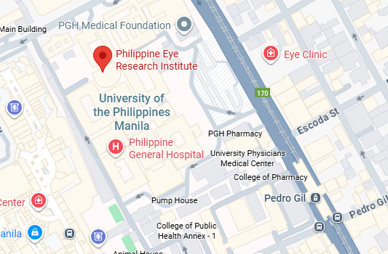

Note: Adapted from Google Maps (2025). Retrieved from https://www.google.com/maps

Research Instrument
This study employs seven research instruments to evaluate the ReColor system across its technical, clinical, and user-centered dimensions. All instruments were validated by the research adviser and subject matter experts prior to administration.
1. End User Survey. A questionnaire administered to both CVD and non-CVD participants, divided into four parts: demographic profile, system usability and accessibility (adapted from the Mobile Application Rating Scale), feature-specific evaluation of the five core modules (Color Enhancement, Color Identification, CVD Simulation, Ishihara Screening, and Education), and open-ended suggestions. Items are rated on a 4-point Likert scale (4 = Highly Acceptable, 3 = Acceptable, 2 = Fairly Acceptable, 1 = Unacceptable).
2. IT Expert Checklist. A evaluation instrument completed by software specialists, covering Android Core App Quality standards and WCAG 2.2 accessibility guidelines. The checklist assesses the system across seven dimensions: functionality, performance and stability, accessibility, user interface and navigation, security and data privacy, compatibility, and compliance. Items are rated on the same 4-point scale, with a dedicated open-ended section for technical recommendations.
3. Clinical Expert Validation. A instrument completed by ophthalmologists and optometrists evaluating the clinical appropriateness of the Ishihara screening implementation, the accuracy of CVD simulation rendering, the perceptual effectiveness of the daltonization algorithm, and the adequacy of medical disclaimers and professional referral recommendations. Items are rated on the 4-point scale, with five open-ended clinical questions addressing diagnostic concerns and safeguard recommendations.
4. PERI Ishihara Validation. A specialized clinical validation instrument reviewed and signed by the Philippine Eye Research Institute (Lamento-Villegas, 2026), covering answer key verification for both Quick Mode (14 plates) and Comprehensive Mode (25 plates), scoring threshold validation, classification logic verification for Protan/Deutan differentiation, and testing protocol approval including the 3-second per-plate timer. The instrument was approved with revisions on April 23, 2026.
5. Semi-Structured Interview Guide. A 19-question bilingual (English/Filipino) interview guide organized across seven sections: general CVD experience, Ishihara screening experience, color enhancement and identification, CVD simulation, education and career awareness, overall usability and accessibility, and recommendations. The guide employs open-ended probes designed to elicit in-depth qualitative data on user perceptions, daily impact, and suggestions for improvement.
6. Functionality Test Sheet. A comprehensive software testing instrument containing pass/fail criteria organized across all system modules. The test sheet documents expected behaviour, actual behaviour, and test status for each functional requirement, serving as both a development verification tool and an evaluation artifact for the research adviser's software evaluation logsheet.
7. Ishihara Data Collection Form. A structured data recording instrument used during clinical pilot testing to capture per-plate responses, weighted scores, diagnosis classification, severity determination, shuffled plate order (audit trail), device specifications, screen brightness level, and test duration for both pre-correction and post-correction administrations.
All survey instruments (End User Survey, IT Expert Checklist, Clinical Expert Validation) are subjected to internal consistency analysis using Cronbach's Alpha, with α ≥ 0.70 as the minimum reliability threshold. Content validity is established through expert review and pilot testing, with item-level feedback incorporated prior to full deployment.

Data Gathering Procedure
The data gathering procedure follows a sequential five-phase process designed to accommodate both in-person and online participation modalities, ensuring accessibility and convenience for all participant groups.
Phase 1: Ethical Clearance and Instrument Validation. Prior to data collection, all research instruments were reviewed and validated by the research adviser, thesis instructor, and subject matter experts. The PERI Ishihara Validation instrument was submitted to and approved (with revisions) by the Philippine Eye Research Institute on April 23, 2026. Informed consent forms, privacy notices compliant with RA 10173 (Data Privacy Act of 2012), and medical disclaimers were prepared in both English and Filipino. Ethical clearance was secured through the institutional review process of the College of Information Technology and Computer Science, Lyceum of the Philippines University — Cavite.
Phase 2: Participant Recruitment and Screening. Participants were recruited through purposive and convenience sampling across three channels: referrals from PERI's clinical network, social media outreach targeting CVD communities and university populations, and direct recruitment within LPU-Cavite. Prospective participants completed a brief demographic screener and self-reported CVD status questionnaire. For the CVD cohort, participants with clinically diagnosed or self-identified protanomaly or deuteranomaly were prioritized. For the non-CVD cohort, participants with self-reported normal color vision were included as a control group. Expert evaluators (IT specialists, ophthalmologists, and optometrists) were recruited through professional referral and direct invitation.
Phase 3: Application Deployment and Testing. The ReColor application was distributed to participants via the Google Play Store or direct APK installation for devices meeting the minimum hardware requirements (Android 10+, Snapdragon 600 series or equivalent, 4 GB RAM). Data collection was conducted at the convenience of the participant and was not limited to PERI's physical premises. Participants were given the flexibility to use the application in their preferred environment — at home, in their workplace, or at any location with adequate indoor lighting (approximately 300–500 lux) — to reflect realistic daily-use conditions. For the Ishihara screening module, participants were instructed to ensure a minimum screen brightness of 80% and to complete the test in a well-lit indoor setting, consistent with the testing protocol validated by PERI.
Phase 4: Data Collection. Data were collected through three concurrent streams. First, in-app data collection captured Ishihara test results (weighted scores, diagnosis, severity, shuffled plate order, device information, and test duration) automatically via the dual-write Firestore pattern, simultaneously storing user-linked records for personal history and anonymized copies for research aggregation. Second, survey instruments (End User Survey, IT Expert Checklist, Clinical Expert Validation) were administered either in person or through an online modality using structured digital forms allowing participants and expert evaluators to respond at their convenience regardless of geographic location. Responses collected through the online modality were linked to participant identifiers for validation and subsequently anonymized for analysis. Third, semi-structured interviews were conducted either face-to-face or via video call, recorded with participant consent, and transcribed verbatim for thematic analysis.
Phase 5: Post-Collection Processing. Upon completion of data collection, all quantitative data were exported from Firestore and Google Forms into a consolidated dataset for statistical analysis. Qualitative interview transcripts were reviewed, coded, and analyzed using Braun and Clarke's (2006) six-phase thematic analysis framework. Member checking was conducted with selected participants to verify the accuracy of interpreted themes. All data were stored in encrypted digital formats accessible only to the research team, with anonymized research copies maintained separately for PERI's institutional use.

System Development Process
Figure 13
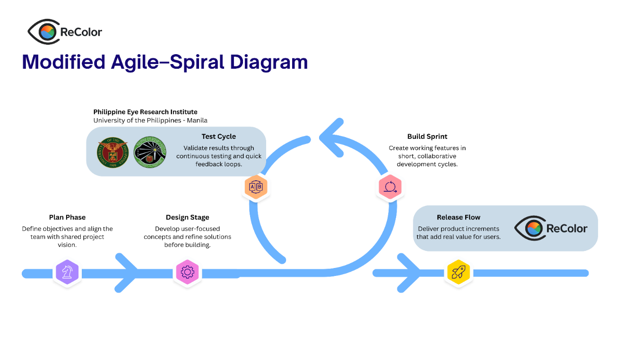
Modified Agile–Spiral Diagram of ReColor

This study employed a Modified Agile–Spiral methodology to accommodate both the dynamic requirements of system development and the structured demands of academic research. While the standard Agile framework emphasizes daily stand-ups and rapid software deliverables, the modified approach extended its scope by incorporating weekly sprint meetings documented through official minutes of the meeting (MoM) led by the scrum lead. Each sprint cycle produced not only functional software increments but also research deliverables, such as conceptual frameworks, survey instruments, and academic documentation.

System Architecture
Figure
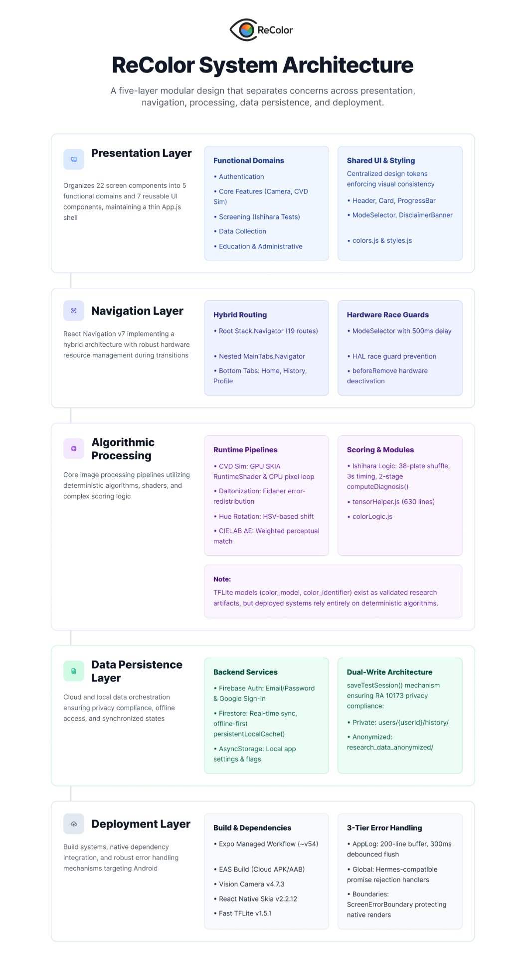
System Architecture of ReColor

The ReColor system architecture follows a five-layer modular design that separates concerns across presentation, navigation, processing, data persistence, and deployment.
Presentation Layer. This layer comprises 22 screen components organized in src/screens/ and 7 reusable UI components in src/components/. Screens are functionally grouped into five domains: authentication (SplashScreen, AppOnboarding, LoginScreen, AdminLoginScreen), core features (CameraEnhanceScreen, ColorIdentifierScreen, CVDSimulationScreen, CVDGalleryScreen), screening (IshiharaIntroScreen, IshiharaOnboarding, TestScreen, ResultsScreen), data collection (SurveyScreen, SurveySuccessScreen), and education (EducationListScreen, ArticleScreen). Administrative interfaces (AdminHubScreen, ResearchDashboardScreen) provide role-based access to anonymized research data aggregation. Shared UI components (Header, Card, ProgressBar, BackgroundBubbles, DisclaimerBanner, ModeSelector) enforce visual consistency through centralized design tokens defined in src/theme/colors.js and src/theme/styles.js.
Navigation Layer. React Navigation v7 implements a hybrid navigation architecture comprising a root Stack.Navigator with 19 routes and a nested Tab.Navigator (MainTabs) containing three bottom tabs: Home, History, and Profile. The ModeSelector component provides modal-based switching between the three camera features (Enhancement, Color Identifier, CVD Simulation) with a 500ms delay and HAL race guard to prevent native camera device conflicts during screen transitions. A beforeRemove listener on each camera screen ensures the camera hardware is deactivated before navigation proceeds, preventing HAL resource contention on Android devices.
Algorithmic Processing Layer. This layer contains the core image processing pipelines implemented across two primary modules: tensorHelper.js (630 lines) for color processing algorithms and src/utils/colorLogic.js for Ishihara scoring logic. Four deployed pipelines operate at runtime: (1) CVD Simulation via Viénot-Brettel-Mollon (1999) combined matrices, executed on GPU via SKIA RuntimeShader for camera captures and on CPU via JavaScript pixel loop for gallery images; (2) Daltonization via Fidaner error-redistribution with self-gating, operating on CPU in linearized sRGB space; (3) Hue Rotation via HSV-based tapered angular shift within CVD-specific confusion bands, serving as a comparative baseline algorithm; and (4) CIELAB ΔE Color Identification via weighted perceptual distance matching against an 80+ shade reference database (IDENTIFIER_DB). A fifth pipeline, Ishihara Weighted Scoring implements 25 and 14-plate digitized screening with Fisher-Yates shuffle, 3-second timed presentation, five plate categories with differential weighting, and two-stage detection-classification logic via computeDiagnosis(). Additionally, tensor utility functions (prepareInputTensor, getClassMask, upscaleMaskNearest) and two bundled TFLite models (color_model.tflite, color_identifier.tflite) exist in the codebase as validated research artifacts but are not invoked at runtime; the deployed system relies entirely on deterministic algorithmic processing.
Data Persistence Layer. Firebase serves as the backend infrastructure providing three services: Firebase Authentication for email/password and Google Sign-In with auto-registration, Firestore for structured data storage with real-time synchronization and offline-first persistence via persistentLocalCache(), and AsyncStorage for local settings persistence (enhancement intensity, onboarding completion flag). The saveTestSession() function in src/database/client.js implements a dual-write pattern: each Ishihara test result is written simultaneously to the user’s private collection (users/{userId}/history/) and to an anonymized research collection (research_data_anonymized/) containing no personally identifiable information. This architecture supports both personalized user experiences and PERI’s research data aggregation requirements while maintaining compliance with the Data Privacy Act of 2012 (RA 10173).
Deployment Layer. The application is built using Expo’s managed workflow (~v54) with EAS Build for cloud-based Android compilation, producing native APKs and AABs for distribution via the Google Play Store. Development builds (not Expo Go) are required to support custom native dependencies including react-native-vision-camera (v4.7.3), @shopify/react-native-skia (v2.2.12), and react-native-fast-tflite (v1.5.1). The application targets Android as the primary platform with package identifier com.recolor.app. Error handling is implemented through a three-tier system: AppLog provides file-based logging with a 200-line rolling buffer and 300ms debounced flush, installGlobalErrorHandlers() installs Hermes-compatible global error and promise rejection handlers, and ScreenErrorBoundary wraps every camera screen and the root navigator to catch rendering failures gracefully.

Table
ReColor System Component Architecture
Component | Type | Architecture / Method | Function(s)
CVD Simulation | Algorithm | Viénot 1999 3×3 matrices; GPU (SkSL) + CPU backends | Renders CVD perception for awareness
Daltonization | Algorithm | Fidaner error-redistribution; self-gating in linearized sRGB | Uniform color correction along confusion lines
Hue Rotation | Algorithm | HSV tapered angular shift; saturation-gated | Comparative baseline enhancement
Color Identifier | Algorithm | CIELAB ΔE weighted nearest-neighbor; 80+ shade DB | Tap-to-identify color naming (10 classes)

System Diagrams
Figure
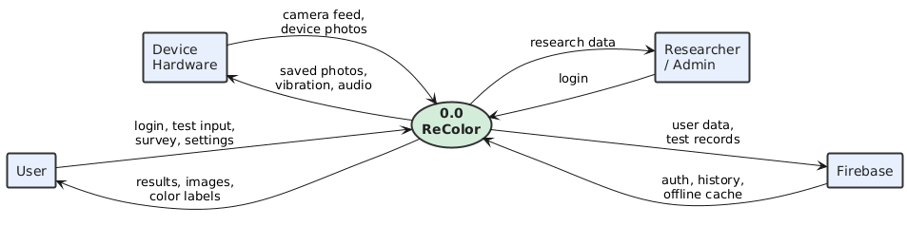
Context Diagram of ReColor

Figure __ presents the context diagram of the ReColor system, identifying the four external entities and their bidirectional data flows with the central application process. The User entity (encompassing both CVD and non-CVD individuals) provides login credentials, Ishihara test input, survey responses, and settings preferences to the system, and receives in return processed results (diagnosis, severity classification), enhanced images (daltonized or hue-rotated captures), and color labels (CIELAB ΔE-matched color names with hex values and confidence scores). The Device Hardware entity supplies camera feed and device photos to the system for freeze-frame capture and processing, while receiving saved photos for gallery export and multimodal feedback outputs including vibration (haptic) and audio (text-to-speech color announcements). The Researcher/Admin entity authenticates through a role-based login portal and receives anonymized research data aggregated from the dual-write Firestore collection for population-level CVD prevalence analysis. Firebase serves as the backend persistence layer, receiving user data and test records from the application and returning authentication tokens, test history for the user's personal record, and offline-cached data via Firestore's persistentLocalCache() for continued functionality without network connectivity.

Figure
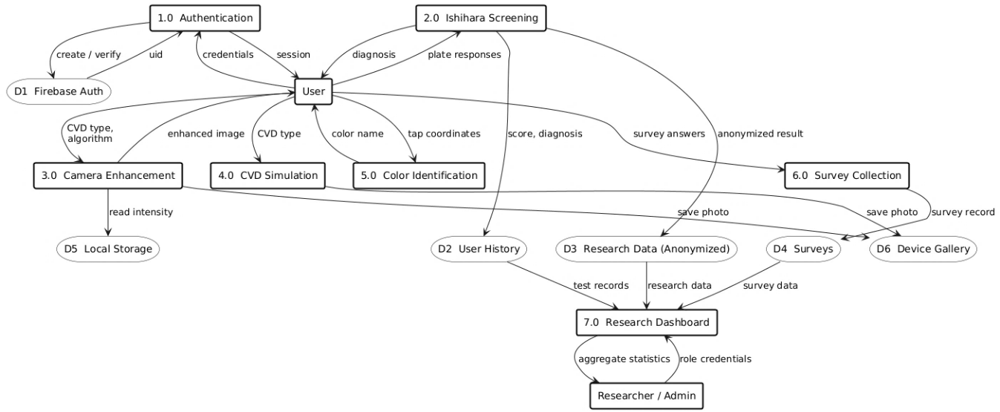
Data Flow Diagram (Level 1) of ReColor

The Level 1 DFD decomposes the system into seven processes (Authentication, Ishihara Screening, Color Enhancement, Color Identification, CVD Simulation, Education, Survey and Data Aggregation) with six data stores (user profiles, test history, anonymized research data, IDENTIFIER_DB reference shades, CVD_COMBINED matrices, and ishiharaData plate definitions). The dual-write pattern is shown as parallel flows from Ishihara Screening and Survey processes to both private and anonymized data stores.

Figure
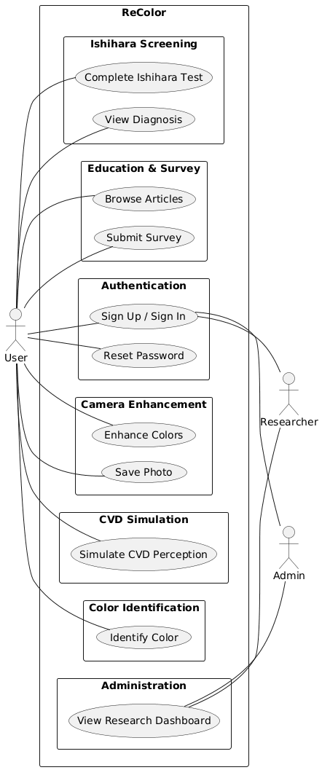
Use Case Diagram of ReColor

Figure __ presents the use case diagram of the ReColor system, illustrating the functional interactions between three actor types and the application's seven module groups. The User actor, representing both CVD and non-CVD individuals, interacts with the full range of application features: Authentication (Sign Up/Sign In and Reset Password) for secure account management via Firebase; Camera Enhancement (Enhance Colors and Save Photo) for freeze-frame daltonization and hue rotation with gallery export; CVD Simulation (Simulate CVD Perception) for GPU-accelerated visualization of how color vision deficiency affects scene perception; Color Identification (Identify Color) for tap-to-identify CIELAB ΔE color naming against the 80+ shade reference database; Ishihara Screening (Complete Ishihara Test and View Diagnosis) for digitized 38-plate weighted screening with severity classification; and Education & Survey (Browse Articles and Submit Survey) for CVD awareness content and post-test data collection. The Researcher and Admin actors access the system through the Authentication module and the Administration module's View Research Dashboard use case, which provides role-based access to anonymized aggregate research data collected via the dual-write Firestore pattern. This separation of actor privileges ensures that end users interact exclusively with assistive and screening features, while research personnel access only de-identified population-level data in compliance with the Data Privacy Act of 2012 (RA 10173).

Sequence Diagram Camera Enhancement Flow
Figure
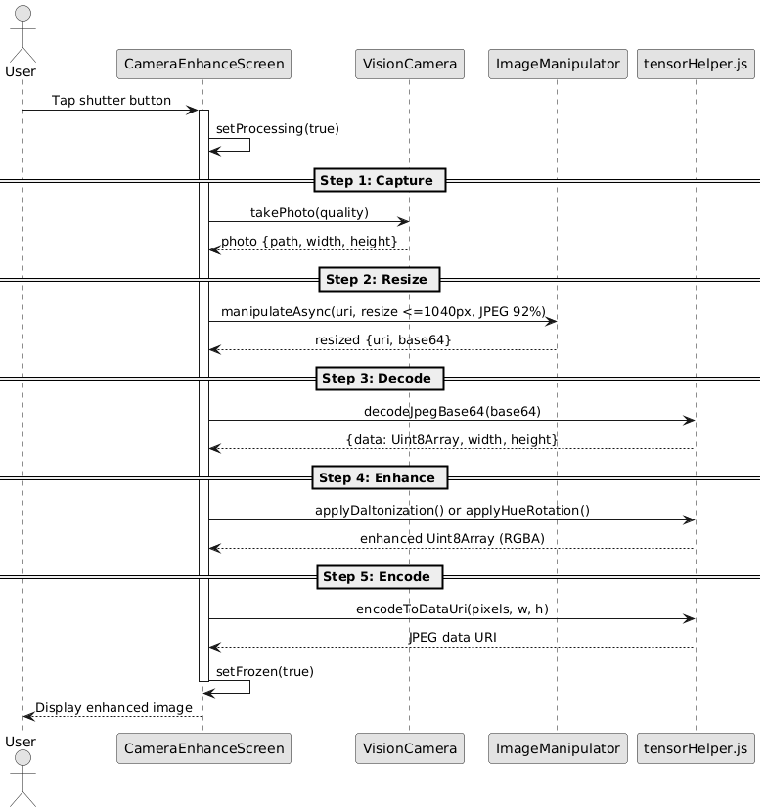
Image Capture and Processing Pipeline

Figure __ illustrates the five-stage image capture and processing pipeline executed within CameraEnhanceScreen whenever the user initiates a color enhancement operation. The pipeline follows a strictly sequential freeze-frame pattern rather than continuous video processing, ensuring deterministic results and avoiding frame-buffer race conditions on Android devices.
In Stage 1 (Capture), the user taps the shutter button, triggering a call to react-native-vision-camera's takePhoto() method with quality prioritized for speed over resolution. The camera returns a JPEG file with its path and native dimensions.
In Stage 2 (Resize), the captured photo is passed to Expo's ImageManipulator, which resizes the image to a maximum dimension of 1040 pixels while maintaining aspect ratio and re-encodes it as JPEG at 92% quality. This normalization step ensures consistent processing times across devices with varying camera resolutions, as raw captures from modern sensors (12MP+) would otherwise impose prohibitive pixel-loop latency.
Stage 3 (Decode) converts the base64-encoded JPEG into a raw RGBA pixel buffer (Uint8Array) via the jpeg-js library's decodeJpegBase64() function, producing a width × height × 4 array suitable for per-pixel algorithmic processing.
Stage 4 (Enhance) applies the selected enhancement algorithm either applyDaltonization() or applyHueRotation() to the decoded pixel buffer, performing the color correction computations described in the preceding algorithm sections. Finally, Stage 5 (Encode) converts the enhanced RGBA buffer back into a JPEG data URI via encodeToDataUri(), which uses chunked base64 encoding to avoid memory allocation limits on mobile JavaScript runtimes. The frozen enhanced image is then displayed to the user, replacing the live camera preview.
The entire pipeline executes synchronously on the JavaScript thread with a processing guard (isProcessingRef) preventing concurrent invocations. Typical end-to-end latency is approximately 2 seconds: 600ms capture, 400ms resize, 200ms decode, 400ms enhancement, and 300ms encode on a mid-range Android device (Snapdragon 700 series).

Figure
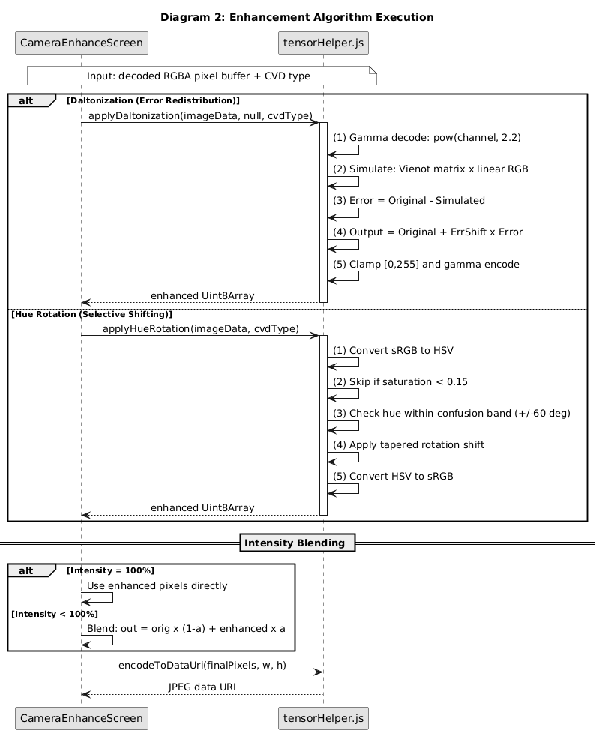
Enhancement Algorithm Execution

Figure __ details the internal execution flow of the two enhancement algorithms available within the processing pipeline. When the user has selected an algorithm via the DAL/HUE toggle, the corresponding function in tensorHelper.js is invoked with the decoded RGBA pixel buffer, the selected CVD type, and the intensity parameter.
The Daltonization path (left branch) implements the Fidaner error-redistribution method in five per-pixel steps, all operating in linearized sRGB space. First, each pixel undergoes gamma decoding via the pow(channel, 2.2) approximation to convert from perceptual sRGB to linear light values. Second, the Viénot combined simulation matrix for the selected CVD type is applied to produce the simulated perception. Third, the perceptual error vector is computed as the difference between the original linear pixel and its simulated counterpart — this error represents the color information invisible to the user. Fourth, the error is redistributed into the user's surviving cone channels via the Fidaner error-shift matrix, producing the corrective adjustment. Fifth, the corrected pixel is clamped to the [0, 255] range and gamma-encoded back to sRGB. The self-gating property emerges naturally from this process: pixels that the user can already perceive correctly produce near-zero error vectors and pass through the pipeline essentially unchanged.
The Hue Rotation path (right branch) operates in HSV color space rather than linearized RGB. Each pixel is converted from sRGB to HSV, where the hue component is evaluated against a CVD-specific confusion band (±60° centered on 0° for Protan/Deutan, ±60° centered on 240° for Tritan). Pixels with saturation below 0.15 are skipped entirely, as near-achromatic colors have unreliable hue values that would produce colored noise if rotated. For pixels within the confusion band, a linearly tapered rotation is applied — strongest at the band center where confusion is most severe, diminishing to zero at the band edges to prevent visible banding artifacts.
Following algorithm execution, an intensity blending step is applied. When the user's enhancement intensity slider is set to 100%, the enhanced pixels are used directly. At values below 100%, each output pixel is computed as a linear interpolation between the original and enhanced values: output = original × (1 − α) + enhanced × α, where α is the intensity parameter. This allows users to calibrate the strength of correction to their individual preference and residual color perception. The final blended buffer is then encoded to a JPEG data URI for display.

Figure
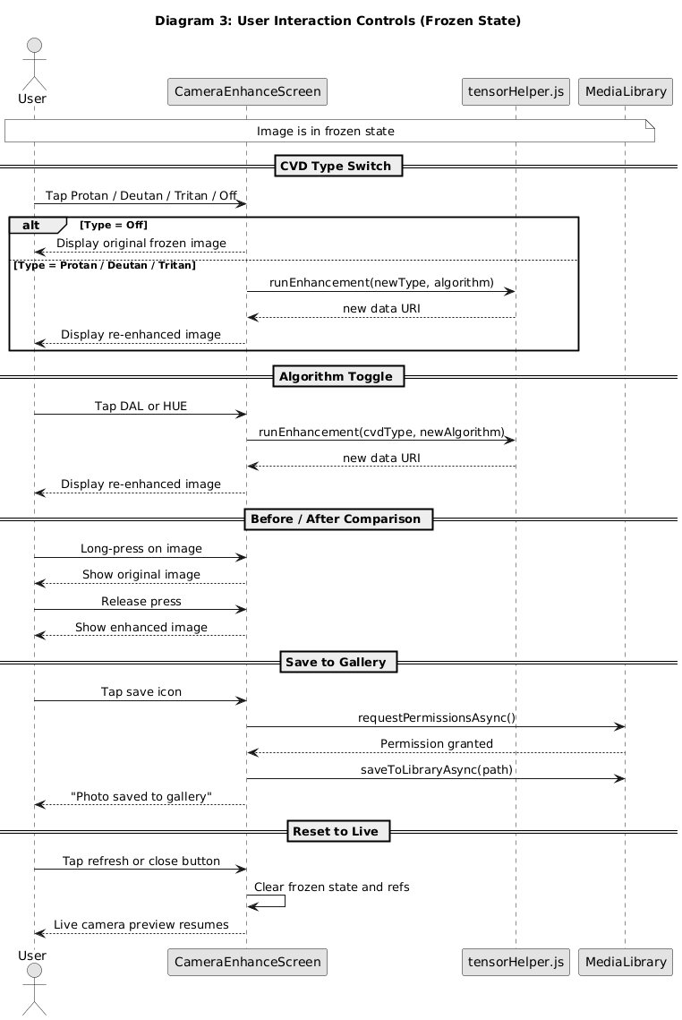
User Interaction Controls

Figure __ describes the user interaction controls available once the image is in the frozen (enhanced) state. These controls allow the user to explore different enhancement configurations without re-capturing the image, providing an interactive comparison experience that supports informed CVD type selection and algorithm preference discovery.
The CVD Type Switch allows the user to tap between Protan, Deutan, Tritan, and Off modes. Selecting Off displays the original frozen image without any enhancement applied. Selecting any CVD type triggers a full re-enhancement of the frozen pixel buffer using the current algorithm and intensity settings, producing a new data URI that replaces the displayed image. This enables rapid A/B comparison between deficiency-specific corrections without the latency of a new camera capture.
The Algorithm Toggle switches between DAL (Daltonization) and HUE (Hue Rotation) modes. Upon toggling, the system re-processes the same frozen pixel buffer using the alternate algorithm, allowing the user to compare the physically-motivated error-redistribution approach against the rule-based hue rotation approach on the same scene. This dual-algorithm design supports the comparative evaluation component of the study, enabling both quantitative metric comparison and qualitative user preference assessment.
The Before/After Comparison implements a long-press gesture: while the user holds their finger on the screen, the display reverts to the original (uncorrected) frozen image, and upon release, the enhanced version is restored. This interaction pattern provides an intuitive, instantaneous visual toggle that allows users to perceive the exact effect of the correction algorithm on the captured scene, which is particularly valuable during user acceptance testing and clinical demonstrations.
The Save to Gallery function requests Android media library permissions (if not previously granted), then saves the currently displayed enhanced image to the device's photo gallery using Expo's MediaLibrary.saveToLibraryAsync(). A confirmation toast notifies the user upon successful save.
Finally, the Reset to Live control clears the frozen state, releases all cached pixel buffers and data URIs from memory, and restores the live camera preview. This prepares the screen for a new capture cycle without navigating away from the enhancement screen, maintaining the user's selected CVD type and algorithm preferences across captures.

Figure
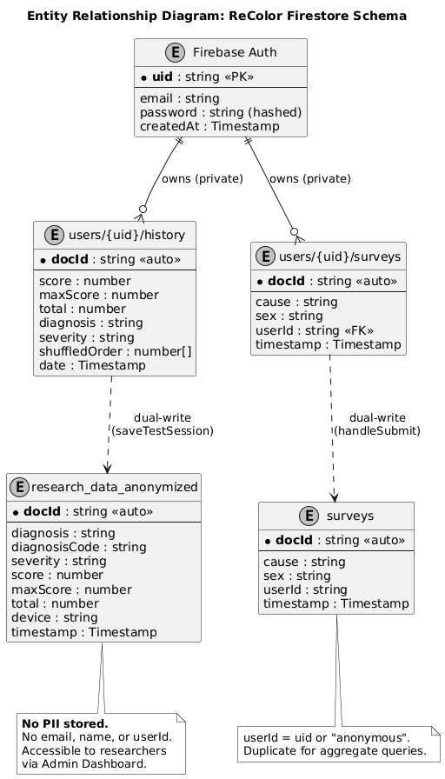
Entity Relationship Diagram: ReColor Firestore Schema

Hardware Specifications
To ensure ReColor delivers a responsive vision assistive experience, the following hardware specifications are recommended. ReColor is implemented in React Native with native camera access (react-native-vision-camera v4.7.3), GPU shader rendering (shopify/react-native-skia v2.2.12), and algorithmic image processing pipelines operating on captured still images.
Table
Recommended Device Specifications for ReColor
Specification | Minimum | Recommended | Justification
Chipset | Snapdragon 600 | Snapdragon 700+ | GPU must support SkSL shader execution
RAM | 4 GB | 6 GB+ | Concurrent camera buffering, GPU rendering, UI
Display | 720p IPS LCD | 1080p AMOLED | AMOLED provides superior color accuracy
Camera | Rear, autofocus | 12MP+, autofocus | Freeze-frame capture at 640–1040px
Android | 10 (API 29) | 14 (API 34) | vision-camera v4 requires API 29+
GPU | OpenGL ES 3.0 | Vulkan-capable | SkSL RuntimeShader requires modern pipeline

Table
Image Processing Resolution Configuration

Operation | Resolution | Rationale
Skia display overlay | min(720, screenWidth) | Balances visual quality with GPU memory
Saved/gallery photo | min(1024, screenWidth) | Full-resolution output for user export
CVD simulation resize | 1040px max dimension | Optimized for GPU shader throughput
Color identification | 640px | Sufficient for single-pixel CIELAB matching

Algorithm Pseudocode
Figure
Pseudocode for CVD Simulation (Viénot 1999)

Figure
Pseudocode for Daltonization (Error-Redistribution)

Figure
Pseudocode for Hue Rotation Enhancement

Figure
Pseudocode for CIELAB ΔE Color Identification

Data Analysis

The data analysis framework for this study integrates quantitative evaluation, descriptive statistical analysis, and qualitative thematic analysis to comprehensively assess the effectiveness, usability, and clinical relevance of the ReColor system across its research objectives.
Color Correction and Enhancement Analysis. The perceptual effectiveness of the Daltonization and Hue Rotation algorithms is evaluated using the CIEDE2000 ΔE (color difference) metric, computed between the color vision deficiency (CVD)-perceived enhanced image and the original normal-vision reference. This metric quantifies the degree of perceptual shift introduced by each algorithm. Structural preservation is assessed using the Structural Similarity Index (SSIM), which evaluates the retention of luminance, contrast, and structural information after enhancement. SSIM values range from 0 to 1, with values closer to 1 indicating higher structural fidelity.
A comparative analysis between the Daltonization and Hue Rotation algorithms is conducted across standardized test images representing different CVD confusion axes (Protan, Deutan, Tritan). It is important to note that ΔE values in this study serve as relative comparison measures between algorithms, rather than absolute indicators of perceptual equivalence, as physiological cone deficiencies prevent full alignment with normal color vision.
Color Identification Accuracy. The CIELAB ΔE-based color identification module is evaluated by comparing its predicted color labels against expert-verified ground-truth labels across a standardized set of color swatches covering ten color families (Red, Orange, Yellow, Green, Cyan, Blue, Violet, Pink, Brown, Neutral). Performance is measured using overall classification accuracy, per-class precision, and a confusion matrix to identify misclassification patterns between perceptually adjacent colors. These metrics provide insight into the system’s ability to reliably distinguish colors under varying conditions.
CVD Simulation Fidelity. The fidelity of the GPU-accelerated CVD simulation is assessed by comparing its output to a CPU-based reference implementation using identical Viénot simulation matrices. The per-pixel perceptual difference between the two outputs is measured using CIEDE2000 ΔE. A mean ΔE below 1.0 is considered indicative of perceptually indistinguishable differences, confirming that the GPU implementation maintains simulation accuracy despite reduced floating-point precision.
Processing Latency and Device Compatibility. System performance is evaluated by measuring end-to-end processing latency across key stages: image capture, algorithm execution, and output encoding. Measurements are conducted on multiple Android devices representing different performance tiers (budget, mid-range, and flagship) to assess variability in execution time, memory usage, and thermal behavior. These results are used to determine the system’s responsiveness and suitability for real-time mobile deployment.
Ishihara Screening Evaluation. The Ishihara screening module is evaluated based on its adherence to established test procedures, scoring logic, and consistency with expected screening outcomes. Evaluation focuses on the correctness of plate presentation, scoring thresholds, and classification logic (normal, CVD, and indeterminate results). Due to the limited availability of clinically confirmed diagnostic datasets, formal inferential statistical measures such as sensitivity, specificity, and Cohen’s Kappa are not computed. Instead, validation is supported through alignment with standard Ishihara protocols and clinical expert evaluation.
User Acceptance and Expert Validation. The End User Survey (32 items), IT Expert Checklist (57 items), and Clinical Expert Validation instrument (28 items) utilize a 4-point Likert scale (4 = Highly Acceptable, 3 = Acceptable, 2 = Fairly Acceptable, 1 = Unacceptable). Descriptive statistics, including mean and standard deviation, are computed for each item and grouped by evaluation dimensions.
Cronbach’s Alpha is used to assess the internal consistency of the End User Survey instrument. This measure is not applied to the IT Expert Checklist and Clinical Expert Validation instruments, as these evaluate multiple independent constructs and involve limited sample sizes, making internal consistency measures inappropriate.
A supplementary analysis is conducted for participants with diagnosed color vision deficiency (CVD), whose responses are analyzed separately using descriptive statistics to assess the system’s effectiveness for its intended target users. Due to the limited sample size, these results are treated as exploratory.
Overall system acceptability is interpreted using the following scale: 3.50–4.00 (Highly Acceptable), 2.50–3.49 (Acceptable), 1.50–2.49 (Fairly Acceptable), and 1.00–1.49 (Unacceptable).
Qualitative Analysis .Qualitative data collected from end users and participants with color vision deficiency (CVD), as well as open-ended responses from expert evaluations, are analyzed using thematic analysis following the framework of Braun and Clarke (2006). The analysis involves data familiarization, initial coding, theme generation, and refinement to identify recurring patterns related to usability, effectiveness, and user experience.
This approach enables a deeper understanding of user perceptions beyond quantitative measures, capturing insights into real-world applicability, accessibility, and perceived benefits of the system. Qualitative findings are triangulated with quantitative results to provide a comprehensive evaluation of the ReColor application.

Qualitative Sample Size Justification.The qualitative component of the study follows a purposive sampling approach, focusing on information-rich participants relevant to the research objectives. The participant group includes general end users, individuals with color vision deficiency (CVD), and expert evaluators, resulting in a heterogeneous dataset.
Rather than adhering to fixed numerical thresholds, sample adequacy is determined by the richness and relevance of the data. The inclusion of multiple participant groups allows for diverse perspectives while maintaining sufficient depth for thematic analysis. Responses from CVD participants are treated as targeted validation of the system’s effectiveness, complementing insights from general users and experts.

Ethical Considerations

In line with recommendations from the Philippine Eye Research Institute (PERI, 2025), we employ strict ethical considerations throughout the study. The following measures were implemented to protect participants, preserve data integrity, and ensure responsible scientific conduct during the development, deployment, and evaluation of ReColor.

- Data privacy and confidentiality. Participant privacy and confidentiality are principal concerns given the collection of sensitive vision and health-related information. All personally identifiable information will be removed or replaced with a unique participant code prior to analysis and reporting. Data in transit will be protected using TLS 1.2 or higher and data at rest will be encrypted using AES-256. Firebase security rules and App Check will be configured to restrict access to authenticated applications only. Aggregate and anonymized datasets may be shared with collaborating institutions such as the Philippine Eye Research Institute for approved research purposes only. Individual-level data will not be disclosed without explicit participant consent.
- Participant Code System and Pseudonymization. To preserve confidentiality and uphold ethical research standards, every participant will be assigned a unique participant code upon enrollment. These codes will replace personal identifiers in all data records, logs, transcripts, images, spreadsheets, and published materials. The following procedures will be implemented to ensure robust privacy protection:
a. Code Format. Participant codes will follow a consistent structure, for example: OPT-001, where 001 represents a zero-padded sequence number.
b. Linkage Key. A separate mapping file linking participant names to their corresponding codes will be stored independently from all research data in an encrypted file. Access to this linkage key will be restricted to authorized personnel only and managed by the project data steward.
c. Secure Storage. The linkage key will be encrypted using industry-standard encryption algorithms and stored on a secure server or encrypted drive. Access controls will utilize role-based permissions and multi-factor authentication for additional protection.
d. Access Logging and Audit. All instances of access to the linkage key will be automatically logged. An access audit trail will be maintained to record user identity, access time, and purpose of retrieval.
e. Use in Outputs. All analyses, transcripts, figures, tables, and appendices will exclusively reference participant codes. No direct identifiers (e.g., names, contact information) will appear in any thesis outputs or related publications.
f. Retention and Deletion. The linkage key will be retained only for the duration necessary to complete the study objectives and any clinical referral obligations. Upon verified participant withdrawal or at the end of the retention period, all identifiable linkage files will be permanently deleted within 30 days. Fully anonymized datasets may be retained for up to five years for reproducibility and secondary analysis.
g. Images and Media. Any images or visual data used for algorithm validation will be renamed using participant codes, stripped of metadata (e.g., EXIF data), and stored securely. Faces or identifiable features will be blurred or removed unless explicit written consent for identifiable media has been obtained.
- Compliance with law and institutional policy. The research will comply with the Philippine Data Privacy Act of 2012 (Republic Act No. 10173), university IRB or ethics committee requirements, and other applicable institutional policies. Where data are shared across borders, the research team will follow relevant legal and contractual data transfer safeguards.
- Informed consent and voluntary participation. Participants will receive clear written information about the study purpose, procedures, expected duration, potential benefits, and risks. Consent forms will explain how data are stored, who will have access, how participant codes are used, and how participants can withdraw. Participation is voluntary and participants may withdraw at any time without penalty. The consent form will be available in English and Tagalog and will include the following short statement about pseudonymization: "To protect your privacy we will assign you a unique participant code. Your name will be stored separately from your survey responses and test results. The linkage file that maps names to codes will be encrypted and accessible only to authorized researchers. You may request deletion of your identifiable data at any time."
- Screening and clinical referral. The Ishihara module is a screening tool and not a clinical diagnostic instrument. Participants who screen positive will receive guidance and referral information to seek confirmatory clinical evaluation from qualified eye care professionals, including contacts at the Philippine Eye Research Institute when appropriate. The research team will not provide medical diagnoses.
- Minimization of risk. The study involves minimal physical risk. Potential psychosocial risks include distress following a positive screening result. To mitigate this, the consent process will outline possible outcomes and provide referral resources. The research team will document and respond to any adverse events.
- Image and media handling. Camera captures or uploaded images used in algorithm validation may include identifiable content. Only images explicitly consented for research use will be stored. Identifiers will be removed or blurred unless separate consent is obtained. All image data will be subject to the same encryption and access control measures as other sensitive data.
- Cybersecurity and data integrity. Technical safeguards to protect the system and participant data will include secure authentication via Firebase Authentication, App Check, least-privilege access roles, encrypted storage, routine software updates, and scheduled security audits. Critical operations and access events will be logged for accountability and forensic review if needed. A data breach response plan is in place to notify the IRB and affected participants within 72 hours of detection.
- Bias, fairness, and model transparency. The research team will mitigate algorithmic bias by using diverse training and validation datasets and by reporting model performance across demographic subgroups where feasible. Model conversion, quantization, and compression steps performed for TensorFlow Lite deployment will be documented. Model limitations and known failure modes will be disclosed to participants and expert evaluators.
- Intellectual property and licensing. The study will use third-party libraries, datasets, and test materials in accordance with their licenses. Copyrighted test materials such as Ishihara plates will be used only with appropriate permissions or under fair-use provisions and will be properly credited.
- Social impact, inclusion, and non-discrimination. The project will design inclusive interfaces and educational content and will avoid discriminatory recruitment or evaluation practices. Recruitment and communication will accommodate accessibility needs. Career guidance content will be factual and non-stigmatizing.
- Dual-use and misuse prevention. To reduce dual-use risks, access to raw datasets will be restricted, and any external sharing will require data-use agreements that prohibit misuse. Sensitive operational details that could facilitate misuse will be handled with care while maintaining scientific transparency.
- Accountability and integrity. The research team commits to honest and accurate reporting of methods and results. Any conflicts of interest will be disclosed. A record of protocol changes, ethical approvals, consent forms, and minutes of stakeholder consultations including PERI meetings will be maintained and made available to the IRB upon request.
- Collaboration ethics and credit. All collaborators, advisors, and participants will receive appropriate acknowledgment. Authorship will follow accepted academic conventions. Any financial or professional relationships that could influence the study will be declared.
- Data retention and participant rights. The consent form will state the data retention schedule and provide instructions for participant requests such as data access, correction, or deletion. The procedure for honoring deletion requests will be described and executed within the specified timeframes.
- Data steward and point of contact. A designated project data steward will manage encryption keys, linkage files, and data access requests. Contact details for privacy and data deletion inquiries will be included in the consent form and the study documentation.

CHAPTER IV

RESULTS AND DISCUSSION

Design and Development of ReColor
This chapter presents the results and discussion of the evaluation conducted on the ReColor mobile application. The presentation is organized into two phases: (1) internal evaluation, which assesses the performance of the system's core image processing pipelines specifically the LMS-based daltonization algorithm, HSV-based hue rotation baseline, CIELAB ΔE color identifier, and SKIA GPU-accelerated CVD simulation; and (2) external evaluation, which presents findings from participant testing using validated research instruments administered to end users, IT experts, and clinical experts.
Section 4.1 presents the user interface design of the ReColor application. Sections 4.2 through 4.4 present the internal algorithm evaluation results for color enhancement, color identification, and CVD simulation respectively. Section 4.5 presents the Ishihara screening module results. Section 4.6 presents the external evaluation results from the functionality test, surveys, expert checklists, and semi-structured interviews. Section 4.7 provides a summary and synthesis of all findings.

User Interface Design
Authentication Screens
Figure ___
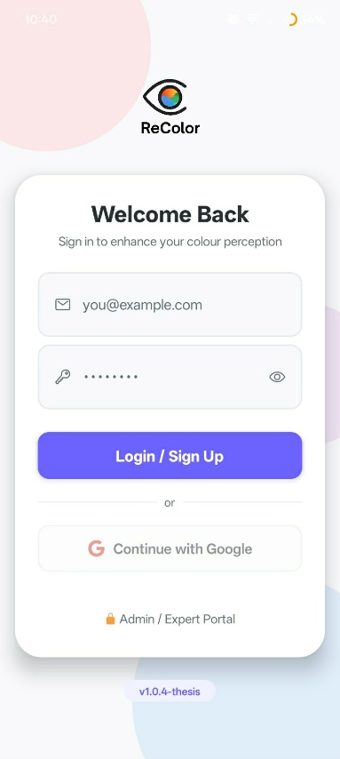
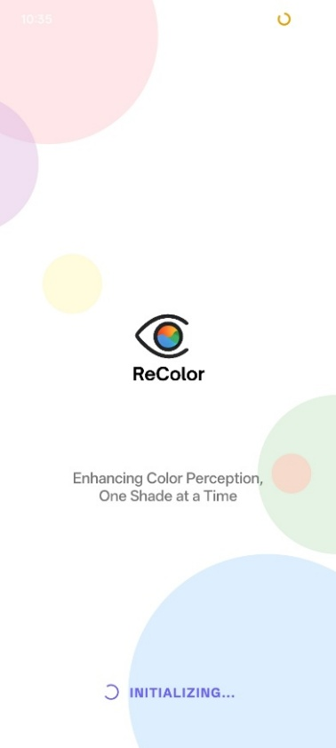
Authentication Sceens of ReColor

The authentication screens handle user login and first-time onboarding. Users sign in via email and password through Firebase, with automatic account creation for new users. First-time users are guided through a five-slide onboarding wizard covering CVD type selection, permissions, and application features before reaching the main screen.

Home and Navigation Screens

Figure ___
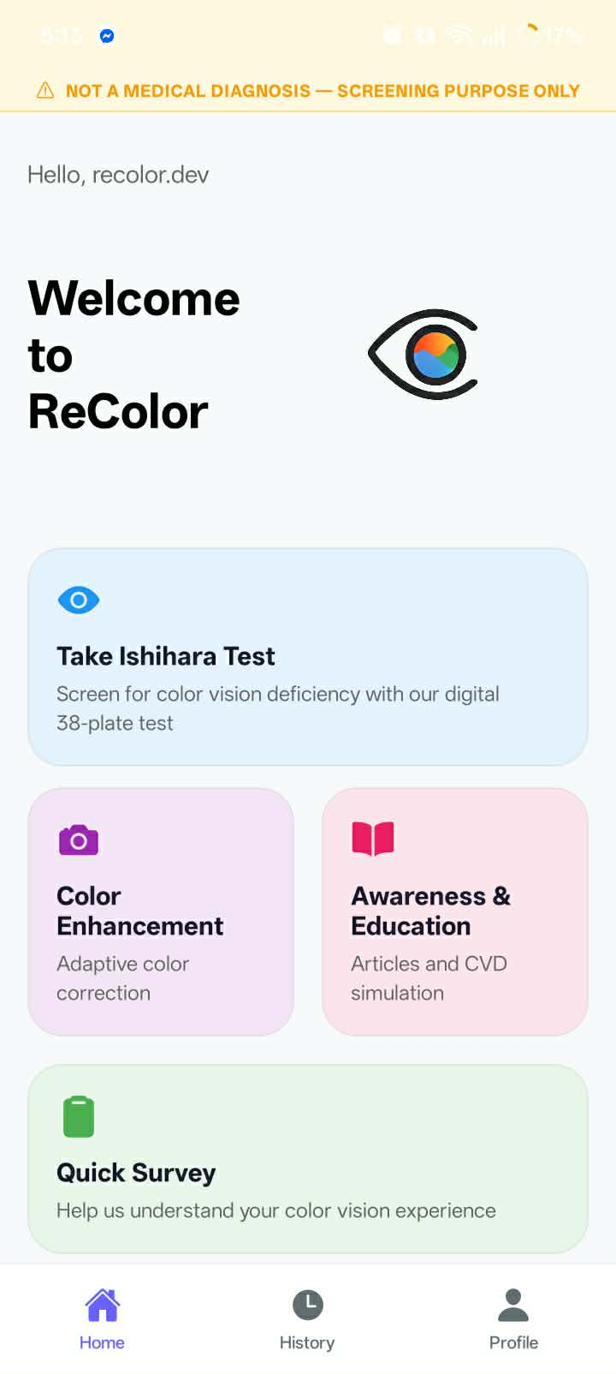
Home Screen of ReColor

The HomeScreen serves as the main navigation hub, presenting four feature cards: Ishihara Test, Color Enhancement, Quick Survey, and Awareness and Education, alongside a bottom navigation bar for Home, History, and Profile. A dismissable disclaimer banner reminds users that the screening module does not constitute a clinical diagnosis.

Camera & Color Enhancement
Figure ___
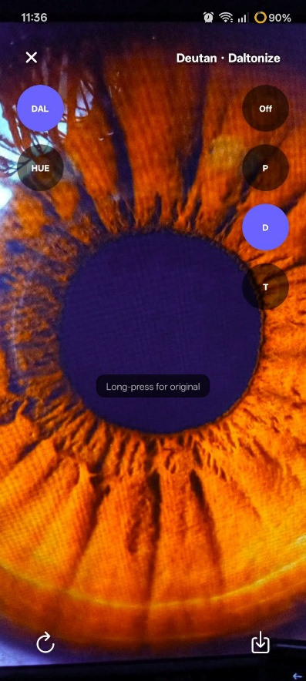
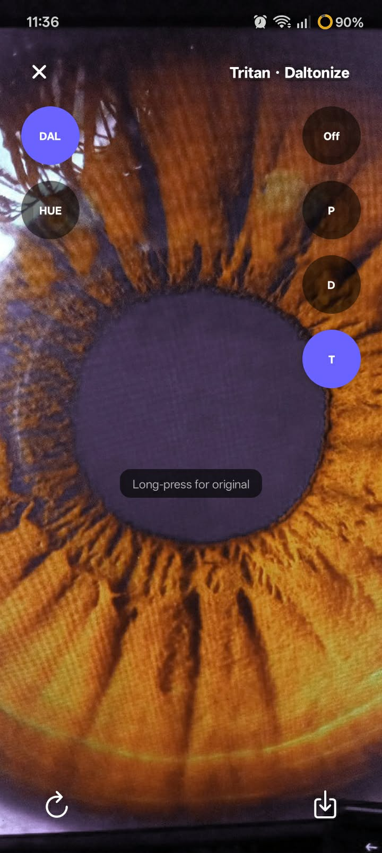
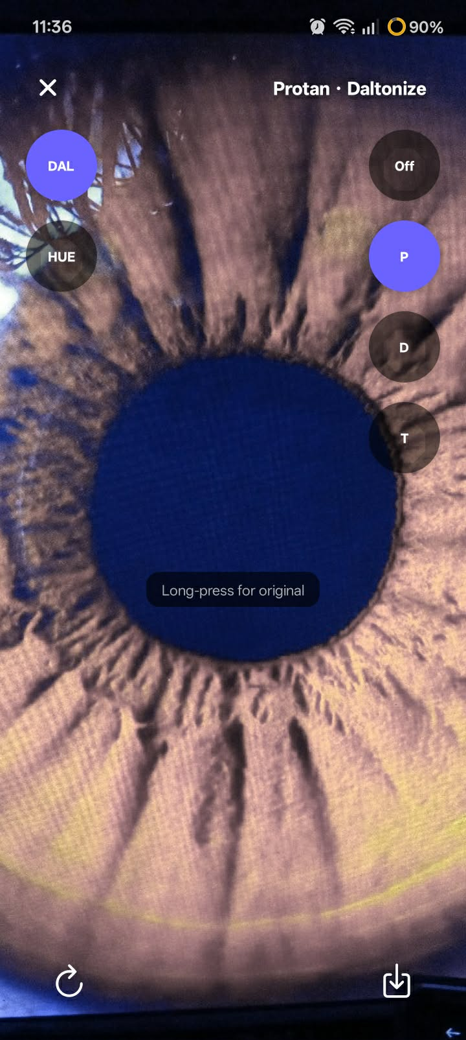
Camera view, Enhancement ON (Protan), Enhancement ON (Deutan), CVD Type Selector

The Camera Enhancement screen allows users to capture a freeze-frame image and apply adaptive color correction using either the Daltonization or Hue Rotation algorithm. Users can switch between CVD types (Protan, Deutan, Tritan) and toggle the algorithm without re-capturing, perform before/after comparison via long-press, and save the corrected image to their gallery.

CVD Simulation
Figure ___
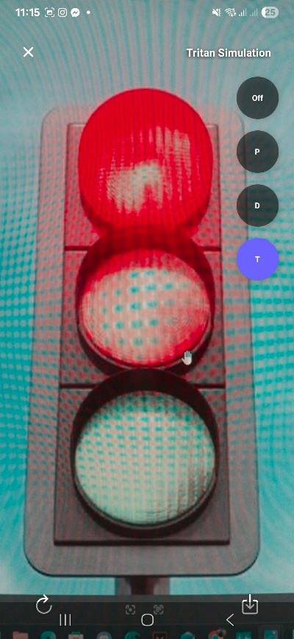
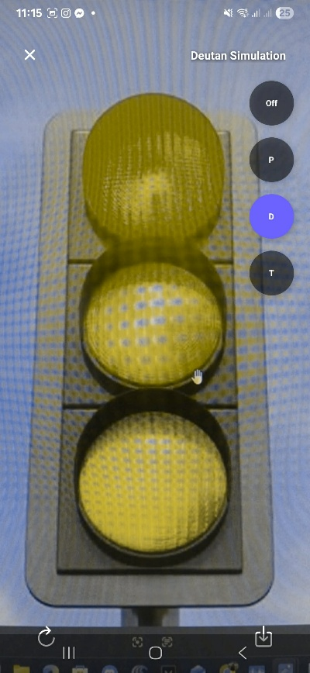
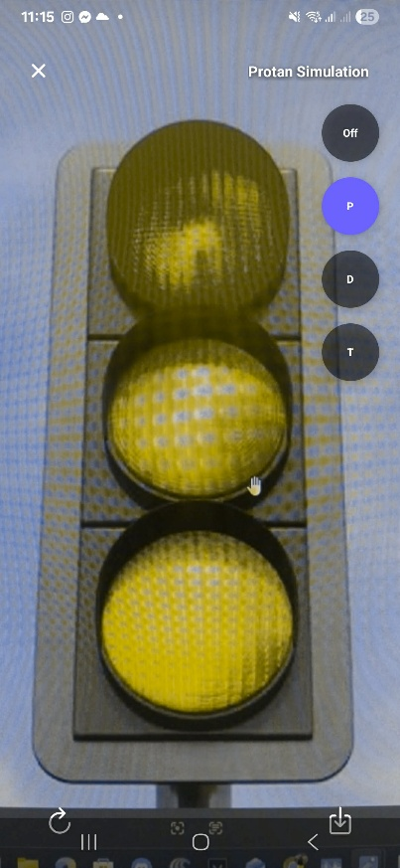
Simulation OFF vs ON (Protan), Simulation ON (Deutan), Front Camera Simulation

The CVD Simulation screen renders a freeze-frame capture as perceived by a color vision deficient individual using GPU-accelerated Viénot color transformation matrices. Users can instantly switch between Protan, Deutan, and Tritan simulation types and save the simulated image for sharing or educational purposes.

Color Identifier
Figure ___
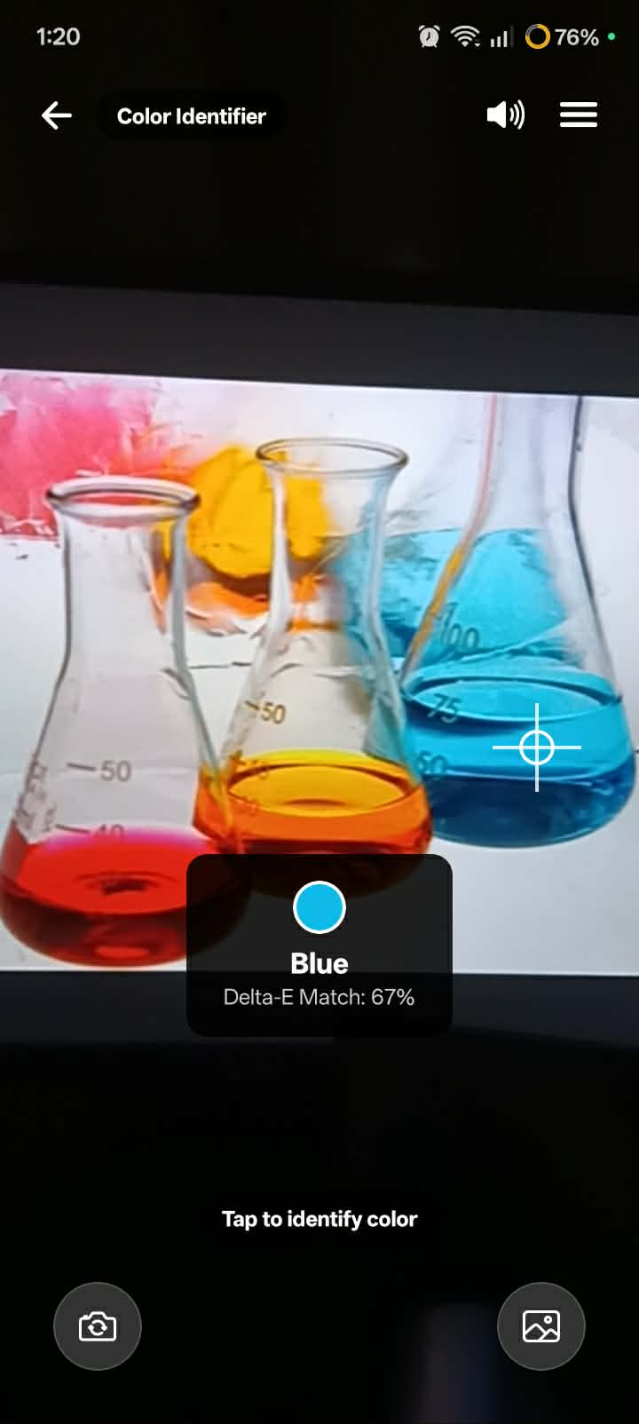
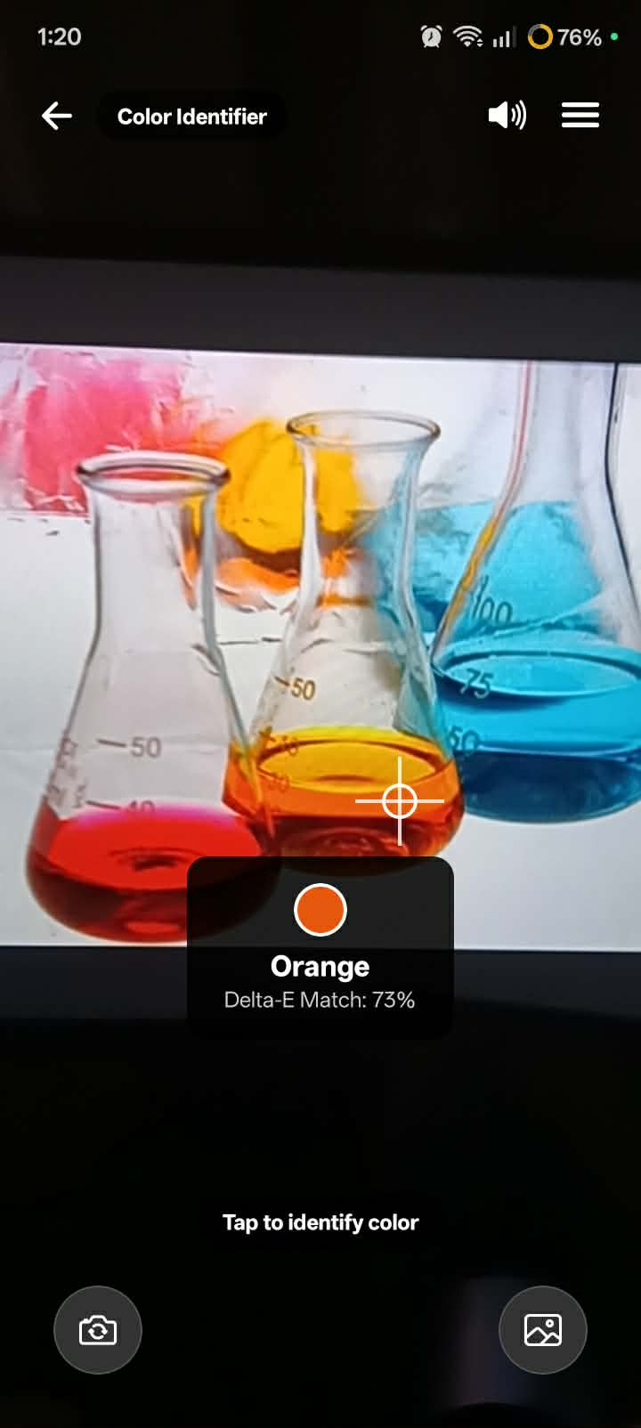
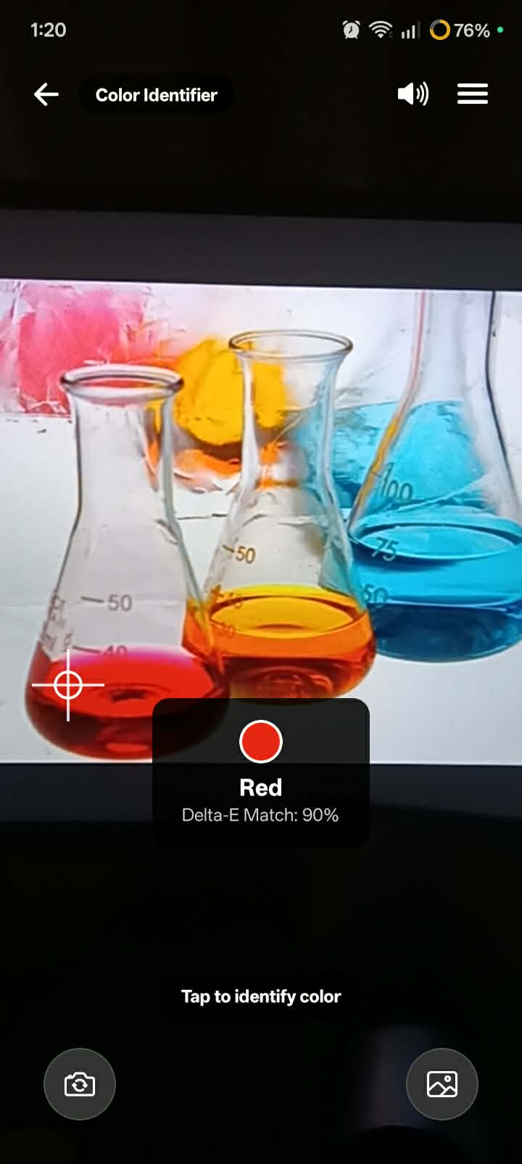
Identifier with Crosshair, Color Label Display, Freeze Frame + Identify.

The Color Identifier screen enables tap-to-identify color naming using CIELAB perceptual distance matching. Users tap on any area of the live camera feed to capture and classify the color at that point, receiving the color name and Delta-E match confidence scores.

Ishihara Screening
Figure ___
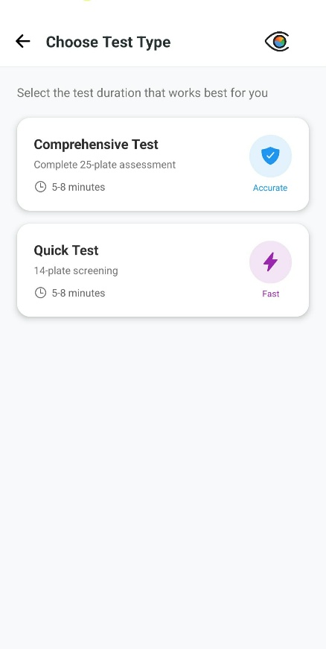
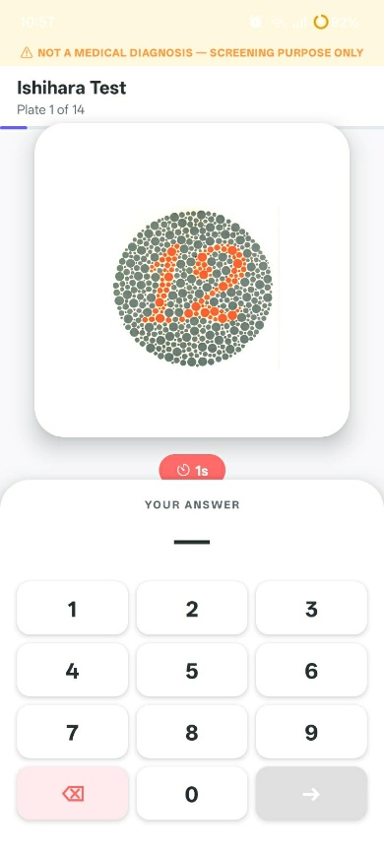
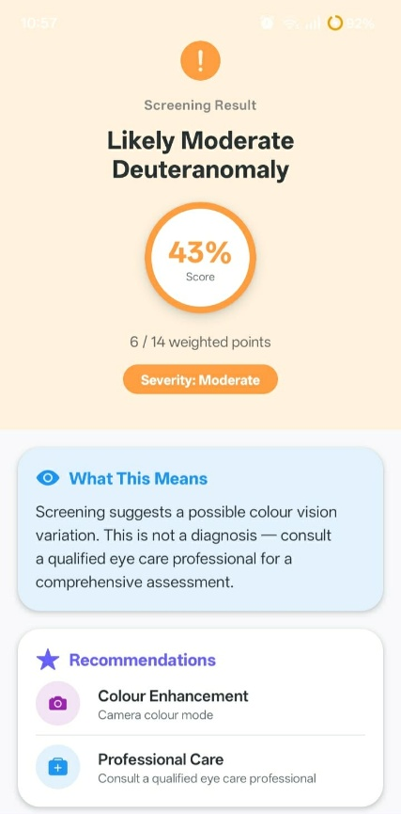
Plate Display, Response Input, Ishihara Test Results.

The Ishihara Screening module presents digitized test plates in two modes: Quick (14 plates) and Comprehensive (25 plates) with a 3-second timer per plate and weighted scoring. Results display a severity classification (Normal through Severe) and CVD type (Protanomaly or Deuteranomaly), with a disclaimer recommending professional clinical follow-up.

Career Awareness and Education
Figure ___
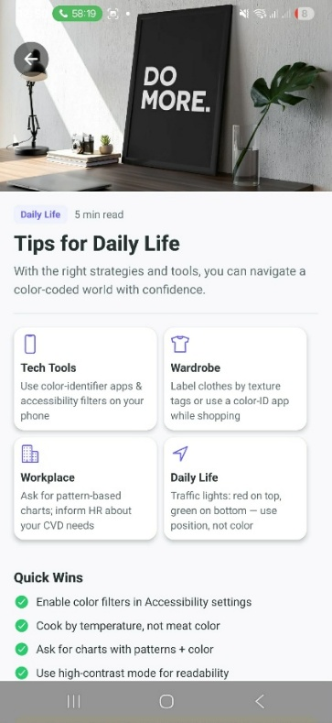
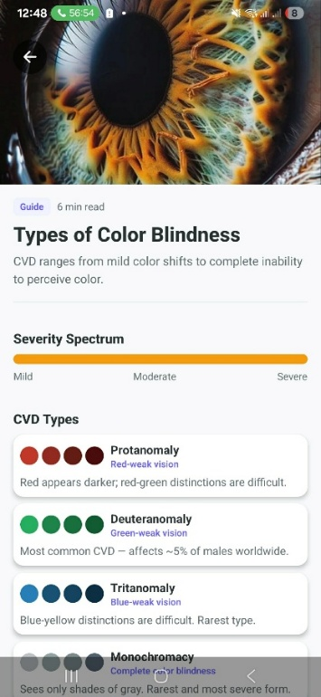
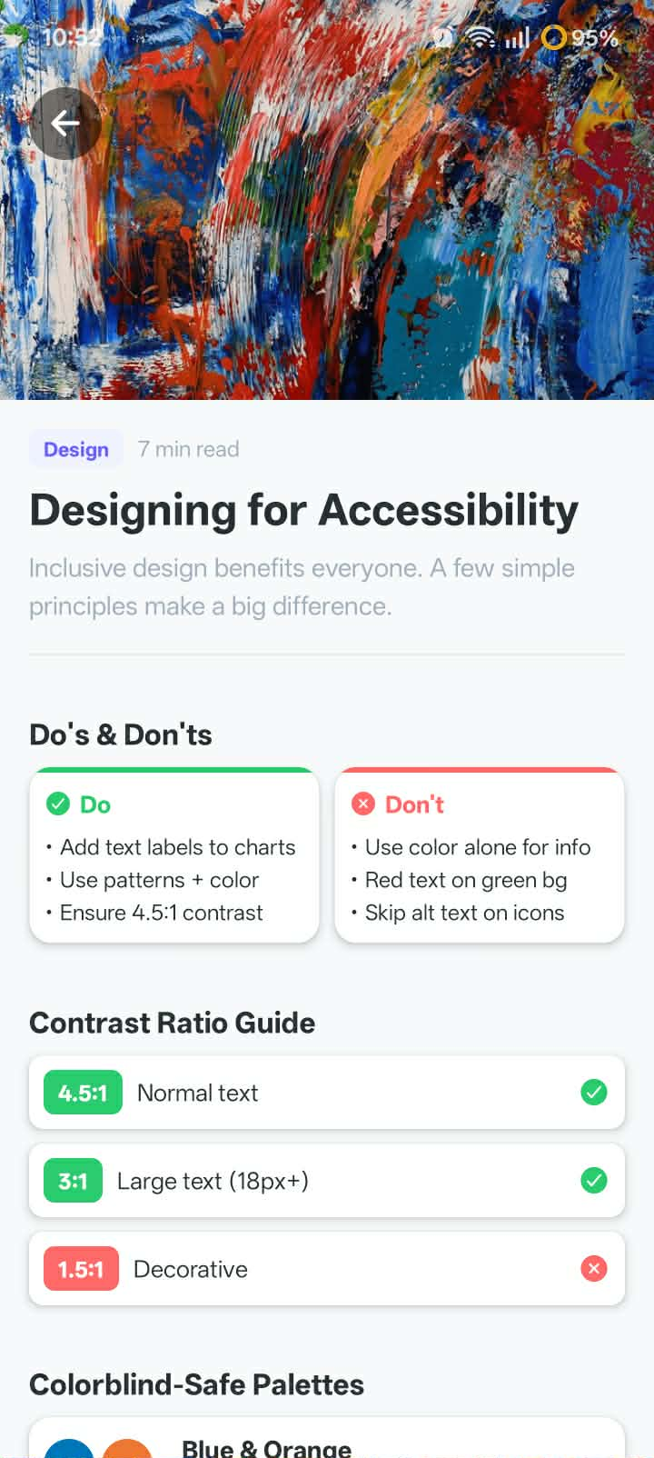
CVD Awareness Articles
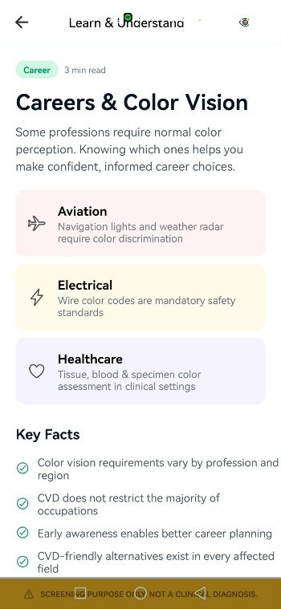
The Education screen provides CVD awareness content in partnership with PERI, including descriptions of each CVD type, colorblind-friendly design guidelines, career awareness information, and curated articles. An external link directs users to PERI's official website for further clinical resources.

Gallery and Image
Figure ___
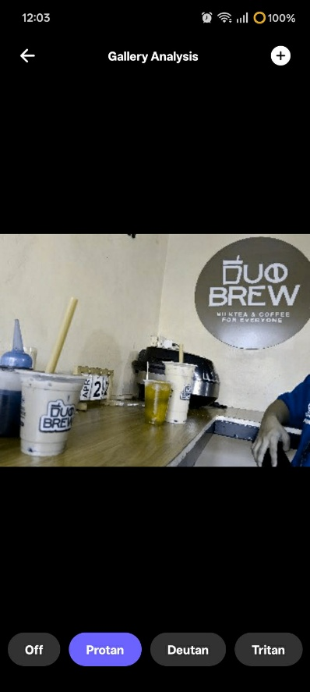
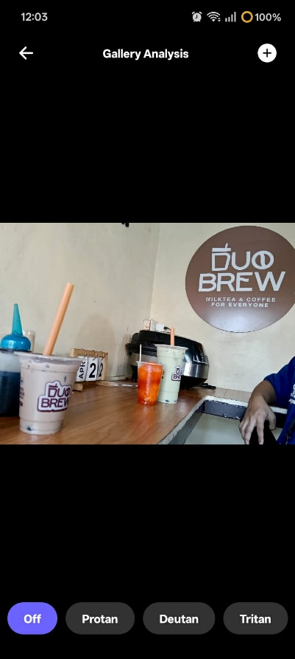
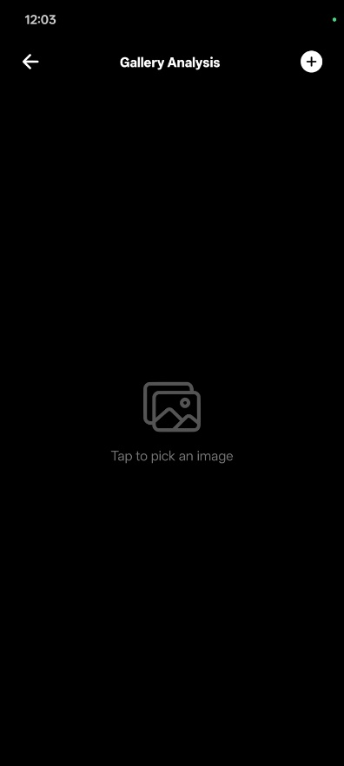
Gallery View, Upload Image, Before/After Comparison

The CVDGalleryScreen enables users to apply CVD simulation to images stored on their device. Accessible via the Education module or Mode Selector, it allows image selection through the system gallery and processes the photo using the Viénot (1999) CPU-based simulation pipeline with the selected CVD matrix. Users can toggle between the original and simulated images for direct comparison. This feature supports education and awareness by allowing users to demonstrate their visual perception using familiar photographs, promoting understanding and empathy.

Settings Screen
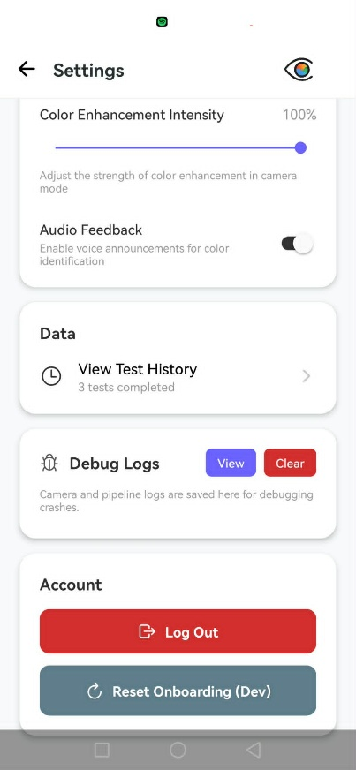
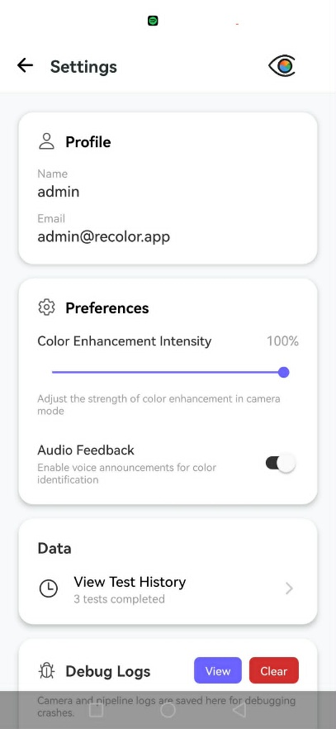
Figure ___

The SettingsScreen provides configuration options for personalizing the ReColor experience. It includes an enhancement intensity slider that adjusts the strength of the daltonization and hue rotation algorithms, allowing users to balance correction and natural color appearance. An audio feedback toggle controls text-to-speech output in the Color Identifier module. A debug log viewer (AppLog) displays recent application logs with an option to clear them. The logout function ends the Firebase authentication session and redirects to the LoginScreen. All settings are stored locally using AsyncStorage, ensuring persistence across sessions.

Evaluation of Color Enhancement Algorithm
Overview
The color enhancement pipeline was evaluated using two algorithms: Daltonization (Viénot-Brettel-Mollon 1999 with Fidaner error redistribution) and Hue Rotation (HSV-based tapered shift) on six synthetic images covering major CVD confusion axes (red-green, blue-yellow, neutral, mixed, and saturated primaries) across Protan, Deutan, and Tritan types.
Evaluation used CIEDE2000 ΔE (perceptual difference) and SSIM (structural similarity) between the CVD-enhanced output and the original normal-vision image. Since full perceptual equivalence is physiologically impossible, these metrics serve as relative comparisons rather than absolute measures. Future evaluation should focus on discrimination gain between previously confused colors, as noted in this study’s limitations.

Structural Preservation (SSIM)
Table
Per-image, per-CVD SSIM results
Image | CVD | Algorithm | Mean SSIM | R | G | B
gradient_red_green.png | Protan | Daltonization | 0.7011 | 0.802 | 0.779 | 0.522
gradient_red_green.png | Protan | Hue Rotation | 0.8590 | 0.763 | 0.814 | 1.000
gradient_red_green.png | Deutan | Daltonization | 0.6598 | 0.770 | 0.825 | 0.384
gradient_red_green.png | Deutan | Hue Rotation | 0.5282 | 0.780 | 0.798 | 0.007
gradient_red_green.png | Tritan | Daltonization | 0.4933 | 0.545 | 0.934 | 0.001
gradient_red_green.png | Tritan | Hue Rotation | 0.5107 | 0.780 | 0.750 | 0.002
gradient_blue_yellow.png | Protan | Daltonization | 0.7645 | 0.698 | 0.881 | 0.714
gradient_blue_yellow.png | Protan | Hue Rotation | 0.7933 | 0.686 | 0.896 | 0.797
gradient_blue_yellow.png | Deutan | Daltonization | 0.8463 | 0.710 | 0.894 | 0.934
gradient_blue_yellow.png | Deutan | Hue Rotation | 0.8447 | 0.677 | 0.922 | 0.935
gradient_blue_yellow.png | Tritan | Daltonization | 0.7990 | 0.770 | 0.818 | 0.809
gradient_blue_yellow.png | Tritan | Hue Rotation | 0.7622 | 0.685 | 0.821 | 0.780
color_checker_24.png | Protan | Daltonization | 0.8715 | 0.885 | 0.925 | 0.805
color_checker_24.png | Protan | Hue Rotation | 0.8978 | 0.862 | 0.957 | 0.874
color_checker_24.png | Deutan | Daltonization | 0.9094 | 0.884 | 0.948 | 0.896
color_checker_24.png | Deutan | Hue Rotation | 0.9360 | 0.876 | 0.944 | 0.988
color_checker_24.png | Tritan | Daltonization | 0.9055 | 0.865 | 0.956 | 0.895
color_checker_24.png | Tritan | Hue Rotation | 0.9068 | 0.900 | 0.950 | 0.870
natural_scene.png | Protan | Daltonization | 0.6008 | 0.645 | 0.689 | 0.468
natural_scene.png | Protan | Hue Rotation | 0.7347 | 0.592 | 0.788 | 0.824
natural_scene.png | Deutan | Daltonization | 0.7241 | 0.630 | 0.836 | 0.706
natural_scene.png | Deutan | Hue Rotation | 0.7870 | 0.644 | 0.747 | 0.969
natural_scene.png | Tritan | Daltonization | 0.7159 | 0.611 | 0.900 | 0.636
natural_scene.png | Tritan | Hue Rotation | 0.7192 | 0.715 | 0.926 | 0.517
saturated_primaries.png | Protan | Daltonization | 0.6383 | 0.639 | 0.464 | 0.811
saturated_primaries.png | Protan | Hue Rotation | 0.6592 | 0.478 | 0.500 | 1.000
saturated_primaries.png | Deutan | Daltonization | 0.5821 | 0.591 | 0.495 | 0.660
saturated_primaries.png | Deutan | Hue Rotation | 0.5327 | 0.598 | 0.493 | 0.507
saturated_primaries.png | Tritan | Daltonization | 0.5376 | 0.643 | 0.486 | 0.483
saturated_primaries.png | Tritan | Hue Rotation | 0.7084 | 1.000 | 0.666 | 0.459
neutral_grays.png | Protan | Daltonization | 1.0000 | 1.000 | 1.000 | 1.000
neutral_grays.png | Protan | Hue Rotation | 1.0000 | 1.000 | 1.000 | 1.000
neutral_grays.png | Deutan | Daltonization | 1.0000 | 1.000 | 1.000 | 1.000
neutral_grays.png | Deutan | Hue Rotation | 1.0000 | 1.000 | 1.000 | 1.000
neutral_grays.png | Tritan | Daltonization | 1.0000 | 1.000 | 1.000 | 1.000
neutral_grays.png | Tritan | Hue Rotation | 1.0000 | 1.000 | 1.000 | 1.000

Table reports CIEDE2000 ΔE values indicating how closely the CVD-perceived enhanced image matches the original normal-vision view. Mean ΔE was 15.721 for Daltonization and 15.312 for Hue Rotation. As noted in the methodology, these values reflect the unavoidable perceptual gap from cone loss, not algorithmic failure ΔE = 0 (perfect equivalence) is physiologically impossible. The neutral gray image (ΔE = 0.000 across all CVD types) serves as a control, confirming correct metric behavior in no-change regions.
Higher ΔE values (22–27) for red-green gradients and saturated primaries are expected, as corrections along confusion axes require significant chromatic shifts. Lower ΔE values (7–9) for blue-yellow gradients in Protan and Deutan cases reflect minimal adjustments, since both algorithms primarily target red-green deficiencies.

Perceptual Distance from Normal Vision (CIEDE2000 ΔE)
Table 4.2 — Per-image, per-CVD CIEDE2000 ΔE results

Image | CVD | Algorithm | Mean ΔE | Median ΔE | P95 ΔE | Max ΔE
gradient_red_green.png | Protan | Daltonization | 26.21 | 28.76 | 39.01 | 39.80
gradient_red_green.png | Protan | Hue Rotation | 27.07 | 27.05 | 46.91 | 47.64
gradient_red_green.png | Deutan | Daltonization | 25.38 | 25.11 | 43.70 | 44.15
gradient_red_green.png | Deutan | Hue Rotation | 27.44 | 26.00 | 49.62 | 50.58
gradient_red_green.png | Tritan | Daltonization | 22.85 | 25.49 | 28.59 | 29.32
gradient_red_green.png | Tritan | Hue Rotation | 19.86 | 23.49 | 27.30 | 28.07
gradient_blue_yellow.png | Protan | Daltonization | 9.05 | 7.41 | 18.64 | 19.28
gradient_blue_yellow.png | Protan | Hue Rotation | 7.55 | 6.95 | 13.82 | 14.97
gradient_blue_yellow.png | Deutan | Daltonization | 7.40 | 6.11 | 14.48 | 15.52
gradient_blue_yellow.png | Deutan | Hue Rotation | 5.57 | 5.89 | 8.84 | 10.30
gradient_blue_yellow.png | Tritan | Daltonization | 27.55 | 28.37 | 48.45 | 49.71
gradient_blue_yellow.png | Tritan | Hue Rotation | 27.45 | 27.89 | 40.36 | 41.06
color_checker_24.png | Protan | Daltonization | 12.67 | 14.29 | 29.67 | 31.26
color_checker_24.png | Protan | Hue Rotation | 12.80 | 12.23 | 36.84 | 40.13
color_checker_24.png | Deutan | Daltonization | 13.18 | 12.48 | 39.36 | 42.63
color_checker_24.png | Deutan | Hue Rotation | 12.98 | 11.62 | 38.98 | 42.25
color_checker_24.png | Tritan | Daltonization | 12.09 | 12.69 | 27.47 | 27.98
color_checker_24.png | Tritan | Hue Rotation | 13.14 | 12.12 | 31.36 | 34.23
natural_scene.png | Protan | Daltonization | 16.98 | 17.02 | 26.17 | 29.06
natural_scene.png | Protan | Hue Rotation | 16.78 | 17.04 | 24.30 | 36.23
natural_scene.png | Deutan | Daltonization | 15.83 | 16.44 | 22.64 | 36.83
natural_scene.png | Deutan | Hue Rotation | 16.62 | 17.23 | 23.18 | 37.65
natural_scene.png | Tritan | Daltonization | 16.57 | 17.08 | 23.58 | 26.16
natural_scene.png | Tritan | Hue Rotation | 18.17 | 19.15 | 22.55 | 27.68
saturated_primaries.png | Protan | Daltonization | 26.72 | 30.70 | 39.80 | 39.80
saturated_primaries.png | Protan | Hue Rotation | 26.02 | 27.33 | 47.55 | 47.55
saturated_primaries.png | Deutan | Daltonization | 25.25 | 27.15 | 44.15 | 44.15
saturated_primaries.png | Deutan | Hue Rotation | 25.18 | 27.48 | 50.49 | 50.49
saturated_primaries.png | Tritan | Daltonization | 25.25 | 28.20 | 49.71 | 49.71
saturated_primaries.png | Tritan | Hue Rotation | 19.00 | 21.94 | 41.06 | 41.06
neutral_grays.png | Protan | Daltonization | 0.00 | 0.00 | 0.00 | 0.00
neutral_grays.png | Protan | Hue Rotation | 0.00 | 0.00 | 0.00 | 0.00
neutral_grays.png | Deutan | Daltonization | 0.00 | 0.00 | 0.00 | 0.00
neutral_grays.png | Deutan | Hue Rotation | 0.00 | 0.00 | 0.00 | 0.00
neutral_grays.png | Tritan | Daltonization | 0.00 | 0.00 | 0.00 | 0.00
neutral_grays.png | Tritan | Hue Rotation | 0.00 | 0.00 | 0.00 | 0.00

Table reports CIEDE2000 ΔE values showing how closely CVD-perceived enhanced images match the original normal-vision view. Mean ΔE was 15.721 for Daltonization and 15.312 for Hue Rotation. These values reflect the unavoidable perceptual gap from cone loss, not algorithmic error ΔE = 0 is physiologically impossible. The neutral gray image (ΔE = 0.000 across all CVD types) serves as a control, confirming correct metric behavior.
Higher ΔE values (22–27) for red-green gradients and saturated primaries are expected, as corrections along confusion axes require large chromatic shifts. Lower ΔE values (7–9) for blue-yellow gradients in Protan and Deutan cases reflect minimal changes, since both algorithms primarily target red-green deficiencies.

Comparative Analysis: Daltonization vs. Hue Rotation
Table
Per-CVD aggregate comparison
CVD | DAL Mean  ΔE | HUE Mean  ΔE | ΔE  Winner | DAL Mean  SSIM | HUE Mean  SSIM | SSIM Winner
Protan | 15.271 | 15.036 | HUE | 0.7627 | 0.8240 | HUE
Deutan | 14.507 | 14.631 | DAL | 0.7869 | 0.7714 | DAL
Tritan | 17.384 | 16.269 | HUE | 0.7419 | 0.7679 | HUE

Table 4.3 compares both algorithms by CVD type. Hue Rotation achieved lower mean ΔE for Protan (15.036 vs 15.271) and Tritan (16.269 vs 17.384), while Daltonization performed slightly better for Deutan (14.507 vs 14.631). For SSIM, Hue Rotation led in Protan (0.824 vs 0.763) and Tritan (0.768 vs 0.742), while Daltonization was higher for Deutan (0.787 vs 0.771).
This pattern aligns with theory: Daltonization (Viénot-Fidaner) is optimized for red-green deficiencies, particularly Deutan, while Hue Rotation’s flexible angular shifts better accommodate Protan and Tritan variations. This supports ReColor’s dual-algorithm design: Daltonization for physically grounded Deutan correction, and Hue Rotation as a more conservative, structure-preserving option for Protan and Tritan cases.
Higher SSIM in Hue Rotation reflects its narrower adjustments, not necessarily better usability, while lower SSIM in Daltonization is expected from broader corrections. Determining true effectiveness requires measuring discrimination gain between confused colors, identified as future work.

Evaluation of Color Enhancement Accuracy

Overall and Per-Class Performance
Table
Per-class precision, recall, and F1-score for the CIELAB ΔE color identifier (C* threshold = 12, 10 color families, 132 test swatches)
Color Class | Precision | Recall | F1-Score | Support
Red | 0.86 | 0.86 | 0.86 | 14
Orange | 0.85 | 0.85 | 0.85 | 13
Yellow | 0.89 | 0.89 | 0.89 | 9
Green | 0.93 | 0.87 | 0.90 | 15
Cyan | 0.82 | 0.82 | 0.82 | 11
Blue | 0.80 | 0.80 | 0.80 | 15
Violet | 0.77 | 0.77 | 0.77 | 13
Pink | 1.00 | 0.71 | 0.83 | 14
Brown | 0.93 | 0.87 | 0.90 | 15
Neutral | 0.54 | 1.00 | 0.70 | 13
Overall / Weighted Avg | 0.846 | 0.846 | 0.838 | 132

Table shows the performance of the CIELAB ΔE color identifier across 10 color families. Overall accuracy was 84.6%, with 100% self-classification accuracy, confirming consistency within the reference database.
Precision ranged from 0.54 (Neutral) to 1.00 (Pink), while recall ranged from 0.71 (Pink) to 1.00 (Neutral). Top-performing classes included Green (0.93/0.87), Brown (0.93/0.87), and Yellow (0.89/0.89), reflecting clear separation in CIELAB space. Lower precision for Neutral (0.54) was due to false positives from near-gray pixels, while Violet (0.77) showed confusion with Blue and Pink due to perceptual similarity.

Confusion Matrix Analysis
Figure
Confusion Matrix for Color Identifier
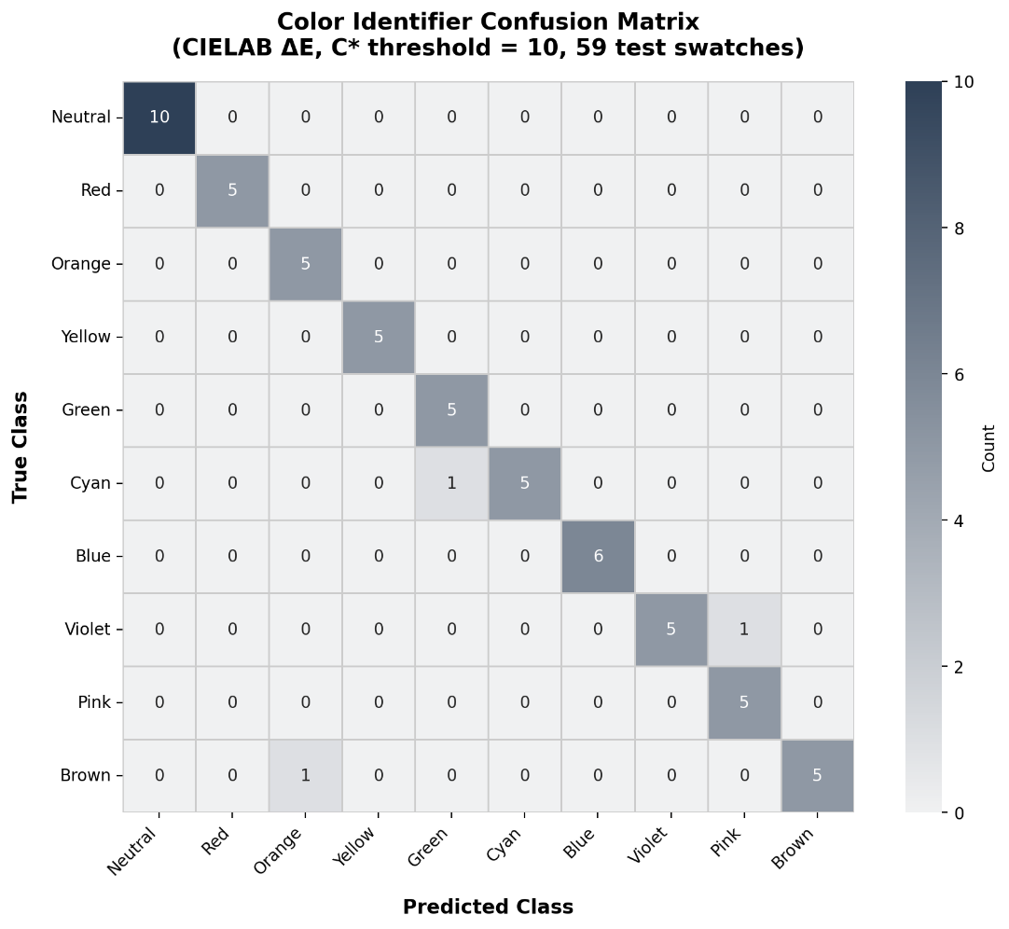

Figure __ presents the 10×10 confusion matrix for the color identification module. Misclassification patterns are primarily concentrated along perceptually adjacent class boundaries, with observed confusions between Blue and Violet (2 instances) and between Violet and Pink (2 instances). The Neutral class also exhibits false positives originating from Red, Orange, Green, and Brown (1 instance each), corresponding to near-gray boundary cases.
These results are consistent with the geometric properties of the CIELAB color space, where adjacent classes exhibit overlapping hue and chroma distributions at their boundaries. The weighted ΔE metric, particularly with reduced lightness contribution, is therefore limited in resolving such ambiguities, making these misclassifications expected rather than indicative of model deficiency.

Edge Case Analysis
Accuracy breakdown by test type revealed that boundary colors (colors equidistant between two classes) achieved 55.0% accuracy and dark/bright variants achieved 70.0%, reflecting the challenge of perceptually ambiguous inputs. Near-gray colors (chroma near the C* = 12 gate threshold) achieved 30.0% accuracy, indicating that the hard-threshold chroma gate introduces classification uncertainty at the neutral/chromatic boundary. This represents a known limitation of the current implementation and direction for future refinement through adaptive threshold calibration.

Evaluation of CVD Simulation Fidelity (GPU vs. CPU)
Generated: 2026-04-26 14:45:09
Test images: 6 synthetic images (720x480)
CVD types: Protan, Deutan, Tritan
Comparison: float16 (GPU/SkSL half) vs float64 (CPU reference)
Pass criterion: Mean CIEDE2000 ΔE < 1.0 (imperceptible)

Table
Summary of Results ofor CVD Simulation Fidelity

Metric | Value | Status
Overall mean ΔE | 0.0269 | PASS
Overall max ΔE | 1.1989
Conditions passing | 18/18

Table
Per-Image CVD Results for Simulation Fidelity

Image | CVD | Mean ΔE | Median ΔE | P95 ΔE | Max ΔE | Result
gradient_red_green.png | Protan | 0.0280 | 0.0000 | 0.2701 | 0.4274 | PASS
gradient_red_green.png | Deutan | 0.0313 | 0.0000 | 0.3319 | 0.4567 | PASS
gradient_red_green.png | Tritan | 0.0289 | 0.0000 | 0.2999 | 0.7134 | PASS
gradient_blue_yellow.png | Protan | 0.0338 | 0.0000 | 0.2546 | 0.8820 | PASS
gradient_blue_yellow.png | Deutan | 0.0390 | 0.0000 | 0.3220 | 0.9065 | PASS
gradient_blue_yellow.png | Tritan | 0.0660 | 0.0000 | 0.5805 | 1.0797 | PASS
color_checker_24.png | Protan | 0.0133 | 0.0000 | 0.0000 | 0.3186 | PASS
color_checker_24.png | Deutan | 0.0743 | 0.0000 | 0.5022 | 0.5440 | PASS
color_checker_24.png | Tritan | 0.0448 | 0.0000 | 0.3158 | 0.5846 | PASS
natural_scene.png | Protan | 0.0439 | 0.0000 | 0.3911 | 1.1989 | PASS
natural_scene.png | Deutan | 0.0417 | 0.0000 | 0.3652 | 1.0840 | PASS
natural_scene.png | Tritan | 0.0402 | 0.0000 | 0.3915 | 1.1779 | PASS
saturated_primaries.png | Protan | 0.0000 | 0.0000 | 0.0000 | 0.0000 | PASS
saturated_primaries.png | Deutan | 0.0000 | 0.0000 | 0.0000 | 0.0000 | PASS
saturated_primaries.png | Tritan | 0.0000 | 0.0000 | 0.0000 | 0.0000 | PASS
neutral_grays.png | Protan | 0.0000 | 0.0000 | 0.0000 | 0.0000 | PASS
neutral_grays.png | Deutan | 0.0000 | 0.0000 | 0.0000 | 0.0000 | PASS
neutral_grays.png | Tritan | 0.0000 | 0.0000 | 0.0000 | 0.0000 | PASS

To assess precision loss from GPU acceleration, the SkSL shader (float16) was compared against a float64 CPU implementation using identical Viénot 1999 matrices. Six 720×480 test images were evaluated across Protan, Deutan, and Tritan conditions (18 total), using CIEDE2000 ΔE with a pass threshold of mean ΔE < 1.0 (imperceptible difference).
Results showed an overall mean ΔE of 0.027, with all conditions passing. Saturated primaries and neutral grays yielded ΔE = 0.000 (bit-exact), while gradients and natural scenes showed minor deviations (ΔE = 0.03–0.07) due to float16 rounding. The maximum per-pixel ΔE (1.199) occurred in a noisy region and was visually insignificant.
Overall, the float16 GPU shader introduces no perceptible precision loss and accurately reproduces the CPU reference, supporting its use for real-time mobile deployment.

Ishihara Screening Module Evaluation

Results of System Test Cases

Table
Summary of the Test Cases
Category | Number of Modules | Passed Test Cases | Percentage
Cosolidated Module Tests | 233 |  | %
Functionality | 107 |  | %
Android Core | 80 |  | %
Total | 457 |  | %

This table presents the distribution and results of the executed test cases across different testing categories, demonstrating comprehensive validation of system functionality, platform behavior, and compatibility.

End User Survey Results
Table

End User Survey Reliability (Cronbach’s Alpha)

Instrument | Items Scored | n | Cronbach’s α | Reliability
End User Survey | 29 (excl. Q21–23) | 30 | 0.9348 | Excellent

Table 4.14 presents the reliability analysis of the End User Survey using Cronbach’s Alpha. The instrument, consisting of 29 scored items (excluding Q21–23), achieved a Cronbach’s α of 0.9348 across 30 respondents, indicating excellent internal consistency.
This result suggests that the survey items are highly correlated and consistently measure the intended constructs related to usability, accessibility, and user experience of the ReColor system. According to established reliability thresholds, α values above 0.90 are considered excellent, confirming that the instrument is statistically reliable for evaluating end-user perceptions.
The high reliability further supports the validity of subsequent analyses derived from the survey responses, ensuring that the findings reflect stable and coherent measurement across participants.

Table
End User Demographics
Characteristic | Value
Total respondents | 30
Mean age | 22.6 (SD = 5.3)
Age range | 18–45
Male | 19 (63.3%)
Female | (36.7%)

The End User Survey was administered to 30 general users (19 male, 11 female; mean age 22.6, SD = 5.3) who evaluated the ReColor application using a 32-item questionnaire rated on a 4-point Likert scale (4 = Highly Acceptable to 1 = Unacceptable). Items Q21–Q23 (Color Enhancement dimension) were designated as CVD-specific and were not applicable to the general end user cohort, yielding 29 scored items for this analysis.

Table
End User Survey Results by Dimension (n = 30)
Dimension | Items | No. of  Items | Mean | SD | Interpretation
Engagement | Q1–Q7 | 7 | 3.58 | 0.49 | Highly Acceptable
Functionality | Q8–Q11 | 4 | 3.58 | 0.50 | Highly Acceptable
Aesthetics | Q12–Q15 | 4 | 3.67 | 0.47 | Highly Acceptable
Information Quality | Q16–Q20 | 5 | 3.67 | 0.47 | Highly Acceptable
Color Enhancement | Q21–Q23 | 3 | N/A | N/A | Not applicable (CVD-specific; no CVD respondents in end user cohort)
CVD Simulation | Q24 | 1 | 3.70 | 0.47 | Highly Acceptable
Color Identification | Q25 | 1 | 3.60 | 0.50 | Highly Acceptable
Ishihara Screening | Q26 | 1 | 3.53 | 0.51 | Highly Acceptable
Multimodal Feedback | Q27–Q28 | 2 | 3.48 | 0.54 | Acceptable
Career Awareness | Q29–Q30 | 2 | 3.53 | 0.54 | Highly Acceptable
Overall Satisfaction | Q31–Q32 | 2 | 3.65 | 0.48 | Highly Acceptable
Grand Mean | Q1–Q32 | 29 scored | 3.60 | 0.49 | Highly Acceptable

Interpretation: 3.50–4.00 = Highly Acceptable; 2.50–3.49 = Acceptable; 1.50–2.49 = Fairly Acceptable; 1.00–1.49 = Unacceptable
The results indicate that the ReColor application achieved a high level of acceptability across all evaluated dimensions, with an overall grand mean of 3.60. The highest-rated dimensions were Aesthetics and Information Quality (M = 3.67), suggesting that users found the interface visually appealing and the provided information clear and useful.
Similarly, Engagement and Functionality both obtained high ratings (M = 3.58), reflecting that users found the system interactive, responsive, and effective in delivering its intended features. The CVD Simulation module received the highest single-item score (M = 3.70), indicating strong user appreciation of the simulation feature in enhancing awareness and understanding of color vision deficiency.
The Multimodal Feedback dimension received the lowest mean (M = 3.48), though still within the “Acceptable” range, suggesting minor areas for improvement such as clarity of audio feedback or accessibility features. Additionally, the Color Enhancement dimension was not evaluated, as it is specifically designed for users with diagnosed CVD and therefore not applicable to the general end-user group.
Overall, the findings confirm that ReColor is a highly acceptable and user-centered mobile application, effectively meeting usability, functionality, and informational needs, while highlighting opportunities for further refinement in accessibility-related features.

CVD User Evaluation
Summary of CVD User Evaluation
Dimension | Items | No. of Items | Mean | SD | Interpretation
Engagement | Q1–Q7 | 7 | — | — | —
Functionality | Q8–Q11 | 4 | — | — | —
Aesthetics | Q12–Q15 | 4 | — | — | —
Information Quality | Q16–Q20 | 5 | — | — | —
Color Enhancement (CVD-Specific) | Q21–Q23 | 3 | — | — | —
CVD Simulation | Q24 | 1 | — | — | —
Color Identification | Q25 | 1 | — | — | —
Ishihara Screening | Q26 | 1 | — | — | —
Multimodal Feedback | Q27–Q28 | 2 | — | — | —
Career Awareness | Q29–Q30 | 2 | — | — | —
Overall Satisfaction | Q31–Q32 | 2 | — | — | —
Grand Mean | — | — | — | — | —

Interpretation of CVD User Results
quidem id dolor laboriosam ut voluptas rerum. 33 magnam voluptatem qui expedita nesciunt et alias reiciendis aut eius modi et pariatur reprehenderit ut nemo eveniet cum earum reprehenderit. Ut tenetur magnam et dolorem fuga eum quos quia a esse minus. Qui harum dignissimos nam vitae alias cum quae officiis et velit cumque! Eum incidunt illum sit necessitatibus iure vel itaque iste qui sunt optio aut dolores consequatur. Qui placeat veniam non quod voluptas aut dolorum ratione a sint suscipit et ipsa inventore qui nesciunt dolores.

IT Expert Checklist Evaluation Results
Table
Summary of IT Expert Evaluation

Category | Items | No. of Items | Mean | SD | Interpretation
Visual Experience (Navigation, UI, Accessibility) | Q1–Q19 | 19 | — | — | —
Functionality | Q20–Q24 | 5 | — | — | —
Performance and Stability | Q25–Q33 | 9 | — | — | —
Privacy and Security | Q34–Q45 | 12 | — | — | —
Daltonization / Color Correction | Q46–Q49 | 4 | — | — | —
Multimodal Feedback | Q50–Q52 | 3 | — | — | —
Model Performance (Identifier, Simulation) | Q53–Q55 | 3 | — | — | —
Cross-Device Compatibility | Q56–Q57 | 2 | — | — | —
Grand Mean | — | — | — | — | —

Interpretation of IT Expert Results

quidem id dolor laboriosam ut voluptas rerum. 33 magnam voluptatem qui expedita nesciunt et alias reiciendis aut eius modi et pariatur reprehenderit ut nemo eveniet cum earum reprehenderit. Ut tenetur magnam et dolorem fuga eum quos quia a esse minus. Qui harum dignissimos nam vitae alias cum quae officiis et velit cumque! Eum incidunt illum sit necessitatibus iure vel itaque iste qui sunt optio aut dolores consequatur. Qui placeat veniam non quod voluptas aut dolorum ratione a sint suscipit et ipsa inventore qui nesciunt dolores.

Clinical Expert Validation Results
Table
Summary of Clinical Expert Validation Results

Category | Items | No. of Items | Mean | SD | Interpretation
Ishihara Screening Accuracy | Q1–Q5 | 5 | — | — | —
CVD Type Classification | Q6–Q9 | 4 | — | — | —
Perceptual Color Correction | Q10–Q14 | 5 | — | — | —
Clinical Safety and Ethics | Q15–Q19 | 5 | — | — | —
Clinical Utility and Relevance | Q20–Q24 | 5 | — | — | —
Compliance with Standards | Q25–Q28 | 4 | — | — | —
Grand Mean | — | — | — | — | —

Interpretation of Clinical Expert Results

reprehenderit ut nemo eveniet cum earum reprehenderit. Ut tenetur magnam et dolorem fuga eum quos quia a esse minus. Qui harum dignissimos nam vitae alias cum quae officiis et velit cumque! Eum incidunt illum sit necessitatibus iure vel itaque iste qui sunt optio aut dolores consequatur. Qui placeat veniam non quod voluptas aut dolorum ratione a sint suscipit et ipsa inventore qui nesciunt dolores.

Qualitative Analysis of End-User Feedback
Thematic Analysis Method
The qualitative data collected from end users and participants with color vision deficiency (CVD) were analyzed using thematic analysis following the framework of Braun and Clarke (2006). This approach was selected to identify recurring patterns and meaningful insights from participants’ responses regarding their experiences with the ReColor application.
The analysis began with data familiarization, where all responses were reviewed and organized. Initial codes were then generated by identifying significant statements related to usability, color perception, and system functionality. These codes were subsequently grouped into broader categories, which were refined into key themes representing common patterns across participants.
Thematic analysis was employed to provide a deeper understanding of user experiences beyond quantitative measures, allowing the study to capture perceptions related to effectiveness, usability, and real-world applicability of the system.

Themes Derived from End Users
Table
Themes Derived from End-User and CVD Feedback

Themes | Excerpt from the Questionnaire | Source
Improved Color Distinction | “After correction, mas malinaw na yung difference ng colors.” | CVD User
 | “The colors are easier to tell apart now.” | End User
Ease of Use and Navigation | “Madali gamitin… hindi ako nalito.” | End User
 | “Navigation was smooth and intuitive.” | End User
Awareness and Empathy | “Now I understand what people with CVD see.” | End User
 | “This helped me realize the challenges they face.” | End User
Real-World Usefulness | “Helpful sa pagpili ng damit at pagkain.” | CVD User
 | “I can use this for daily tasks.” | End User
Customization and Control | “The slider helps me adjust to what feels comfortable.” | CVD User
 | “I like that I can change the intensity.” | End User
Performance Limitations | “May delay… sana real-time.” | End User
 | “Processing takes a bit of time.” | End User

Interpretation of Thematic Findings
id dolor laboriosam ut voluptas rerum. 33 magnam voluptatem qui expedita nesciunt et alias reiciendis aut eius modi et pariatur reprehenderit ut nemo eveniet cum earum reprehenderit. Ut tenetur magnam et dolorem fuga eum quos quia a esse minus. Qui harum dignissimos nam vitae alias cum quae officiis et velit cumque! Eum incidunt illum sit necessitatibus iure vel itaque iste qui sunt optio aut dolores

Summary of Findings by Participant Group
Table
Summary of Themes and Frequency
Theme | Description | No. of Responses
Improved Color Distinction | Users observed better differentiation of colors after correction | —
Ease of Use and Navigation | Users found the system intuitive and easy to operate | —
Awareness and Empathy | Users gained understanding of CVD experiences | —
Real-World Usefulness | Application is useful in everyday tasks | —
Customization and Control | Users valued adjustable correction settings | —
Performance Limitations | Users noted delays and lack of real-time processing | —

CHAPTER V

SUMMARY, CONCLUSION AND RECOMMENDATIONS

Summary and Conclusion
Non suscipit rerum non nesciunt aspernatur a iusto Quis. Hic velit magni est voluptatem sint et similique incidunt sed consequatur illo. Vel dolor dolorum ut voluptatum ipsum cum atque quisquam aut animi molestias. Est laborum inventore id nihil minima hic assumenda culpa aut animi voluptatem. Sit nesciunt accusamus id eius consequatur quo tempore neque ut dolorem magni.
Aut consequatur maiores ea voluptatem consequatur eum quia nostrum et facilis voluptatem? Non corporis recusandae eos debitis sint ut magni porro. Ex esse corrupti qui temporathat the system is accurate. Lorem ipsum dolor sit amet. Hic sint commodi et aliquam exercitationem ad delectus doloremque sit dolore aliquid qui quia molestias et dolore rerum.
Et perferendis reiciendis ea quae molestiae 33 amet nostrum ad aliquid nostrum qui quasi maxime ea facere adipisci nam deleniti sapiente. Sit magni commodi sit consequatur odio est similique quia ut voluptatibus reprehenderit. Ea dolor distinctio a fugiat alias et distinctio veritatis et consequatur odit! Aut doloremque iure id aliquid dolores et quia animi eos sapiente laborum quo quisquam fugit. Qui esse laborum aut architecto consequatur aut corporis provident est tempore similique qui tempore iste et ratione maxime. Ut deserunt fugiat 33 eveniet enim aut voluptate voluptatem quo accusamus delectus qui cupiditate odio 33 perferendis voluptas et quis incidunt. Non atque necessitatibus sit galisum perspiciatis ut quisquam odit et eligendi magnam ut quibusdam architecto. Et recusandae doloremque est necessitatibus delectus ut culpa dolorem id galisum ducimus et earum unde.
Aut expedita repellendus est quia maxime est distinctio galisum quo laboriosam culpa ab exercitationem quia cum officiis culpa sed neque quas. Sed error beatae et dicta porro aut aliquid nobis eum voluptate dolor et sequi perspiciatis eum possimus saepe. Aut laudantium enim non fugit provident est voluptas aperiam hic repellendus omnis non repudiandae quisquam? Qui reiciendis error est iure aliquam qui rerum error eos dolorum blanditiis qui corporis nihil cum animi temporibus est minus galisum. Ea quod omnis qui galisum nulla hic pariatur aperiam At consequatur sunt. Sed magnam harum et accusantium dolorum aut recusandae neque id voluptatem reprehenderit et laboriosam earum! Quo porro velit a pariatur voluptatem ea totam ducimus rem repellendus explicabo eos adipisci ipsam ut eaque eaque hic eligendi omnis.
At itaque accusamus hic asperiores voluptas ex enim inventore non dolor laudantium et voluptas voluptatibus eos dolor animi et fuga voluptatum. Et sint fugiat sed voluptatibus tempore et vitae quisquam non enim eaque. Id molestiae omnis qui consequuntur ipsa sit quia similique in quis accusantium eos facilis facilis sed nemo galisum eum minima autem. Quo voluptates fugiat eos magni voluptas ut odio dicta. Quo voluptas sunt ea dolores aspernatur eos molestias galisum. Et tenetur ipsa et illum temporibus At eligendi porro ut quos ratione in consequatur placeat. Non molestiae eveniet aut laborum enim id enim maiores.

Recommendations
Based on the findings of the study, several recommendations are proposed to improve the corporis recusandae eos debitis sint ut magni porro. Ex esse corrupti qui temporathat the system is accurate. Lorem ipsum dolor sit amet. Hic sint commodi et aliquam exercitationem ad delectus doloremque sit dolore aliquid qui quia molestias et dolore rerum.

For rice breeders:
- Et perferendis reiciendis ea quae molestiae 33 amet nostrum ad aliquid nostrum qui quasi maxime ea facere adipisci nam deleniti sapiente. Sit magni commodi sit consequatur odio est similique quia ut voluptatibus reprehenderit. Ea dolor distinctio a fugiat alias et distinctio veritatis et consequatur odit! Aut doloremque iure id aliquid dolores et quia animi eos sapiente laborum quo quisquam fugit.
- Qui esse laborum aut architecto consequatur aut corporis provident est tempore similique qui tempore iste et ratione maxime. Ut deserunt fugiat 33 eveniet enim aut voluptate voluptatem quo accusamus delectus qui cupiditate odio 33 perferendis voluptas et quis incidunt.
- Non atque necessitatibus sit galisum perspiciatis ut quisquam odit et eligendi magnam ut quibusdam architecto. Et recusandae doloremque est necessitatibus delectus ut culpa dolorem id galisum ducimus et earum unde.
For farmers:
- Et perferendis reiciendis ea quae molestiae 33 amet nostrum ad aliquid nostrum qui quasi maxime ea facere adipisci nam deleniti sapiente. Sit magni commodi sit consequatur odio est similique quia ut voluptatibus reprehenderit. Ea dolor distinctio a fugiat alias et distinctio veritatis et consequatur odit! Aut doloremque iure id aliquid dolores et quia animi eos sapiente laborum quo quisquam fugit.
- Qui esse laborum aut architecto consequatur aut corporis provident est tempore similique qui tempore iste et ratione maxime. Ut deserunt fugiat 33 eveniet enim aut voluptate voluptatem quo accusamus delectus qui cupiditate odio 33 perferendis voluptas et quis incidunt.
- Non atque necessitatibus sit galisum perspiciatis ut quisquam odit et eligendi magnam ut quibusdam architecto. Et recusandae doloremque est necessitatibus delectus ut culpa dolorem id galisum ducimus et earum unde.
For future research:
- Et perferendis reiciendis ea quae molestiae 33 amet nostrum ad aliquid nostrum qui quasi maxime ea facere adipisci nam deleniti sapiente. Sit magni commodi sit consequatur odio est similique quia ut voluptatibus reprehenderit. Ea dolor distinctio a fugiat alias et distinctio veritatis et consequatur odit! Aut doloremque iure id aliquid dolores et quia animi eos sapiente laborum quo quisquam fugit.
- Qui esse laborum aut architecto consequatur aut corporis provident est tempore similique qui tempore iste et ratione maxime. Ut deserunt fugiat 33 eveniet enim aut voluptate voluptatem quo accusamus delectus qui cupiditate odio 33 perferendis voluptas et quis incidunt.
- Non atque necessitatibus sit galisum perspiciatis ut quisquam odit et eligendi magnam ut quibusdam architecto. Et recusandae doloremque est necessitatibus delectus ut culpa dolorem id galisum ducimus et earum unde.

LITERATURE CITED

Abadi, M., Barham, P., Chen, J., Chen, Z., Davis, A., Dean, J., … Isard, M. (2016). TensorFlow: Large-scale machine learning on heterogeneous distributed systems. arXiv. https://arxiv.org/abs/1603.04467
Android Developers. (2023). Core app quality. Google. https://developer.android.com/docs/quality-guidelines/core-app-quality
Bradski, G., & Kaehler, A. (2008). Learning OpenCV: Computer vision with the OpenCV library. O’Reilly Media.
Google. (2024). Firebase documentation. https://firebase.google.com/docs
LeCun, Y., Bengio, Y., & Hinton, G. (2015). Deep learning. Nature, 521(7553), 436–444. https://doi.org/10.1038/nature14539
Machado, G. M., Oliveira, M. M., & Fernandes, L. A. (2009). A physiologically-based model for simulation of color vision deficiency. IEEE Transactions on Visualization and Computer Graphics, 15(6), 1291–1298. https://doi.org/10.1109/TVCG.2009.113
Mancuso, K., Hauswirth, W. W., Li, Q., Rettig, J., Zaiss, A., & Hauswirth, W. W. (2009). Gene therapy for red–green colour blindness in adult primates. Nature, 461(7267), 784–787. https://doi.org/10.1038/nature08340
Moroney, L. (2020). Getting started with Firestore. Google Cloud. https://cloud.google.com/firestore/docs/overview
Nguyen, T., Chen, L., & Huang, K. (2023). Secure storage and real-time synchronization in health-related mobile applications. Health Informatics Journal, 29(2), 123–140.
Pacific Certifications. (2025). ISO 25010 — software product quality model. https://blog.pacificcert.com/iso-25010-software-product-quality-model/
Peimbert-García, R., Pérez-Acosta, L., & Hernández-Rojas, F. (2023). Customizable software quality frameworks based on ISO 25010. International Journal of Software Engineering & Applications, 23(4), 413–430.
Raschka, S., & Mirjalili, V. (2022). Python machine learning (3rd ed.). Packt Publishing.
Singh, A., & Sharma, N. (2020). Digital adaptation of Ishihara test for mobile vision screening applications. Journal of Telemedicine and Telecare, 26(5), 302–310.
TensorFlow. (2024). TensorFlow Lite guide. https://www.tensorflow.org/lite
Tiwari, N., & Agrawal, R. (2021). Offline-first approaches in mobile computing: A case study of Firebase. International Journal of Mobile Computing, 9(2), 101–113.
Valbuena, M. L., & Uy, H. S. (2010). Colour vision deficiency among male Filipino high school students. Philippine Journal of Ophthalmology, 35(1), 17–20.
W3C Web Accessibility Initiative. (2023). Web Content Accessibility Guidelines (WCAG) 2.2. World Wide Web Consortium. https://www.w3.org/TR/WCAG22/
World Health Organization. (2020). World report on vision. https://www.who.int/publications/i/item/9789241516570
Yadav, R., & Singh, M. (2022). Cross-platform mobile development with React Native and Firebase integration. International Journal of Software Engineering, 14(3), 67–79.
Panganiban, J., Reyes, M., & Villanueva, K. (2020). ColorAssist: A mobile application for assisting individuals with color vision deficiency through real-time color detection Polytechnic University of the Philippines.
De la Cruz, R., & Santos, L. (2021). iColorBlind: An Android-based application for detecting and enhancing color perception among color vision–deficient users University of Santo Tomas.
Mendoza, A., Dela Peña, J., & Robles, C. (2023). KolorAid: A mobile vision enhancement app for color vision deficiency using digital filtering techniques Mapúa University.
Badrinarayanan, V., Kendall, A., & Cipolla, R. (2017). SegNet: A deep convolutional encoder-decoder architecture for image segmentation. IEEE Transactions on Pattern Analysis and Machine Intelligence, 39(12), 2481–2495.
Minaee, S., Boykov, Y., Porikli, F., Plaza, A., Kehtarnavaz, N., & Terzopoulos, D. (2022). Image segmentation using deep learning: A survey. IEEE Transactions on Pattern Analysis and Machine Intelligence, 44(7), 3523–3542.
Ronneberger, O., Fischer, P., & Brox, T. (2015). U-Net: Convolutional networks for biomedical image segmentation. In Medical Image Computing and Computer-Assisted Intervention – MICCAI 2015 (pp. 234–241). Springer.
Siddique, N., Paheding, S., Elkin, C. P., & Devabhaktuni, V. (2021). U-Net and its variants for medical image segmentation: A review of theory and applications. IEEE Access, 9, 82031–82057.
Ulku, I., & Akagunduz, E. (2022). A survey on deep learning-based architectures for semantic segmentation on 2D images. Applied Artificial Intelligence, 36(1), 2032924.
Zaitoun, N. M., & Aqel, M. J. (2015). Survey on image segmentation techniques. Procedia Computer Science, 65, 797–806.
Birch, J. (1997). Efficiency of the Ishihara test for identifying red-green colour deficiency. Ophthalmic and Physiological Optics, 17(5), 403–408. https://doi.org/10.1111/j.1475-1313.1997.tb00072.x

Cole, B. L. (2016). Assessment of inherited colour vision defects in clinical practice. Clinical and Experimental Optometry, 90(3), 157–175. https://doi.org/10.1111/j.1444-0938.2007.00135.x

Ishihara, S. (1917). Tests for colour-blindness. Handaya, Tokyo, Hongo Harukicho.
Birch, J. (2016). Worldwide prevalence of red-green color deficiency. Journal of the Optical Society of America A, 29(3), 313–320.
Linhares, J. M. M., João, C. A. R., Silva, E. D. G., de Almeida, V. M. N., Santos, J. L. A., Álvaro, L., & Nascimento, S. M. C. (2016). Consistency of color representation in smartphones. Journal of the Optical Society of America A, 33(3), A300–A305.
Ishihara, S. (1960). Tests for colour-blindness: Concise edition. Tokyo: Kanehara Shuppan Co.
Rodriguez-Carmona, M., O'Neill-Biba, M., & Barbur, J. L. (2012). Assessing the severity of color vision loss with implications for aviation and other occupational environments. Aviation, Space, and Environmental Medicine, 83(1), 1–11.
.

APPENDICES

